UNIT-2

NUCLEAR POWER STATIONS

It is a generating station in which nuclear energy is converted into electrical energy.

Basic Principle:

Heavy elements such as Uranium(U235) or Thorium (Th232) are subjected to nuclear fission in a special apparatus called nuclear reactor and releases heat energy. This heat energy is utilized in raising the steam at high temperature and pressure. The steam runs the steam turbine which converts steam energy into mechanical energy and drives an alternator which converts this mechanical energy into electrical energy.

Advantages:

1. Less fuel required compared to that in conventional power plants,

2. Requires less space compared to that for other conventional power plants of same capacity,

3. Low running charges (as less fuel is required for power generation),

4. Economical for production of bulk power,

5. Can be located near to load centers as it does not require large quantity of water,

6. Availability of nuclear fuel is high,

7. Greater nuclear power generation leads to conservation of coal, oil which can be used for other

chemical processes.

Disadvantages:

1. High capital cost,

2. Erection and commissioning of plant requires more technical knowledge,

3. Fuel is expensive and not recoverable,

4. High maintenance charges due to the requirement of specially trained persons,

5. Cannot respond to load fluctuations efficiently (So these stations are not well suited for varying loads),

6. Radio active bi products are formed which are dangerous,

7. Disposal of products is a big problem. (Should be disposed in deep trench or in sea away from sea shore)

Selection of site for nuclear power stations:

1.Availability of water supply:

More water is required for cooling purposes. Therefore site selected should be near to the river, lake or by sea side.

2. Transportation facilities:

As nuclear power plant needs very little fuel, hence it does not require direct rail facilities for fuel transport. However to transport heavy equipment during erection transportation facilities are required.

3.Availability of site for Disposal of radio active waste:

To avoid health hazards, the radio active products should be buried in a deep trench (or) disposed off in sea away from sea shore.

4. Distance from populated areas:

There should be a reasonable distance between the nuclear power plant and the nearest populated area from the point of view of safety as there is a danger of presence of radio-activity in the atmosphere near the plant. However as precautionary measure, a dome is used in the plant which does not allow the radioactivity to spread by wind or underground water ways. It is highly undesirable to choose a site adjacent to chemical industries, oil refineries, PWD works, hospitals and schools.

5. Nearness to load center: Such plants should be located as near to the load centre as possible, consistent with safety considerations in order to reduce the transmission costs.

6. Type of Land: The substra should be strong enough to support the heavy reactors which may weigh as high as 1,00,000 tones and impose bearing pressure around 50 tones/m2. Areas remote from coal fields and hydro–site are preferable so as to improve the reliability of supply over the area.

Structure of atom:

The smallest particle of an element is termed as atom consists of nucleus at the center and one or more negatively charged electrons moving around the nucleus indefinite orbits. The nucleus contains protons (positively charged particles)& nucleons which do not have any charge. Normally the number of protons and electrons in each atom are equal and hence net charge of an atom is zero.

The electric charge completely determines the chemical properties of an atom.

The process of adding or removing electrons from an atom is known as ionization and such an atom is known as ion.

Charge of one electron = 1.602×10-19C (negative charge)

Charge of one proton = 1.602×10-19C (positive charge)

The nucleus is stable provided the neutrons ara capable of keeping the positive charged protons bound within the nucleus.

So in case of loss of a neutron from the nucleus, the atomic nucleus becomes unstable.

Atomic mass unit:

It is defined as (1/16th) of weight of oxygen atom (or) (1/12th) of mass of carbon atom.

1amu= 1.66×10-27 Kg

Mass of 1 proton = 1.007277 amu

Mass of 1 neutron = 1.008665 amu

Mass of 1 electron = 0.00054amu

So most of the weight of an atom is concentrated in its center i.e. nucleus.

Electron volt: (units of energy in nuclear physics)

It is defined as the energy gained by an electron in falling through a potential difference of one volt.

1ev = 1.602×10-19J

1Mev = 1.602×10-13J

Mass-energy equivalence:

According to Einstein, mass and energy are interchangeable and the relation is given by,

E = mc2where, c is speed of light = 3×108 m/s

Energy corresponding to 1amu = 1.66×10-27 × (3×108)2

= 1.494 × 10-10 J

= 

= 931Mev

Atomic number (Z):Number of protons in a nucleus

Mass number (A) :Number of neutrons and protons in an atom.

⇒ A= Z+n where n=number of neutrons

ZXArepresents anelement X with Z atomic number and A as mass number.

Ex: 2He4

Isotopes: Atoms with same number of protons but with different number of neutrons are called isotopes.

Ex: 92U234, 92U235, 92U238

* Isotopes have same chemical properties as the elements have same number of electrons.
* Some isotopes of some elements are unstable and disintegrates into two or more nuclei. Those which do so are known as radio active isotopes and the phenomenon is known as radio active decay.
* This process is accompanied by the release of particles ( like α, β ) or energy in the form of rays which is known as radiation.

Ex: a) Radioactive isotopes are Uranium, Thorium and radium

92U238→90Th234 + 2He4 + 4.2Mev

Rate of radio active decay:Radiation (or) Nuclear disintegration occurs at a definite rate measured by half lifei.e the time in which half of the atoms in a specimen disintegrates.

N=N0e-λt

(i.e the number of nuclei of an isotope decreases exponentially with time.)

Where N – Number of radio active nuclei at time ‘t’

N0 - Number of radio active nuclei at time t = 0

λ –radio active disintegration (or) decay constant

N = N0/2 when t=t1/2 (half life time)

⇒t1/2= 0.693/λ

Ex: Isotope Half life

U-235 7×106 years

U-238 4.5×109 years

P-239 2.4×104 years

Average life (or) Mean life:

In a radioactive substance, some atoms decay earlier and others survive longer. The statistical average life time of all the atoms is known as average (or) mean time.



Mass defect :

* The atomic nucleus consists of protons & neutrons, collectively known as nucleons. It is found that the measured mass of a nucleus is always less than the sum of masses of individual nucleons which make it up.
* This difference between experimental & calculated mass of the nucleus is called the mass defect (or) mass deficit.
* Mass defect ( Δm) = Zmp + (A-Z) mn –nucleus mass

Where mp – mass of proton

mn - mass of neutron

Binding energy:

* There exist intensive repulsive forces among the protons which present in the nucleus of an atom. But the protons bound together to one another by very power forces and this energy which binds the nucleons together is known as nuclear binding energy.
* This binding energy of an atom is equivalent to its mass defect.Thus various nuclei have different binding energies.
* Binding energy of a nucleus = Δmc2

Binding energy of a nucleon = binding energy of a nucleus/A

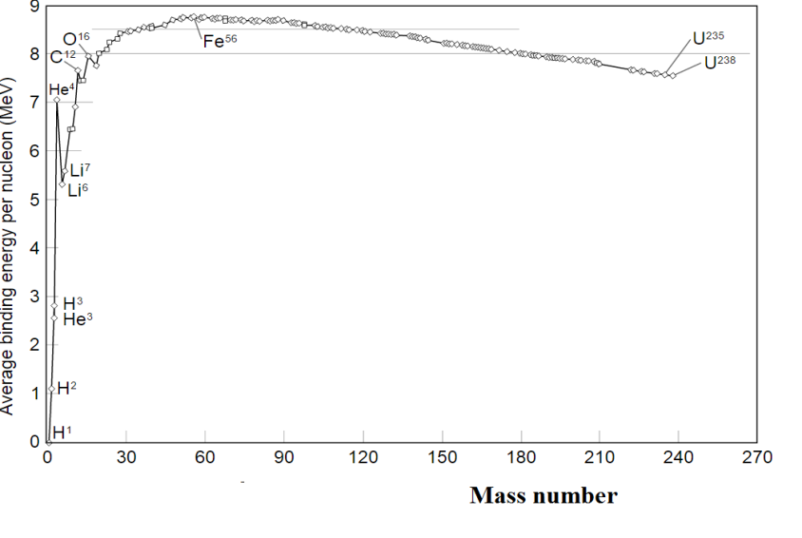

Plot of binding energy per nucleon versus Mass number

The above plot shows the relative stability of various nuclei. The greater the binding energy per nucleon, the more stable is the nucleus. The nuclei of about 60 atomic mass having maximum energy per nucleon are most stable (Ex: Fe56). The nuclei that are heavier or lighter have lower binding energies per nucleon and are less stable.

* The heavier nuclei undergo fission reaction with the release of some energy.
* The lighter nuclei undergo fusion reaction with the release of some energy.

⇒ The nuclear energy can be obtained in two ways.

1. Nuclear fission

2. Nuclear fusion.

Nuclear fission:

* The splitting of heavy nuclei into two or more smaller nuclei with the release of energy is termed as nuclear fission. This energy is released due to the mass defect of products ie the mass of products is less than that of the reactants.
* This fission can be caused by bombarding with a heavy energy particles such as protons, neutrons, x-rays etc. in which neutron bombardment is more suited for fission.

(Since they are neutral and they can make their way through the shells of electrons & then through the nucleus at low energy)

* A given nucleus cans fission in many ways.

Ex: The fission of U235canoccur in 35 ways.

i) 92U235+0n1→56Ba139+36Kr94+30n1+energy

ii) 92U235+0n1→42Mo106+50Sn128+20n1+energy

In the above reaction the mass defect per atom = 0.2amu

⇒ Energy released per atom = 0.2 × 931.5 = 187 Mev (Generally considered as 200 Mev)

Energy released by 1Kg uranium = 0.007 × 25.64 × 1023× 200

(since 1Kg uranium contains 25.64× 1023 atoms and assume natural uranium contains 0.7% of U235)

= 57.4336 × 1010J

* All the fission products are radio active, giving of beta and gamma radiations.

Chain reaction:

In the fission reaction of U-235, 3neutrons are released and these three neutrons strikes another 3 Uranium atoms causes nine subsequent reactions and so on. The propagation of the reaction by multiplication of three at each fission is known as chain reaction.

92U235+0n1→56Ba139+36Kr94+30n1+energy

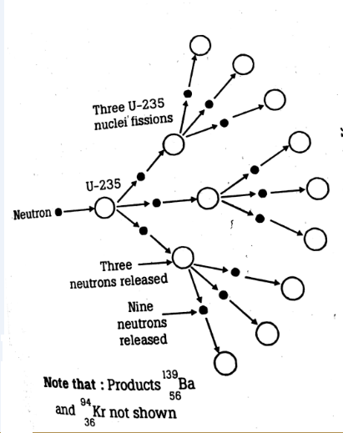

Chain reaction

* This reaction continues till most of the original nuclei in the given sample are fissioned.
* For this chain reaction to occur, all the neutrons emitted should propagate the reaction without escaping to the surroundings. It is possible if the sample of fission material is large enough to capture the neutrons internally.
* The energy released in fission process is called nuclear fission energy or nuclear energy.
* Critical mass: The minimum mass of fissionable material required to sustain the chain reaction.

Ex: For U-235, the critical mass is 10Kg.

Nuclear fuels:

1. Natural uranium

2. Enriched uranium

3. Plutonium

4. U233

(The last two fuels are secondary fuels which are not available in nature but can be formed in different reactions)

→ Fissionable materials:

U235, Pu239, U233

Out of these , U235 has higher fission percentage & mostly used.

Formation of 94Pu239: (from U238)

Called conversion process.







Formation of 92U233: (from Th232)

Called breeding process.







**LAY OUT OF NUCLEAR POWER PLANT**:

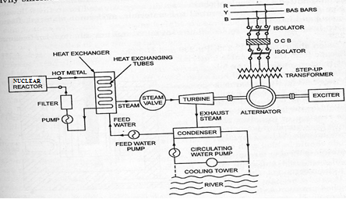

The main parts of nuclear power plant are,

i. Nuclear reactor

ii. Heat exchanger

iii. Steam turbine

iv. Alternator

Operating principle:

In nuclear reactor, heat is produced by nuclear fission reaction. A cooling material takes up this heat and delivers it to the heat exchanger in which water extracts this heat energy and converts into steam. This steam is allowed to expand over the steam turbine and produces mechanical energy which is converted into electrical energy by the alternator. The exhaust steam is condensed in condenser and converted into water which is again sent into heat exchanger forming a closed loop..

1. Nuclear reactor:

A nuclear reactor is a cylindrical shaped steel pressure vessel in which nuclear fission reactiontakes place.

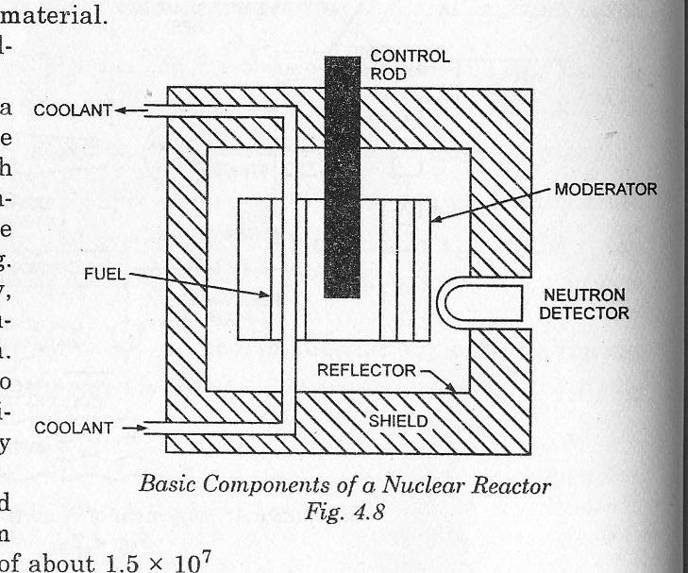

Basic components are,

i) Reactor core:

* Contains number of fuel rods diluted with non-fissionable materials.
* The fuel rods are clad with Al, stainless steel, Zirconium materials to reduce oxidization of U.
* Critical size of reactor:The size of corejust sufficient tomaintain chain reaction.

ii) Fuel rods:

* Natural or enriched Uranium are shaped into rods and located in the reatir which undergoes fission reaction.

iii) Moderator:

* Function: Slow down the neutrons which are generated in fission reaction.
* Process: Neutrons produced in fission reaction moves with high velocity about 1.5×107m/s and are known as fast neutrons. These neutrons collide with moderator nuclei and loose their energy. In this way, the neutrons get slowed down and move with less velocity. These neutrons are calledthermal (or) slow neutrons.
* Properties of good moderator:

1. Low neutron absorbing property,

2. High scattering cross section,

3. In expensive and chemically inert.

* Materials: raphite, Ordinary water, Heavy water and beryllium

iv) Control rods:

* Function: Controls the rate of fission reaction by absorbing some of the thermal neutrons.
* Properties of control rods:

1. High absorbing property of neutrons

* Necessity of control rods:

1. Tomaintain the chain reaction at the initial stage of plant operation,

2. To maintain steady rate of fission reaction during the operation of reactor,

3. To stop the plant operation under emergency conditions.

4. To prevent the destruction of reactor, melting of fuel rods, disintegration of coolant (at the time of enormous release of heat energy)

* All these controls are possible by moving the control rods in and out of the reactor core.
* Materials: Boron, Cadmium, Hafnium

v) Coolant:

* Function: 1. Transfers the heat generated in the reactor to heat exchanger.

2. Keeps the interior of the reactor at desired temperature.

* Materials:

1. Gasses: Air, CO2, Hydrogen, Helium

2. Liquids: Light & Heavy water

3. Liquid metals: Molten sodium, Lithium, Potassium

* Properties of good coolant:

1. Should not absorb neutrons,

2. Non-corrosive nature,

3. Non-oxidizing nature,

4. Non-toxic nature,

5. Good heat transfer capability

vi) Reflector:

* Function: Bounds back most of escaped neutrons into the reactor core.
* Properties of good reflector:

1. Good neutron scattering property

2. Small tendency to absorb neutrons

* It gets heated due to collision of neutrons with its atoms, therefore its cooling is essential.
* Material: Same as the moderator materials

vii) Shielding:

* Gives protection from the deadly α and β particles, γ rays & neutrons which are released from fission process. (by absorbing all these radiations)
* Materials: Concrete, Concrete with boron compounds, Iron

viii) Reactor vessel:

* It encloses the reactor core, reflector and shielding materials.
* Strong walled container
* It should withstand high pressures
* Provides entrance and exit of coolant flow & also holes at the top of the vessel for the control rods operation.
* 2. Heat Exchanger:
* In heat exchanger, the heat carried by coolant( from reactor), is dissipated in water and water is converted to high pressure steam here. After releasing heat in water the coolant comes back to the reactor by means of coolant circulating pump.
* 3.Steam Turbine:
* In nuclear power plant, the steam turbine plays the same role as in coal power plant. The steam drives the turbine in same way and produce mechanical energy. After doing its job, the exhaust steam comes into steam condenser where it is condensed to provide space to the steam behind it.
* 4. Alternator:
* An alternator, coupled with turbine, rotates and generates electrical power, for utilization.

Classification of nuclear reactors:

i) According to application:

a) Research & development reactors

b) Production reactors,

c) Power reactors

ii)According to neutron energy,

a) Thermal reactors b) Fast reactors

iii) According to the fuel used,

a) Natural uranium b) Enriched uranium

iv) According to the coolant used,

a) Water cooled reactors b) Gas cooled reactors,

c) Liquid metal cooled reactors d) Organic liquid cooled reactors

v) According to the moderator used,

a) Graphite reactors, b) Beryllium reactors

c) Water (ordinary or heavy water) reactors

vi) According to the type of core used,

a) Homogeneous reactors b) heterogeneous reactors

Types of nuclear reactors:

1. Pressurized Water Reactor (PWR):

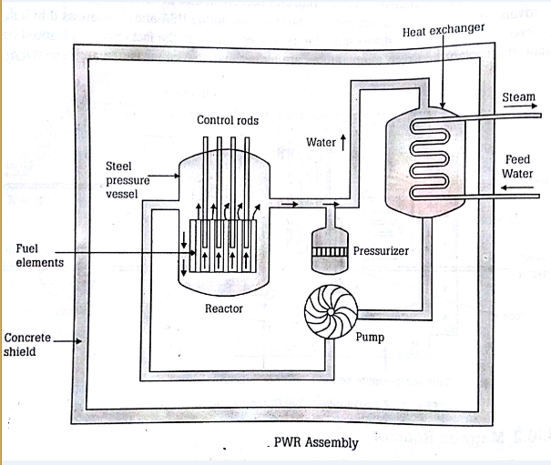

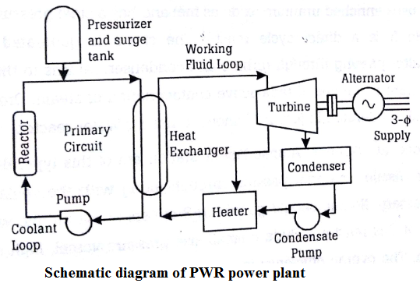

1. Fuel- Enriched uranium oxide clad in zinc alloy, placed inside the steel pressure vessel.

2. Coolant & moderator– Pressurised water

3. Pressure vessel & heat exchanger are surrounded by a concrete shield.

Working:

Water is passed into the reactor at 190oc& 140Kg/m2 pressure and is discharged from reactor at 270oc. This water is passed through exchanger where steam is raised.This steam is allowed to expand over the steam turbine and the exhaust steam is condensed incondensor. The condensate is pumped to heat exchanger which forms a closed circuit.

There are 2 circuits in the operation of a PWR :

i) Primary circuit : It contains a pressurizer. It maintains the pressure of the water throughout the load range.

• It is a pressure vessel with an electric heating coil at the bottom and a water spray at the top. The top of the

vessel is filled with steam at primary circuit pressure.

• When the primary circuit pressure decreases, the heating coil gets energized and boils the water to form

steam resulting in increase in steam content in the vessel.

• In case the steam pressure of the primary circuit becomes too high cold water is sprayed. The steam is

condensed and therefore primary circuit pressure is reduced.

• In the primary circuit, feed water takes up the heat from the reactor, exchanges its heat in the heat exchanger

and then given to the reactor, at a pressure.

ii) Secondary circuit : Heat received from the heat exchanger produces steam to drive the turbine. Exhaust

steam is condensed in the condenser. The condensate is again fed back to the heat exchanger.

A pressurizer & surge tank are tapped in the pipe loop which maintains constant pressure in the water system throughout the load range. The efficiency of cycle is improved by including economizer and super heaters.

Advantages:

1.Compact size,

2.Isolation of radio-active materials from the main steam system

3.Cheap (as light water can be used as coolant-cum-moderator )

4.High power density

5. Can meet load variations by using pressurizer and surge tank,

6.Possibility of breeding plutonium byproviding U-238.

Disadvantages:

1. Strong pressure vessel is required due to the use of high pressure water system

2. Formation of low temperature steam

3. Use of expensive cladding material for prevention of corrosion

4.High losses from heat exchanger

5.High power consumption by auxiliaries

6.Requires more elaborate safety devices

2. Boiling water reactor (BWR):

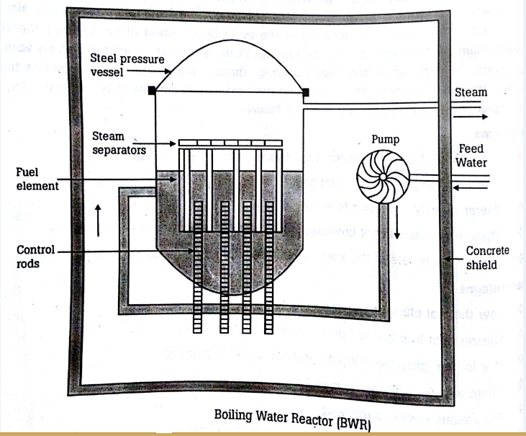

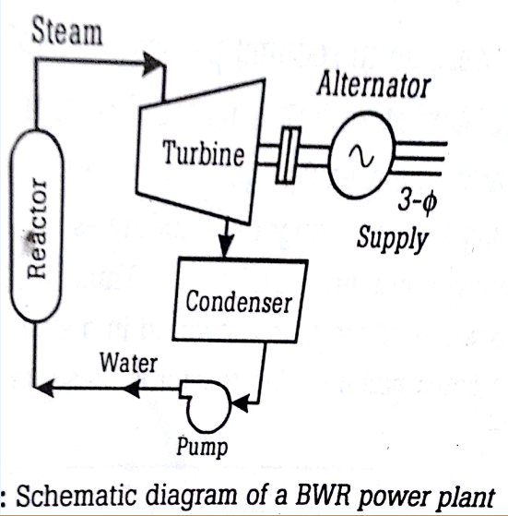

It has a steel pressure vessel surrounded by a concrete shield.

Fuel : Enriched uranium oxide

Moderator and coolant: Ordinary water

Working:

It contains a steam pressure vessel surrounded by concrete shield. It is a direct cycle reactor. Steam is generated in the reactor itself. Feed water enters the reactor vessel at the bottom and takes the heat produced due to fission of fuel and gets converted into steam. This steam leaves the reactor at the top and after it passes through turbine and condenser returns to the reactor.

Due to the direct conversion of water into steam in the reactor, there is danger of radio active contamination in steam. Because of this danger , more biological protection is necessary and more over no one should go within 3 meters of the turbine when it is operating.

Advantages:

1.Less costlier than PWR,

2. More efficient than PWR,

3. Less pressure exists inside the vessel compared to that in PWR,

4. More stable than PWR,

5. Temperature of metal surface is less compared to PWR

Disadvantages:

1. Expensive because more elaborate safety measures are to be provided, in view of the danger of radio-

active contamination of steam.

2. More biological protection is required, because of the danger of small amounts of fissile materials passing

along with the coolant.

3.Thermal efficiency is low due to wastage of steam

4.It cannot meet a sudden increase in load.

5. Less pressure density compared to PWR.

Fast breeder reactor (FWR):

A fast breeder reactor is a small vessel in which the required quantity of enriched uranium or plutonium is kept without moderator.

Coolant : Liquid Sodium / Potassium.

The fissionable fuel core (U-235) is surrounded by a blanket of fertile material(U-238).

Fertile material (U-238 & Th-232) is converted into fissile material (Pu-239 & U-233 respectively),by absorbing neutrons from the fission of U-235.

Two heat exchangers are used.

This prevents the possibility of a sodium – water reaction with the radioactive sodium ( in heat exchanger 1).

In the first heat exchanger, coolant-liquid sodium/potassium takes up the heat from the reactor andtransfers it to the coolant of 2nd circuit. Here it is pumped back to the reactor.

In the second heat exchanger, the coolant (again liquid sodium/potassium ) transfers heat to feed water to generate steam.

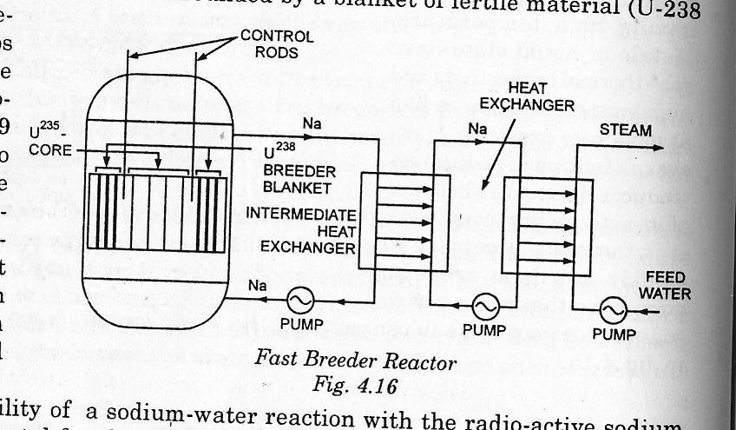

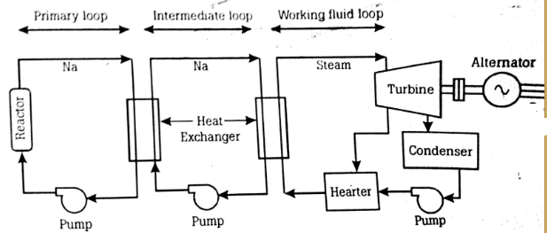

Schematic diagram of a LMFBR plant

Fast Reactors & Thermal Reactors

Fast neutrons: Neutrons ejected out of the nucleus, by the fission process are called fast neutrons. They travel with a very high velocity and have a large Kinetic Energy.

Thermal or slow neutrons: Fast neutrons when slowed down to speeds corresponding to the speed of molecules in a gas at NTP(=2.2 *1000 m/s) are called slow neutrons.

In Fast reactors, the fission is carried out by fast neutrons & in thermal reactors, fission is carried out by slow neutrons. So, moderator is used / moderator is mixed with the fissile material (fuel) in thermal reactors, to slow down the speed of the fast neutrons. This causes:

a) Size of reactor core larger in a thermal reactor (when compared to the core size in a fast reactor).

b)Heat generated per unit volume of the reactor core in a thermal reactor is very much less.

Advantages of Fast Reactors:

1.Fast reactors can convert more fertile material to fissile material with the result that the net fuel

consumption is much less. So, more fissile material is produced in a fast reactor than it is consumed.

2. These reactors are small & compact. So shielding is easy.

3.Any structural material can be used.

Disadvantages of Fast Reactors:

1. High fuel loading requirement.

2. Complicated heat transfer & cooling problems.

3. Core requires high enrichment.

4. Radiation damage of the structural material, due to fast / high energy neutrons.

5. Shorter lifetime of fast neutrons, cause some control problems.

Advantages of Thermal Reactors:

1.Ease of control due to low power densities& longer neutron lifetime.

2.Greater inherent safety.

3.Low fuel loading.

Disadvantages of Thermal Reactors:

1. Very much restricted choice of fuel.

2. Higher size & weight of reactor per unit power, due to low power density.

3. More fissile material consumption.

4. Requirements of structural material of small absorption cross-section.

**THE IMPACT OF RADIOACTIVITY AND ITS HAZARDS**

A nuclear Reactor produces alpha particles, beta particles, gamma rays and neutrons e=which candisturb the working of normal organisms.

**Types of Radiations:**

* alpha particles
* beta particles
* gamma rays
* neutrons

Radioactive materials are composed of atoms that are unstable. An unstable atom gives off its excess energy until it becomes stable. The energy emitted is radiation. Radiation has a cumulative effect. The longer a person is exposed to radiation, the greater the effect. A high exposure to radiation can cause serious illness or death.

**Penetrating power**



Alpha particles are absorbed by thin paper and can travel only a few centimeters in air. Beta particles are absorbed by thin aluminum and can travel a meter or so in air. Gamma radiation is absorbed by a few centimeters of lead and can travel many meters in air.

**Deflection in an electric field.**



**ALPHA PARTICLES**

* + It is the heaviest particle (not a wave). It is produced when the heaviest elements decay.
  + They are high-energy particles that are ejected from unstable nuclei.
  + It is an helium atom and contains two neutrons and two protons.
  + It leaves the nucleus of an unstable atom at a speed of 16,000 kilometers per second, around a tenth the speed of light.
  + The alpha particles are relatively large and heavy. As a result, alpha rays are not very penetrating and are easily absorbed. A sheet of paper or a 3-cm layer of air is sufficient to stop them.
  + Alpha radiation travels a very short distance through air.
  + Alpha radiation is not able to penetrate skin.
  + Alpha-emitting materials can be harmful to humans if the materials are inhaled, swallowed, or
  + absorbed through open wounds.
  + The delicate internal workings of the living cell forming the lining of the lungs or internal organs, most certainly will be changed or killed outright by the energetic alpha particle.

**BETA PARTICLES**

* Beta rays are much lighter energy particles.
* It is an energetic electron given off by the nucleus of unstable isotopes to restore an energy balance.
* They leave the nucleus at a speed of 2, 70,000 kilometers per second.
* They can be stopped, for instance, by an aluminum sheet of few millimeters thick or by 3 meters of air.
* Beta radiation may travel meters in air and is moderately penetrating.
* Beta particles are around 8000 times smaller than the alpha particles; it is capable of penetrating much deeper into living matter.
* Beta radiation can penetrate human skin to the "germinal layer," where new skin cells are produced. If beta-emitting contaminants are allowed to remain on the skin for a prolonged period of time, they may cause skin injury.
* It damages some of the chemical links between the living molecules of the cell or cause some permanent genetic change in the cell nucleus.

**GAMMA RAYS**

* They are very high energy "X-rays".
* It is an energetic photon or light wave in the same electromagnetic family as light and x-rays, but is much more energetic and harmful.
* It is capable of damaging living cells as it slows down by transferring its energy to surrounding cell components.
* They can travel many meters in air and many centimeters in human tissue.
* Dense materials are needed for shielding from gamma radiation.
* Gamma radiation accompanies the emission of alpha and beta radiation.

**NEUTRONS**

* They are produced in fission with a wide range of energy of 10Mev.
* They possess no charge.
* They are highly penetrating.
* Their effects are similar to that of Gamma rays.

**Radiation Hazards:**

Radioactive wastes, isotopes formed in nuclear reactors have high toxicity, if not handled properly during transportation, operation, repair, storage or disposal will pollute rivers, streams and atmosphere. The hazards caused may be external or internal.

**External Hazards:**

The external hazards are caused when the *body is bombarded by energetic radiation* from radioactive sources. The deep penetrating gamma rays, beta particles, and neutrons. Penetrate through the skin and damage the internal tissues.

The radiation dose rate is measured in rem (roentgen equivalent mammal). This is a unit of radiation damage that embodies both the magnitude of the dose and the relative biological effectiveness of particular type of radiation.

The maximum integrated dose for a person of age A years is (A-18)× 5 rem.

**Internal Hazards:**

The internal hazard is caused either by food, or by inhalation or by breaking up of the skin by radioactive radiation. It is very difficult to express the tolerance of the body as it depends on many variables like,

1. Degree of retention of radio active material in the body. If the material is retained for longer time, it is capable of

doing more harm.

2. The fraction of the radio active material which is passed to the critical tissues by the blood stream. The greater will be

the harm.

3. The radio sensitivity of the tissues involved for example bone, lymph glands are more vulnerable to energetic

radiation.

4. Size of organ involved. : If the organ is small the concentration of the radioactive material is high which can cause

more damage.

5. Essentiality of organ. : The most essential organ damaged by radioactivity can cause early death.

**RADIOACTIVE WASTE:**

Waste, by definition, is any material (solid materials such as process residues as well as liquid and gaseous effluents) that has been or will be discarded as being of no further use.

**A.Classification of waste on basis of radioactivity**

1. Low level (90%)

2. Intermediate level (7%)

3. High level(3%)

**Low-level waste:**

Generated from hospitals and industry, as well as the nuclear fuel cycle. Low-level wastes include paper, rags, tools, clothing, filters. Some high-activity LLW requires shielding during handling and transport but most LLW is suitable for shallow land burial

**Intermediate-level waste**

* Intermediate-level waste (ILW) contains higher amounts of radioactivity and in some cases requires shielding.
* Includes resins, chemical sludge and metal reactor nuclear fuel cladding
* It may be solidified in concrete or bitumen for disposal
* Short-lived waste (mainly non-fuel materials from reactors) is buried in shallow repositories
* Long-lived waste (from fuel and fuel reprocessing) is deposited in geological repository

**High-level waste:**

* It contains fission products and transuranic elements generated in the reactor core.
* Though it is only 3% of total volume but it is responsible for 95% of total radioactivity.
* It is highly radioactive and often hot.
* HLW is the most dangerous and the main candidate for geological disposal
* Certain radioactive elements (such as plutonium 239) in “spent” fuel will remain thousands of years Tc-99 (half-life 220,000 years)
* I-129 (half-life 15.7 million years)

**B.Management of radio-active wastes:**

The basic steps involved in waste management are,

1. Pretreatment: Involves collection, segregation, Chemical adjustment & decontamination

2. Treatment: Involves changing the characteristics of waste,

3. Conditioning: Involves the operations that transforms radio-active waste into a form suitable for handling, transportation, storage & disposal.

4. Storage: To isolate the radio-active waste from environment.

5. Disposal: It involves the authorized emplacement of packages of radio-active waste in a disposal facility.

**Disposal Methods:**

• Above ground disposal

• Geological disposal

• Deep borehole disposal

• Disposal at subduction zones

• Ocean disposal

• Disposal in outer space

i)**Above ground disposal Method**

1. Generally used for intermediate and high level waste

2. Waste from a spent fuel pool is sealed (along with an inert gas) in a steel cylinder, which is placed in a concrete cylinder which acts as a radiation shield.

3. Cheap , relatively easy to construct and monitor.

4. Dry cask storage area

**Deep borehole disposal:**

Disposing of high-level radioactive waste from nuclear reactors in extremely deep boreholes. Placing the waste as much as five kilometers beneath the surface of the Earth. Waste is sealed in strong steel containers and lowered down the borehole, filling the bottom one or two kilometers of the hole. Borehole is then sealed with materials, including perhaps clay, cement, crushed rock backfill, and asphalt, to ensure a low-permeability

**iii) Geological Repository**

A deep geological repository is a nuclear waste repository excavated deep within a stable geologic environment (typically below 300 m). Repositories include the radioactive waste, the containers enclosing the waste, other engineered barriers or seals around the containers, the tunnels housing the containers, and the geologic makeup of the surrounding area. Geological disposal can be safe, technologically feasible and environmentally sound Management.

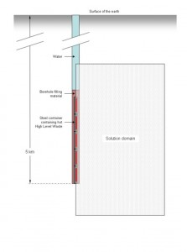

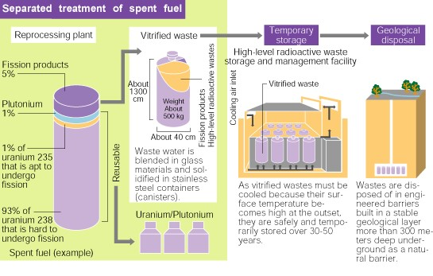

Impractical methods:

Methods :Main Reasons

Disposal in outer space :Very costly High risk of space vehicle failure

Ocean Disposal : Declared illegal by international treaty

Disposal at seduction zones : High risk of earthquakes since located on plate boundaries