Chapter-1: INTRODUCTION

Contents:

* Basic elements of control system
* Open loop and closed loop systems
* Examples of control systems
* Differential equation – Transfer function
* Modeling of electric systems – Translational and rotational mechanical systems

In this lecture, we lead you through a study of the basics of control system. After completing the chapter, you should be able to

Q Describe a general process for designing a control system.

Q Understand the purpose of control engineering

Q Examine examples of control systems

**Introduction:**

**Control engineering** is based on the foundations of feedback theory and linear system analysis, and it generates the concepts of network theory and communication theory. Accordingly, control engineering is not limited to any engineering discipline but is applicable to aeronautical, chemical, mechanical, environmental, civil, and electrical engineering.

## Some Basic Deﬁnitions

#### What is a system?

A collection of components that interact with one another and with their environment.

*Some examples of systems.* Human beings, mechanical devices, an electrical switch, plants, animals, the atmosphere, the stock market, the political system, etc. As aerospace engineers we may consider some aerospace systems like aircraft, helicopters, missiles, avionics, rocket engines, and so on.

#### What is a control system?

A control system is a collection of components that is designed to drive a given system (plant) with a given input to a desired output. In other words, a **control system** is an interconnection of components forming a system configuration that will provide a desired system response. The basis for analysis of a system is the foundation provided by linear system, which assumes a cause- effect relationship for the components of a system.

In recent years, **control systems** plays main role in the development and advancement of modern technology and civilization. Practically every aspects of our day-to-day life is affected less or more by some control system. A bathroom toilet tank, a refrigerator, an air conditioner, a geezer, an automatic iron, an automobile all are control system. These systems are also used in industrial process for more output. We find control system in quality control of products, weapons system, transportation systems, power system, space technology, robotics and many more. The **principles of control theory** is applicable to engineering and non engineering field both.

### Feature of Control System

The main **feature of control system** is, there should be a clear mathematical relation between input and output of the system. When the relation between input and output of the system can be represented by a linear proportionality, the system is called linear control system. Again when the relation between input and output cannot be represented by single linear proportionality, rather the input and output are related by some non-linear relation, the system is referred as non-linear control system.

### Requirement of Good Control System

**Accuracy :** Accuracy is the measurement tolerance of the instrument and defines the limits of the errors made when the instrument is used in normal operating conditions. Accuracy can be improved by using feedback elements. To increase accuracy of any control system error detector should be present in control system.  
**Sensitivity :** The parameters of control system are always changing with change in surrounding conditions, internal disturbance or any other parameters. This change can be expressed in terms of sensitivity. Any control system should be insensitive to such parameters but sensitive to input signals only.  
**Noise :** An undesired input signal is known as noise. A good control system should be able to reduce the noise effect for better performance.  
**Stability :** It is an important characteristic of control system. For the bounded input signal, the output must be bounded and if input is zero then output must be zero then such a control system is said to be stable system.  
**Bandwidth :** An operating frequency range decides the bandwidth of control system. Bandwidth should be large as possible for frequency response of good control system.  
**Speed :** It is the time taken by control system to achieve its stable output. A good control system possesses high speed. The transient period for such system is very small.  
**Oscillation :** A small numbers of oscillation or constant oscillation of output tend to system to be stable.

# Types of Control Systems:

***1. Different types of systems:***

All our tools and machines need appropriate control to work, otherwise it will be difficult to finish their designated tasks accurately. Therefore, we need control systems to guide, instruct and regulate our tools and machines. Common control systems include mechanical, electronic, pneumatic and computer aided. A system usually contains three main parts: input, process and output.

*Mechanical system*

A mechanical system is a device made up of various mechanical parts. Its input is provided by an effort. Once the effort and is applied, it can set off a motion to move a load. The force applied to the load is the output of the mechanical system. Examples of mechanical systems include levers, gears and shafts.



Fig. 1 Can opener as an example of mechanical systems

*Electronic system*

An electronic system is a system that employs electronic signals to control devices, such as

radios, calculators, video game machines, mobile phones, portable computers, etc . The input of an electronic system is provided by electronic signals. After they are processed, they can generate output signals, which control the operation of various devices, such as amplifiers and LCD. Electronic systems can carry out many different tasks, such as generating sound, transmitting information, displaying video, measuring, memorising, calculating, etc. Common examples of electronic devices include semi-conducting diode, transistors, capacitors that they are usually welded onto electronic circuit boards .



Fig. 2 Electronic circuit board

*Computer control system*

A computer control system uses a computer to control its output devices according to different input signals. Its function is similar to that of an electronic system. Yet a computer control system can use high speed calculation to process large volume of input signals within a very short time, and then generates appropriate outputs with the help of preset programs. Examples of computer control systems include computer numerical control press brakes, computer controlled home appliances, computer controlled underground railway systems, etc (Fig. 4).



Fig. 4 A proposed computer controlled home appliances

*Pneumatic system*

A pneumatic system is a system that uses compressed air to transport and control energy. Air is first pressurized to give energy in the cylinder. Then signals are input into the system through the use of switches. Next, air is transferred through sealed pipes to the pneumatic parts for processing. Finally, the force produced by the pneumatic parts is utilized to finish the designated task. The use of pneumatic systems is very extensive, for example, in controlling the movement of train doors, the operation of automatic production lines and mechanical clamps, etc (Fig. 5).



Fig. 5 Production line of CD-ROM

In this chapter, we will discuss some of the most common control systems.

***2 Sub-systems:***

A system can be very simple, for example, a switch is only needed in controlling a light bulb to work. However, with the advancement of technology, most of the control systems gradually become complicated that various parts are involved. Take a lift as an example. It needs a number of parts to be cooperative in operation, so as to transport passengers to different storeys safely and rapidly (Fig. 6).



Fig. 6 (a) A sightseeing lift in a shopping arcade (b) A lift in a hospital

A system may comprise some relatively small parts. They are known as sub-systems. For

instance, a lift system includes driving system, door opening system, control system, safety

system, lighting system, ventilation system and security system (Fig. 7). Fig. 8 shows a

diagram to illustrate those sub-systems in a lift.







# Fig. 7 Sub-systems in a lift

In fact, each sub-system can be considered as an independent system that includes input,

process and output. While there exist relationships between the sub-systems that an output of one sub-system may become the input of another. Take the lift as an example. The output generated from the control system may affect the driving and door opening systems (Fig. 8). However, attention should be paid in the complexity of relationships of some sub-systems.

# 

Fig. 8 Relationships between sub-systems

Therefore, when analyzing a complicated control system, that system can be divided into

several comparatively simple sub-systems so as to familiar with the operation of the whole system easily. Besides, based on the sub-system concept, we could understand the relationships of the parts of the whole system much easier.

*3 Different types of control systems:*

## Control Problem

Let us be a little more speciﬁc about what constitutes a control problem and what are the different types of control problems. In Table .1 we consider an aircraft control problem as an example.

|  |  |
| --- | --- |
| *Diﬀerent aspects of the control problem* | *Example* |
| The Plant | Aircraft |
| Control Inputs | Control surface deﬂections |
| Disturbance Inputs | Wind gusts |
|  |  |
| Outputs | Vehicle Translation and rotation, position and velocities |
| Goals of Control – Performance criteria, design criteria, control speciﬁcations | Speed of achieving commanded output, handling qualities,  stability |

Table 1: *Constituents of a control problem (aircraft example)*

In Table .1 note that ’input’ and ’output’ are deﬁned with respect to a plant. So, output of one plant can be the input to another plant.

**Classification Of Control Systems:**

In Table .2 we give some standard classiﬁcation terms used in describing a control system.

|  |  |
| --- | --- |
| Open loop | Closed loop |
| Dynamic | Static |
| Linear | Non-linear |
| Time-variant | Time-invariant |
| Continuous | Discrete-time |

Table 2: *Classiﬁcation of control problems*

### Linear and Non-Linear Control Systems:

In order to understand the **linear control system**, we should know the principle of superposition. The principle of [superposition theorem](https://www.electrical4u.com/superposition-theorem/) includes two the important properties and they are explained below:

*Homogeneity***:** A system is said to be homogeneous, if we multiply input with some constant A then output will also be multiplied by the same value of constant (i.e. A).

*Additivity:* Suppose we have a system S and we are giving the input to this system as a1for the first time and we are getting output as b1 corresponding to input a1. On second time we are giving input a2 and correspond to this we are getting output as b2.

#### Examples of Linear Control System

Consider a purely resistive network with a constant DC source. This circuit follows the principle of homogeneity and additivity. All the undesired effects are neglected and assuming ideal behaviour of each element in the network, we say that we will get linear [voltage](https://www.electrical4u.com/voltage-or-electric-potential-difference/) and [current](https://www.electrical4u.com/electric-current-and-theory-of-electricity/) characteristic. This is the example of **linear control system**.

### *Non-linear Systems*

We can simply define **non linear control system** as all those system which do not follow the principle of homogeneity. In practical life all the systems are non-linear system.

#### Examples of Non-linear System

A well known example of non-linear system is magnetization curve or [no load curve of a DC machine](https://www.electrical4u.com/characteristic-of-separately-excited-dc-generator/#magnetic-or-open-circuit-characteristic-of-separately-excited-DC-generator). We will discuss briefly no load curve of DC machines here: No [load curve](https://www.electrical4u.com/load-curve-load-duration-curve-daily-load-curve/) gives us the relationship between the air gap flux and the field winding mmf. It is very clear from the curve given below that in the beginning there is a linear relationship between winding mmf and the air gap flux but after this, saturation has come which shows the non linear behavior of the curve or characteristics of the **non linear control system**.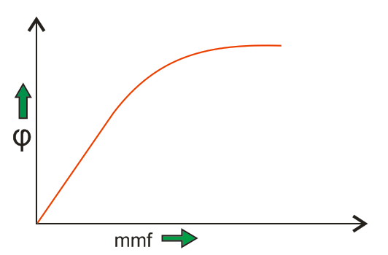

### Analog/Digital or Continuous/ Discrete Control System:

In these **types of control system** we have continuous signal as the input to the system. These signals are the continuous function of time. We may have various sources of continuous input signal like sinusoidal type signal input source, square type of signal input source, signal may be in the form of continuous triangle etc.

### *Digital or Discrete System*

In these types of control system we have discrete signal (or signal may be in the form of pulse) as the input to the system. These signals have the discrete interval of time. We can convert various sources of continuous input signal like sinusoidal type signal input source, square type of signal input source etc into discrete form using the switch.

Now there are various advantages of discrete or digital system over the analog system and these advantages are written below:

1. Digital systems can handle non linear control systems more effectively than the analog type of systems.
2. Power requirement in case of discrete or digital system is less as compared to analog systems.
3. Digital system has higher rate of accuracy and can perform various complex computations easily as compared to analog systems.
4. Reliability of digital system is more as compared to analog system. They also have small and compact size.
5. Digital system works on the logical operations which increases their accuracy many times.
6. Losses in case of discrete systems are less as compared to analog systems in general.

### Single Input Single Output Systems

These are also known as [SISO](https://www.electrical4u.com/serial-in-serial-out-siso-shift-register/) type of system. In this the system has single input for single output. Various example of this kind of system may include temperature control, position control system etc.

### Multiple Input Multiple Output Systems

These are also known as MIMO type of system. In this the system has multiple outputs for multiple inputs. Various example of this kind of system may include PLC type system etc.

### Lumped Parameter System

In these types of control systems the various active ([resistor](https://www.electrical4u.com/types-of-resistor-carbon-composition-and-wire-wound-resistor/)) and passive parameters (like [inductor](https://www.electrical4u.com/what-is-inductor-and-inductance-theory-of-inductor/) and [capacitor](https://www.electrical4u.com/what-is-capacitor-and-what-is-dielectric/)) are assumed to be concentrated at a point and that’s why these are called lumped parameter type of system. Analysis of such type of system is very easy which includes differential equations.

### Distributed Parameter System

In these **types of control systems** the various active (resistor) and passive parameters (like inductor and capacitor) are assumed to be distributed uniformly along the length and that’s why these are called distributed parameter type of system. Analysis of such type of system is slightly difficult which includes partial differential equations.

Based on the classification of Control Systems, they are further classified as:

(a) Open loop and closed loop control systems

There are basically two types of control system: the open loop system and the closed loop

system. They can both be represented by block diagrams. A block diagram uses blocks to represent processes, while arrows are used to connect different input, process and output parts.

\

#### What is an open loop control system?

1. Open loop control system



Fig. 9 Block diagram of an open loop control system

Fig. 9 shows a simple open loop control system. Its operation is very simple, when an input

signal directs the control element to respond, an output will be produced. Examples of the open loop control systems include washing machines, light switches, gas ovens, etc.

***Reference input:***Switch on the fan (that is, press the switch and 230 V is applied). So, the reference input is the 230 V signal.

***Controller:***The electronic voltage controller (that is, turn the knob to the desired position). The eﬀect is to reduce/change the voltage to the appropriate value. We may have approximately 230 V (= full speed) and 115 V (half-speed), and so on.

Once the speed is set there is nothing else that needs to be done. But suppose you have three fans. Even if you give their knobs the same amount of turn, the speeds are likely to be slightly diﬀerent. This may happen due to inaccuracy in the settings, inconsistency in ball bearings performance, imperfect setting of the fan blades causing diﬀerent amount of drag on the blades, or maybe due to non-standard performance of the electronic components.

So, essentially an open loop system is one where there is no way to correct the error between the desired output and the actual output.

Examples of Open- Loop Control System:

Example 1:

A washing machine is an example of an open loop control system. Fig. 12 shows its block

diagram. The input and output of an open loop system are unrelated. An example is that the

operation of a washing machine does not depend on the cleanness of the clothes, but rather on the preset time. Both the structure and the control process of an open loop control system are very simple, but the result of the output depends on whether the input signal is appropriate or not.

# 

# Fig. 10 Block diagram of an open loop control system (washing machine)

Example 2:

More sophisticated example of an open loop control system is the burglar alarm system (Fig.11). The function of the sensor is to collect data regarding the concerned house. When the electronic sensor is triggered off (for example, by the entry of an unauthorized person), it will send a signal to the receiver. The receiver will then activate the alarm, which will in turn generate an alarm signal. The alarm signal will not cease until the alarm is stopped manually.

# Fig. 11 Block diagram of an open loop control system (burglar alarm)

**Example 3:** The open-loop system is also called the non-feedback system. This is the simpler of the two systems. A simple example is illustrated by the speed control of an automobile as shown in Figure 12. In this open-loop system, there is no way to ensure the actual speed is close to the desired speed

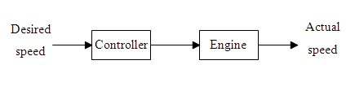

Fig 12 by the speed control of an automobile

automatically. The actual speed might be way off the desired speed because of the wind speed and/or road conditions, such as uphill or downhill etc.

The drawback of an open loop control system is that it is incapable of making automatic

adjustments. Even when the magnitude of the output is too big or too small, the system will not make the appropriate adjustments. For this reason, an open loop control system is not suitable for use as a complex control system. Sometimes it may even require monitoring and response from the user. For example, when a washing machine finishes cleaning the clothes, the user will need to check whether the clothes are clean or not; if they are not, they have to be put back into the machine and washed again.

#### Practical Examples of Open Loop Control System

1. **Electric Hand Drier** - Hot air (output) comes out as long as you keep your hand under the machine, irrespective of how much your hand is dried.
2. **Automatic Washing Machine** - This machine runs according to the pre-set time irrespective of washing is completed or not.
3. **Bread Toaster** - This machine runs as per adjusted time irrespective of toasting is completed or not.
4. **Automatic Tea/Coffee Maker** - These machines also function for pre adjusted time only.
5. **Timer Based Clothes Drier** - This machine dries wet clothes for pre-adjusted time, it does not matter how much the clothes are dried.
6. **Light Switch** - Lamps glow whenever light switch is on irrespective of light is required or not.
7. **Volume on Stereo System** - Volume is adjusted manually irrespective of output volume level.

#### Advantages of Open Loop Control System

1. Simple in construction and design.
2. Economical.
3. Easy to maintain.
4. Generally stable.
5. Convenient to use as output is difficult to measure.

#### Disadvantages of Open Loop Control System

1. They are inaccurate.
2. They are unreliable.
3. Any change in output cannot be corrected automatically.

#### What is a closed loop control system?

(ii) Closed loop control system

Sometimes, we may use the output of the control system to adjust the input signal. This is

called feedback. Feedback is a special feature of a closed loop control system. A closed loop control system compares the output with the expected result or command status, then it takes appropriate control actions to adjust the input signal. Therefore, a closed loop system is always equipped with a sensor, which is used to monitor the output and compare it with the expected result. Fig. 13 shows a simple closed loop system. The output signal is fed back to the input to produce a new output. A well-designed feedback system can often increase the accuracy of the output.

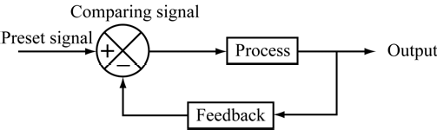

Fig. 13 Block diagram of a closed loop control system

Feedback can be divided into positive feedback and negative feedback. Positive feedback

causes the new output to deviate from the present command status. For example, an amplifier is put next to a microphone, so the input volume will keep increasing, resulting in a very high output volume.

Negative feedback directs the new output towards the present command status, so as to allow more sophisticated control. For example, a driver has to steer continuously to keep his car on the right track.

Most modern appliances and machinery are equipped with closed loop control systems.

Examples include air conditioners, refrigerators, automatic rice cookers, automatic ticketing machines, etc.

Example of Closed Loop Control Systems:

Example :

An air conditioner, for example, uses a thermostat to detect the temperature and

control the operation of its electrical parts to keep the room temperature at a preset constant. Fig.14 shows the block diagram of the control system of an air conditioner.

# 

# 

# 

Fig. 14 Block diagram of the control system of an air conditioner

One advantage of using the closed loop control system is that it is able to adjust its output

automatically by feeding the output signal back to the input. When the load changes, the error signals generated by the system will adjust the output. However, closed loop control systems are generally more complicated and thus more expensive to make.

#### Practical Examples of Closed Loop Control System

1. **Automatic Electric Iron** - Heating elements are controlled by output temperature of the iron.
2. **Servo Voltage Stabilizer** - Voltage controller operates depending upon output [voltage](https://www.electrical4u.com/voltage-or-electric-potential-difference/) of the system.
3. **Water Level Controller** - Input water is controlled by water level of the reservoir.
4. **Missile Launched and Auto Tracked by Radar** - The direction of missile is controlled by comparing the target and position of the missile.
5. **An Air Conditioner** - An air conditioner functions depending upon the temperature of the room.
6. **Cooling System in Car** - It operates depending upon the temperature which it controls.

#### Advantages of Closed Loop Control System

1. Closed loop control systems are more accurate even in the presence of non-linearity.
2. Highly accurate as any error arising is corrected due to presence of feedback signal.
3. Bandwidth range is large.
4. Facilitates automation.
5. The sensitivity of system may be made small to make system more stable.
6. This system is less affected by noise.

#### Disadvantages of Closed Loop Control System

1. They are costlier.
2. They are complicated to design.
3. Required more maintenance.
4. Feedback leads to oscillatory response.
5. Overall gain is reduced due to presence of feedback.
6. Stability is the major problem and more care is needed to design a stable closed loop system.

(b) Manual and automatic control systems

There were several stages in the history of development of technology. After the invention of

steam engine and other machinery, the efficiency and the speed of production was improved in the era of Industrial Revolution. However, so many machines claimed to be automatic were those nonstop machines indeed. Owing to the lack of sensitive sensors and processors, those machines were not equipped with good control systems, thus they were only categorized as open loop control system. To improve the precision of the control systems, operators were engaged to control the machines. They played an important role as sensors and decision-makers. They compared the inputs with the status needed, then provided feedback and made decision (their brains).

Afterwards, they adopted some procedures to stabilize the systems and minimized the errors. Lastly, the outputs were close to the requirements. Therefore, manual operation in the system is a kind of closed loop control system.

After the trustable sensors, processors and driving devices were well developed, automatic machinery gradually replaced those manual ones. Under the conditions of clear and repeated procedures, and those procedures which are operated by automatic adjustment system instead, automatic control machinery is more suitable for use. Therefore, those automatic controlled machines are suitable for boring and repeated works. It is better for a temperature sensor involved in the control of the switching on or off the compressor of the air conditioner. After the emergence of processors and new models of sensors, manual control systems were replaced by computer control systems. Therefore, machinery becomes automatically controlled.

# Example:

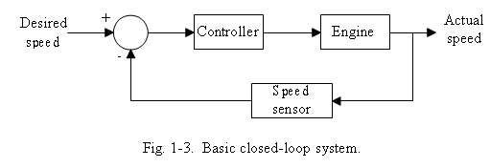The closed-loop system is also called the feedback system. A simple closed-system is shown in Figure 18. It has a mechanism to ensure the actual speed is close to the desired speed automatically.

Fig 18: Automatic Speed control system

A **closed-loop control system**  utilizes an additional measure of the actual output to compare the actual output with the desired output response. The measure of the output is called the **feedback signal**. A feedback control system is a control system that tends to maintain a relationship of one system variable to another by comparing functions of these variables and using the difference as a means of

control. As the system is becoming more complex, the interrelationship of many controlled variables may be considered in the control scheme. An example of closed-loop control system is a person steering an automobile by looking at the auto’s location on the road and making the appropriate adjustments.

© Applications of the control systems

There are many household and industrial application examples of the control systems, such as washing machine, air conditioner, security alarm system and automatic ticket selling machine, etc.

(i) Washing machine

Nowadays, many families use fully automatic washing machines. There are numerous preset washing procedures available for the users. When we have chosen the suitable washing procedures, the machine automatically starts to pour water, add washing powder, spin and wash clothes, discharge wastewater, etc. After the completion of all the procedures, the washing machine will stop the operation. Fully automatic washing machine only requires the user to input a suitable procedure to complete the whole washing process, thus this saves much time for the users. However, this kind of machine only operates according to the preset time to complete the whole washing process. It ignores the cleanness of the clothes and does not generate feedback. Therefore, this kind of washing machine is of open loop control system indeed, and their block diagram of control system of the washing machine as shown in Fig. 15.

# 

# Fig. 15 Block diagram of the open loop control system of the washing machine

(ii)Air conditioner

Nowadays, there are many families using automatic control system for the temperature of the air conditioner. Fig. 16 shows the interior structure of an air conditioner. The coolant circulated in the machine will absorb heat indoor, then it will be transported from the vaporization device to cooling device. The hot air is then blown to outdoor by a fan. There is an adjustable temperature device equipped in the air conditioner for the users to adjust the extent of cooling. When the temperature of the cool air is lower than the preset one, the controller of the air conditioner will stop the operation of the compressor to cease the circulation of the coolant. The temperature sensor installed near the vaporization device will continuously measure the indoor temperature, and send the results to the controller for further processing.

# 

Fig. 16 Internal structure of an air conditioner

Since the output of cool air by the air conditioner will affect its working, thus the control system of the machine is a closed loop. Its block diagram of the control system is as shown in Fig.17



Fig. 17 Block diagram of the closed loop control system of the washing machine

*Therefore, Closed loop systems have different characteristics when compared to open-loop systems.*

1. They are more accurate.

2. They are less sensitive to disturbances.

3. They are less sensitive to system characteristics/parameter variations.

4. However, they have a tendency to oscillate.

**What are the objectives of controller design?**

The main objective is to meet system specifications in the presence of large input disturbances and plant variations. Generally controller design goals are characterized by,

*•* Speed

*•* Accuracy

*•* Stability

Simple systems design

In designing a control system, one should consider factors such as its modes of input, process

and output. Sometimes, a single control system may contain a number of systems, such as electrical driving systems, electronic control systems, mechanical systems, computer control programs, etc. They are all known as sub-systems. Before designing the system, one must first study the relations between each sub-system and how they can be coordinated. For example, when designing an electric toothbrush, one should study its functions and properties to determine factors such as input, process and output. Apparently, an electric toothbrush should consist of two sub-systems: an electronic control system and a mechanical system. The relations between the factors can be represented using two operation block diagrams, as shown in Fig. 19 and Fig.20.

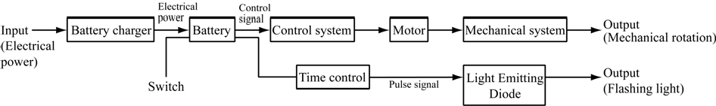

Fig. 19 Block diagram of an electronic control system

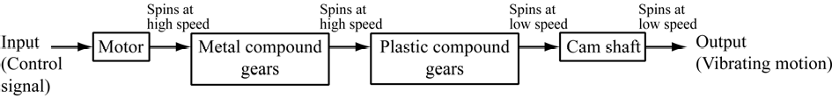

Fig. 20 Block diagram of a mechanical system

The structure of the electric toothbrush can be designed according to its operation block diagram. Fig. 21 shows the cross section of a typical electric toothbrush, the operation of which should correspond with the block diagrams shown above.

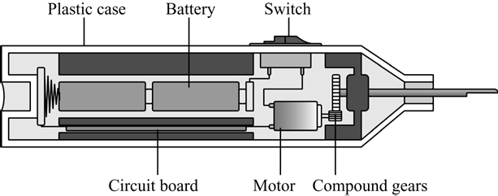

Fig. 21 Cross section of an electric toothbrush

Example:

# On Off Control Theory | Controller

Generally in **on off control system**, the output causes change in process variable. Hence due to effect of output, the process variable again starts changing but in reverse direction. During this change, when process variable crosses certain predetermined level, the output valve of the system is immediately closed and output is suddenly reduced to 0 %.

As there is no output, the process variable again starts changing in its normal direction. When it crosses the preset level, the output valve of the system is again fully open to give 100 % output. This cycle of closing and opening of output valve continues till the said on-off control system is in operation.  
A very common example of **on-off control theory** is fan controlling scheme of transformer cooling system.  
When [transformer](https://www.electrical4u.com/what-is-transformer-definition-working-principle-of-transformer/) runs with such a load, the temperature of the [electrical power transformer](https://www.electrical4u.com/electrical-power-transformer-definition-and-types-of-transformer/) rises beyond the preset value at which the cooling fans start rotating with their full capacity.  
As the cooling fans run, the forced air (output of the cooling system) decreases the temperature of the transformer.  
When the temperature (process variable) comes down below a preset value, the control switch of fans trip and fans stop supplying forced air to the transformer. After that, as there is no cooling effect of fans, the temperature of the transformer again starts rising due to load.

Again when during rising, the temperature crosses the preset value, the fans again start rotating to cool down the transformer.

Theoretically, we assume that there is no lag in the control equipment. That means, there is no time day for on and off operation of control equipment. With this assumption if we draw series of operations of an ideal on off control system, we will get the graph given below.

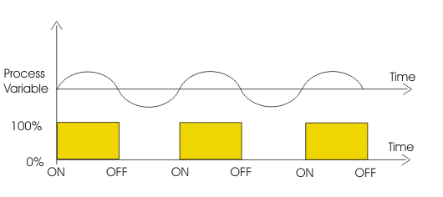

But in practical on off control, there is always a non zero time delay for closing and opening action of **controller** elements.  
This time delay is known as dead time. Because of this time delay the actual response curve differs from the above shown ideal response curve.

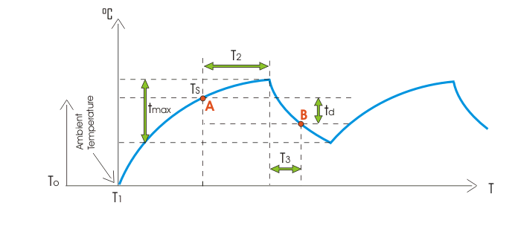Let us try to draw actual response curve of an on off control system. Say at time TOthe temperature of the transformer starts rising. The [measuring instrument](https://www.electrical4u.com/electrical-measuring-instruments-types-accuracy-precision-resolution-speed/) of the temperature does not response instantly, as it requires some time delay for heating up and expansion of mercury in [temperature sensor](https://www.electrical4u.com/temperature-sensor-types-of-temperature-sensor/) bulb say from instant T1 the pointer of the temperature indicator starts rising. This rising is exponential in nature. Let us at point A, the **controller** system starts actuating for switching on cooling fans and finally after period of T2the fans starts delivering force air with its full capacity. Then the temperature of the transformer starts decreasing in exponential manner.At point B, the controller system starts actuating for switching off the cooling fans and finally after a period of T3 the fans stop delivering force air. Then the temperature of the transformer again starts rising in same exponential manner.

**Note:** Here during this operation we have assumed that, loading condition of the electrical power transformer, ambient temperature and all other conditions of surrounding are fixed and constant.

**Comparison of Closed Loop And Open Loop Control System**

|  |  |  |
| --- | --- | --- |
| **Sr. No.** | **Open loop control system** | **Closed loop control system** |
| 1 | The feedback element is absent. | The feedback element is always present. |
| 2 | An error detector is not present. | An error detector is always present. |
| 3 | It is stable one. | It may become unstable. |
| 4 | Easy to construct. | Complicated construction. |
| 5 | It is an economical. | It is costly. |
| 6 | Having small bandwidth. | Having large bandwidth. |
| 7 | It is inaccurate. | It is accurate. |
| 8 | Less maintenance. | More maintenance. |
| 9 | It is unreliable. | It is reliable. |
| 10 | Examples: Hand drier, tea maker | Examples: Servo voltage stabilizer, perspiration |

**Feedback and its characteristics:**

#### Feedback Loop of Control System

A feedback is a common and powerful tool when designing a **control system**. Feedback loop is the tool which take the system output into consideration and enables the system to adjust its performance to meet a desired result of system.  
In any control system, output is affected due to change in environmental condition or any kind of disturbance. So one signal is taken from output and is fed back to the input. This signal is compared with reference input and then error signal is generated. This error signal is applied to controller and output is corrected. Such a system is called feedback system.

Figure below shows the block diagram of feedback system.

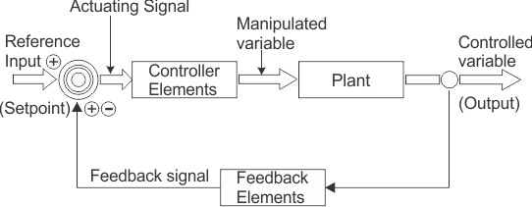

When feedback signal is positive then system called positive feedback system. For positive feedback system, the error signal is the addition of reference input signal and feedback signal. When feedback signal is negative then system is called negative feedback system. For negative feedback system, the error signal is given by difference of reference input signal and feedback signal.

#### Effect of Feedback

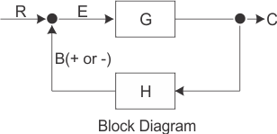Refer figure beside, which represents feedback system where  
R=Input signal  
E=Error signalG=Forward path gain  
H=Feedback   
C=Output signal

B = Feedback signal

1. Error between system input and system output is reduced.
2. System gain is reduced by a factor 1/(1±GH).
3. Improvement in sensitivity.
4. Stability may be affected.
5. Improve the speed of response.

**Summary of Topics:**

[**Control system**](http://engineering.electrical-equipment.org/tag/control-system) is a way of arranging and combining components in such a way that the desired output is obtained. In other words, a system is said to be “controlled”, if it’s working in a stable mode without getting unstable in any span of time.

From the above definition, one can say that a controlled system must have two attributes, which are:

1. Stability
2. Desired output

**[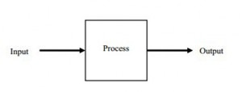](http://engineering.electrical-equipment.org/wp-content/uploads/2014/02/Introduction-to-Control-Systems.jpg)**

A control system can be functioned electrically, mechanically, pressure by fluid (gas or liquid), or it can be combination of these ways. But it more preferred to operate this system by electrical means especially when computer is involved, even though interfusion are common these days.

### Variables Involved in a Control System

In designing a control system, two types of variables are normally involved. These variables are used in control system to achieve the required position.

**1. Controlled Variable**

It is the value or prerequisite that is determined and controlled. These variables are independent variables and are usually not influenced by external factors. These variables are controlled by the engineer, designing the control system, and those values are chose for these variables at which the system gives the best output.

**2. Manipulated Variable**

The value or prerequisite that keep on changing as the controlled variables are changed. These variables are dependent variables and usually dependent on controlled variables. Let’s take a simple example of a fan dimmer.

As someone changes the dimmer position i.e. changes the voltage, rpm of fan also decreases. In this example, voltage is the controlled variable while rpm of fan is the manipulated variable.

### Types of Control Systems

There are three basic types of control systems that are feed forward control systems, feedback or closed [**loop control**](http://engineering.electrical-equipment.org/tag/loop-control) systems and the third type is open [**loop control**](http://engineering.electrical-equipment.org/tag/loop-control) systems.

Let’s have a look on the functionalities of these different control systems

1. Feed Forward Control System

Feed forward is a type of system which counters the changes in its surroundings. It is used to maintain the wanted status of the system. The biggest advantage of this system is that it doesn’t permit the huge disturbance in the output.

A system working on feed-forward behaviour reacts to a calculated disturbance in a pre-defined way which is in contrast with a feedback system. It is used in automotive as engine torque demands, in servo systems (robotics) etc.

**[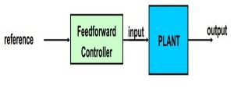](http://engineering.electrical-equipment.org/wp-content/uploads/2014/02/Introduction-to-Control-Systems-2.jpg)**

***2. Feedback or Closed Loop Control System***

A feedback control system is also known as closed loop control system. In these systems out is recorded and alternations are made on the basis of feedback. It can generate the desired output condition compared to the original one. It is insensitive to external disturbances. It useful as the output of system can be measured with ease.

**[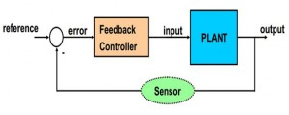](http://engineering.electrical-equipment.org/wp-content/uploads/2014/02/Introduction-to-Control-Systems-3.jpg)**

#### 3. Open Loop Control System

An open-loop control system is also referred as a non-feedback control system. These systems may not require a mathematical model of the physical system. It takes input under the consideration and doesn’t react on the feedback to determine the state of output. It doesn’t encounter any disturbance within the system or recompense them.

Stepper motors are one of the major examples of open-loop control systems. Automatic washing machine is yet another good example.

**[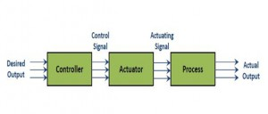](http://engineering.electrical-equipment.org/wp-content/uploads/2014/02/Introduction-to-Control-Systems-4.jpg)**

### Differences between Open-loop and Closed-loop control systems

These two types of control system have contrast with each other. They have dissimilarities some of which are discussed below:

[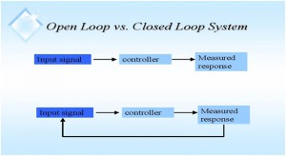](http://engineering.electrical-equipment.org/wp-content/uploads/2014/03/Difference-between-Open-Loop-Closed-Loop-Systems-4.jpg)

1. Effect of output

– An open loop control system acts completely on the basis of input and the output has no effect on the control action.

– A closed loop control system considers the current output and alters it to the desired condition. The control action in these systems is based on the output.

1. Reaction to Internal and External Disturbances

– An open loop control system works on fixed operation conditions and there are no disturbances.

– A closed loop control system doesn’t encounter and react on external disturbances or internal variations.

1. Stability

– Open loop control systems are mostly stable.

– In closed loop control systems stability is a major issue.

1. Effect on gain

– There is no effect on gain.

– There is no-linear change in system gain.

1. Implementation

– The structure of open loop control system is rather easy to construct. These systems can be easily implemented.

– The working principle and structures of closed loop control systems are rather complex and they are often difficult to implement.

1. Cost

– As an open loop control system is easy to implement, it needs lesser number of components to be constructed. Such systems need good calibration and lesser power rating. The overall cost of these systems is low.

– As the principle is complex, a closed loop control system needs larger number of components than an open loop control systems. These systems comparatively need less calibration and higher power rating. The overall cost of these systems is higher.

1. Examples

**[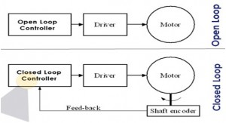](http://engineering.electrical-equipment.org/wp-content/uploads/2014/03/Difference-between-Open-Loop-Closed-Loop-Systems-5.jpg)**

– Stepper motors are one of the major examples of open-loop control systems. Automatic washing machine is yet another good example.

– Television remote is the most significant example of closed loop control systems. A computer mouse is another good example.

**Transfer Function:**

A [control system](https://www.electrical4u.com/control-system-closed-loop-open-loop-control-system/) consists of an output as well as an input signal. The output is related to the input through a function call **transfer function**. This function is represented by a block and the complete diagram of control system using these blocks which represent **transfer function** and arrows which represent various signals, is collectively known as block diagram of a [control system](https://www.electrical4u.com/control-system-closed-loop-open-loop-control-system/). For any control system there exists a reference input termed as excitation or cause which operates through a transfer operation termed as **transfer function** and produces an effect resulting in controlled output or response.  
Thus the cause and effect relationship between the output and input is related to each other through a **transfer function**.

Transfer Function

In [Laplace Transform](https://www.electrical4u.com/laplace-transformation/), if the input is represented by R(s) and output is represented by C(s), then the transfer function will be



That is, transfer function of the system multiplied by input function gives the output function of the system.

#### Why input, output and other signals are represented in Laplace form in a control system?

It is not necessary that output and input of a control system are of same category. For example, in [electric motors](https://www.electrical4u.com/electrical-motor-types-classification-and-history-of-motor/) the input is electrical signal whereas the output is mechanical signal since electrical energy required to rotate the motors. Similarly in an electric generator, the input is mechanical signal and the output is electrical signal, since mechanical energy is required to produce electricity in a generator. But for mathematical analysis, of a system all kinds of signals should be represented in a similar form. This is done by transforming all kinds of signal to their Laplace form. Also the transfer function of a system is represented by Laplace form by dividing output Laplace transfer function to input Laplace transfer function. Hence a basic block diagram of a control system can be represented as

Transfer Function



Where, r(t) and c(t) are time domain function of input and output signal respectively.

## Definition of Transfer Function

**The transfer function of a control system is defined as the ration of the Laplace transform of the output variable to Laplace transform of the input variable assuming all initial conditions to be zero.**

##### Procedure for determining the transfer function of a control system are as follows

1. We form the equations for the system.
2. Now we take Laplace transform of the system equations, assuming initial conditions as zero.
3. Specify system output and input.
4. Lastly we take the ratio of the Laplace transform of the output and the Laplace transform of the input which is the required transfer function.

### Methods of Obtaining a Transfer Function

There are major two ways of obtaining a transfer function for the control system. The ways are –

* **Block Diagram Method :** It is not convenient to derive a complete transfer function for a complex control system. Therefore the transfer function of each element of a control system is represented by a block diagram. Block diagram reduction techniques are applied to obtain the desired transfer function.
* **Signal Flow Graphs :** The modified form of a block diagram is a [signal flow graph](https://www.electrical4u.com/signal-flow-graph-of-control-system/). Block diagram gives a pictorial representation of a control system. Signal flow graph further shortens the representation of a control system.

## Poles and Zeros of Transfer Function

Generally a function can be represented to its polynomial form. For example,

Now similarly transfer function of a control system can also be represented as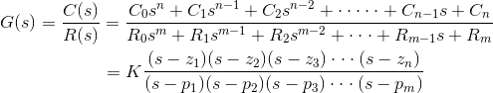

Where, K is known as gain factor of the transfer function.

Now in the above function if s = z1, or s = z2, or s = z3,....s = zn,the value of transfer function becomes zero. These z1, z2, z3,....zn, are roots of the numerator polynomial. As for these roots the numerator polynomial, the transfer function becomes zero, these roots are called zeros of the transfer function.  
Now, if s = p1, or s = p2, or s = p3,....s = pm, the value of transfer function becomes infinite. Thus the roots of denominator are called the poles of the function.



Now let us rewrite the transfer function in its polynomial form.

Now, let us consider s approaches to infinity as the roots are all finite number, they can be ignored compared to the infinite s.

ThereforeHence, when s → ∞ and n > m, the function will have also value of infinity, that means the transfer function has poles at infinite s, and the multiplicity or order of such pole is n - m.

Again, when s → ∞ and n < m, the transfer function will have value of zero that means the transfer function has zeros at infinite s, and the multiplicity or order of such zeros is m - n.

### Concept of Transfer Function

The transfer function is generally expressed in Laplace Transform and it is nothing but the relation between input and output of a system. Let us consider a system consists of a series connected [resistance](http://www.electrical4u.com/electrical-resistance-and-laws-of-resistance/) (R) and [inductance](http://www.electrical4u.com/what-is-inductor-and-inductance-theory-of-inductor/) (L) across a [voltage source](https://www.electrical4u.com/voltage-source/) (V).

In this circuit, the current 'i' is the response due to applied [voltage](http://www.electrical4u.com/voltage-or-electric-potential-difference/) (V) as cause. Hence the voltage and [current](http://www.electrical4u.com/electric-current-and-theory-of-electricity/) of the circuit can be considered as input and output of the system respectively.

From the circuit, we get,

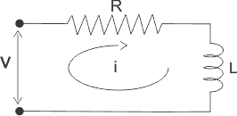 

Now applying Laplace Transform, we get,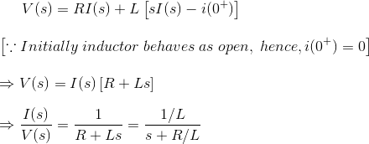

The transfer function of the system, G(s) = I(s)/V(s), the ratio of output to input.

1) Let us explain the concept of poles and zeros of transfer function through an example.



**Answer**  
The zeros of the function are, -1, -2 and the poles of the functions are -3, -4, -5, -2 + 4j, -2 - 4j.  
Here n = 2 and m = 5, as n < m and m - n = 3, the function will have 3 zeros at s → ∞. The poles and zeros are plotted in the figure below

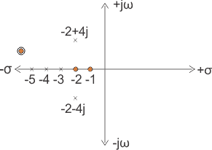

2) Let us take another example of transfer function of control system

**Answer**  
In the above transfer function, if the value of numerator is zero, then

These are the location of zeros of the function. 

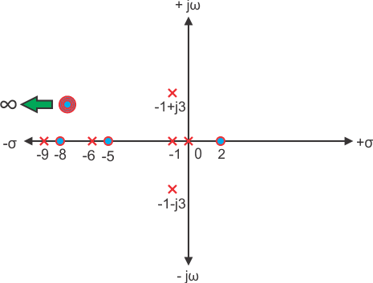  
Similarly, in the above transfer function, if the value of denominator is zero, then

These are the location of poles of the function.

As the number of zeros should be equal to number of poles, the remaining three zeros are located at s →∞.

#### Example of Transfer Function of a Network

3)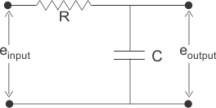

**Answer** In the above network the equation obtained is: 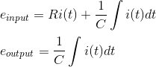

Let us assume,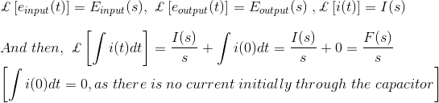Taking the Laplace transform of above equations with considering the initial condition as zero, we get,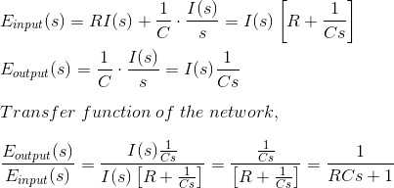

### unit impulse functionImpulse Response:

### The Effect of Impulse Signal

The unit impulse signal is defined as



Laplace transform of unit impulse function is 1.



Now if input signal is unit impulse signal then,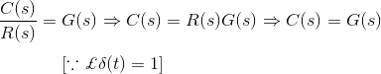

The output function is same as its transfer function.

## Mathematical Modelling of Control System

The main **feature of control system** is, there should be a clear mathematical relation between input and output of the system. When the relation between input and output of the system can be represented by a linear proportionality, the system is called linear control system. Again when the relation between input and output cannot be represented by single linear proportionality, rather the input and output are related by some non-linear relation, the system is referred as non-linear control system.

**General input-output relationships:**

A *model* is a mathematical relationship between the input and the output of a system. It is an approximation of the physical system.

A model may be described by differential equations (continuous-time systems) or difference equations (discrete-time systems).

As discussed earlier, there are various types of physical systems namely we have

1. Mechanical system.
2. Electrical system.
3. Electronic system.
4. Thermal system.
5. Hydraulic system.
6. Chemical system etc.

**What is the meaning of modeling of the system?**

**Mathematical modelling of control system** is the process of drawing the block diagram for these types of systems in order to determine the performance and the transfer functions.

We will derive analogies between mechanical and electrical system only which are most important in understanding the theory of control system.

### Mathematical Modelling of Mechanical Systems

We have two types of mechanical systems. Mechanical system may be a linear mechanical system or it may be a rotational mechanical type of system.

**In linear mechanical type of systems** we have three variables -

1. Force which is represented by ‘F’.
2. Velocity which is represented by ‘V’.
3. Linear displacement represented by ‘X’

And also we have three parameters-

1. Mass which is represented by ‘M’.
2. Coefficient of viscous friction which is represented by ‘B’.
3. Spring constant which is represented by ‘K’.

# Mechanical Translational systems

The model of mechanical translational systems can obtain by using three basic elements mass, spring and dash- pot.When a force is applied to a translational mechanical system, it is opposed by opposing forces due to mass, friction and elasticity of the system. The force acting on a mechanical body is governed by Newton‘s second law of motion. For translational systems it states that the sum of forces acting on a body is zero.

# Force balance equations of idealized elements

Consider an ideal mass element shown in fig. which has negligible friction and elasticity. Let a force be applied on it.

The mass will offer an opposing force which is proportional to acceleration of a body.

Let f = applied force

fm =opposing force due to mass

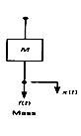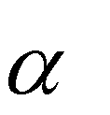*d* 2 *x*

Here fm *M*

*dt* 2

By Newton‘s second law, f = f m= M (*d* 2 *x/dt2)*

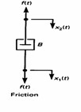Consider an ideal frictional element dash-pot shown in fig. which has negligible mass and elasticity. Let a force be applied on it. The dashpot will be offer an opposing force which is proportional to velocity of the body.

Let f = applied force

f b = opposing force due to friction

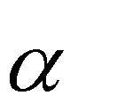*dx*

Here, f b *B*

*dt*

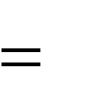By Newton‘s second law, f = f b = *B(dx/dt)*

Consider an ideal elastic element spring shown in fig. which has negligible mass and friction.

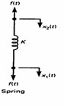

Let f = applied force

fk *x*

By Newton‘s second law, f = f k 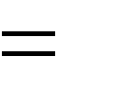*x*

**In rotational mechanical type of systems** we have three variables-

1. Torque which is represented by ‘T’.
2. Angular velocity which is represented by ‘ω’
3. Angular displacement represented by ‘θ’

And also we have two parameters -

1. Moment of inertia which is represented by ‘J’.
2. Coefficient of viscous friction which is represented by ‘B’.

# Mechanical Rotational Systems

The model of rotational mechanical systems can be obtained by using three elements, moment of inertia [J] of mass, dash pot with rotational frictional coefficient [B] and torsional spring with stiffness[k].

When a torque is applied to a rotational mechanical system, it is opposed by opposing torques due to moment of inertia,

friction and elasticity of the system. The torque acting on rotational mechanical bodies is governed by Newton‘s second law of motion for rotational systems.

# Torque balance equations of idealized elements

Consider an ideal mass element shown in fig. which has negligible friction and elasticity. The opposing torque due to moment of inertia is proportional to the angular acceleration.

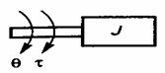

Let T = applied torque

Tj =opposing torque due to moment of inertia of the body

Here Tj

*J*

*dt* 2

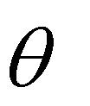

*d* 2

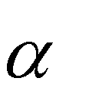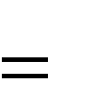

By Newton‘s law

T= Tj =

*J*

*dt* 2

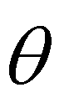

*d* 2

Consider an ideal frictional element dash pot shown in fig. which has negligible moment of inertia and elasticity. Let a torque be applied on it. The dash pot will offer an opposing torque is proportional to angular velocity of the body.

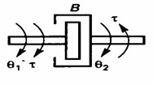

Let T = applied torque

Tb =opposing torque due to friction

*d*

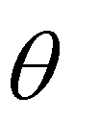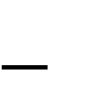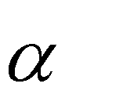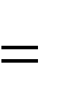

Here Tb

By Newton‘s law

*d*

*B* ( 1 2 )

*dt*

T= Tb =

*B* ( 1 2 )

*dt*

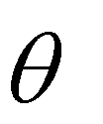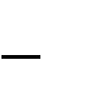

Consider an ideal elastic element, torsional spring as shown in fig. which has negligible moment of inertia and friction. Let a torque be applied on it. The torsional spring will offer an opposing torque which is proportional to angular displacement of the body.

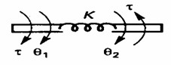

Let T = applied torque

Tk =opposing torque due to friction

Here Tk 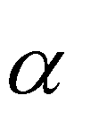*K* ( )

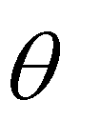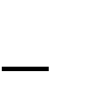

1 2

By Newton‘s law

T = Tk 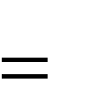*K* ( 1 2 )

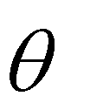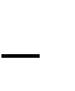

# Steps for modeling of electrical system

* Apply Kirchhoff‘s voltage law or Kirchhoff‘s current law to form the differential equations describing electrical circuits comprising of resistors, capacitors, and inductors
* Form Transfer Functions from the describing differential equations

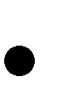 Then simulate the model

1. **Linear/ Translational Mechanical Systems**:

Now let us consider the linear displacement mechanical system which is shown below-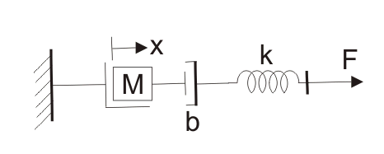

We have already marked various variables in the diagram itself. We have x is the displacement as shown in the diagram. From the Newton’s second law of motion, we can write force as-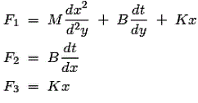

From the diagram we can see that the,https://www.electrical4u.com/equations/mmovs-08-06-14-02.gifOn substituting the values of F1, F2 and F3 in the above equation and taking the [Laplace transform](https://www.electrical4u.com/laplace-transformation/) we have the transfer function as,https://www.electrical4u.com/equations/mmovs-08-06-14-03.gifThis equation is **mathematical modelling of mechanical control system**.

### Mathematical Modelling of Electrical Systems:

**In electrical type of systems** we have three variables -

1. Voltage which is represented by ‘V’.
2. Current which is represented by ‘I’.
3. Charge which is represented by ‘Q’.

And also we have three parameters which are active and passive elements -

1. [Resistance](https://www.electrical4u.com/electrical-resistance-and-laws-of-resistance/) which is represented by ‘R’.
2. Capacitance which is represented by ‘C’.
3. Inductance which is represented by ‘L’.

# Modeling of electrical system

 Electrical circuits involving resistors, capacitors and inductors are considered. The behaviour of such systems is governed by Ohm‘s law and Kirchhoff‘s laws

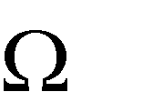 Resistor: Consider a resistance of ‗R‘ carrying current ‗i‘ Amps as shown in Fig (a), then the voltage drop across it is v = R I

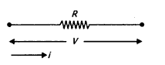

 Inductor: Consider an inductor ―L‘ H carrying current ‗i‘ Amps as shown in Fig (a), then the voltage drop across it can be written as v = L di/dt

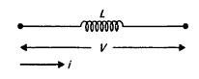

 Capacitor: Consider a capacitor ―C‘ F carrying current ‗i‘ Amps as shown in Fig (a), then the voltage drop across it can be written as v = (1/C) i dt

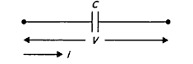

Now we are in condition to derive analogy between electrical and mechanical types of systems. There are two types of analogies and they are written below:

**Force Voltage Analogy :** In order to understand this type of analogy, let us consider a circuit which consists of series combination of [resistor](https://www.electrical4u.com/types-of-resistor-carbon-composition-and-wire-wound-resistor/), [inductor](https://www.electrical4u.com/what-is-inductor-and-inductance-theory-of-inductor/) and [capacitor](https://www.electrical4u.com/what-is-capacitor-and-what-is-dielectric/).

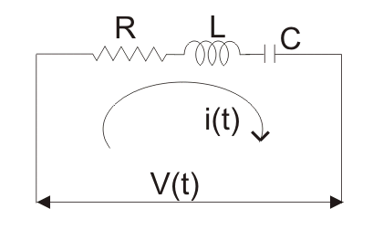A [voltage](https://www.electrical4u.com/voltage-or-electric-potential-difference/) V is connected in series with these elements as shown in the circuit diagram. Now from the circuit diagram and with the help of [KVL](https://www.electrical4u.com/kirchhoff-current-law-and-kirchhoff-voltage-law/) equation we write the expression for voltage in terms of charge, resistance, [capacitor](https://www.electrical4u.com/what-is-capacitor-and-what-is-dielectric/) and inductor as,

https://www.electrical4u.com/equations/mmovs-08-06-14-04.gif

Now comparing the above with that we have derived for the mechanical system we find that-

1. Mass (M) is analogous to [inductance](https://www.electrical4u.com/what-is-inductor-and-inductance-theory-of-inductor/) (L).
2. Force is analogous to voltage V.
3. Displacement (x) is analogous to charge (Q).
4. Coefficient of friction (B) is analogous to resistance R and
5. Spring constant is analogous to inverse of the capacitor (C).

This analogy is known as force voltage analogy.

**Force Current Analogy** : In order to understand this type of analogy, let us consider a circuit which consists of parallel combination of resistor, inductor and capacitor.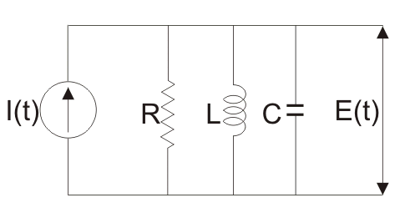

A voltage E is connected in parallel with these elements as shown in the circuit diagram. Now from the circuit diagram and with the help of [KCL](https://www.electrical4u.com/kirchhoff-current-law-and-kirchhoff-voltage-law/) equation we write the expression for current in terms of [flux](https://www.electrical4u.com/what-is-flux-types-of-flux/), resistance, capacitor and inductor as,

https://www.electrical4u.com/equations/mmovs-08-06-14-05.gif

Now comparing the above with that we have derived for the mechanical system we find that,

1. Mass (M) is analogous to Capacitor (C).
2. Force is analogous to current I.
3. Displacement (x) is analogous to flux (ψ).
4. Coefficient of friction (B) is analogous to resistance 1/ R and
5. Spring constant K is analogous to inverse of the inductor (L).

This analogy is known as force current analogy.

**© Mathematical Modelling of Rotational Mechanical Systems:**

Now let us consider the rotational mechanical type of system which is shown below we have already marked various variables in the diagram itself. We have θ is the angular displacement as shown in the diagram. From the mechanical system, we can write equation for torque (which is analogous to force) as torque as,

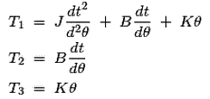

From the diagram we can see that the,

https://www.electrical4u.com/equations/mmovs-08-06-14-07.gif

https://www.electrical4u.com/equations/mmovs-08-06-14-08.gifOn substituting the values of T1, T2 and T3 in the above equation and taking the [Laplace transform](https://www.electrical4u.com/laplace-transformation/) we have the transfer function as,

This equation is mathematical modelling of [electrical control system](https://www.electrical4u.com/control-system-closed-loop-open-loop-control-system/).