UNIT-I

PERFORMANCE CHARACTERISTICS OF INSTRUMENTS

Static & Dynamic Characteristics Of Measurement SYSTEM:

The performance characteristics of an instrument are mainly divided into two categories:
i) Static characteristics
ii) Dynamic characteristics
STATIC CHARACTERISTICS:
The set of criteria defined for the instruments, which are used to measure the quantities which are slowly varying with time or mostly constant, i.e., do not vary with time, is called ‘static characteristics’.
The various static characteristics are:
i) Accuracy
ii) Precision
iii) Sensitivity
iv) Linearity
v) Reproducibility
vi) Repeatability
vii) Resolution
viii) Threshold
ix) Drift
x) Stability
xi) Tolerance
xii) Range or span
Accuracy:
It is the degree of closeness with which the reading approaches the true value of the quantity to be measured. The accuracy can be expressed in following ways:
a) Point accuracy:
Such accuracy is specified at only one particular point of scale.
It does not give any information about the accuracy at any other Point on the scale.
b) Accuracy as percentage of scale span:
When an instrument as uniform scale, its accuracy may be expressed in terms of scale range.
c) Accuracy as percentage of true value:
The best way to conceive the idea of accuracy is to specify it in
terms of the true value of the quantity being measured. Precision: It is the measure of reproducibility i.e., given a fixed value of a quantity, precision is a measure of the degree of agreement within a group of measurements. The precision is composed of two characteristics:
a) Conformity:
Consider a resistor having true value as 2385692, which is being measured by an ohmmeter. But the reader can read consistently, a value as 2.4 M due to the no availability of proper scale. The error created due to the limitation of the scale reading is a precision error.
b) Number of significant figures:
The precision of the measurement is obtained from the number of significant figures, in which the reading is expressed. The significant figures convey the actual information about the magnitude & the measurement precision of the quantity. The precision can be mathematically expressed as:

P=1-|[Xn-Xn(bar)/Xn(bar)]

Where, P = precision
Xn = Value of nth measurement
Xn(bar) = Average value the set of measurement values
Sensitivity:
The sensitivity denotes the smallest change in the measured variable to which the instrument responds. It is defined as the ratio of the changes in the output of an instrument to a change in the value of the quantity to be measured. Mathematically it is expressed as,
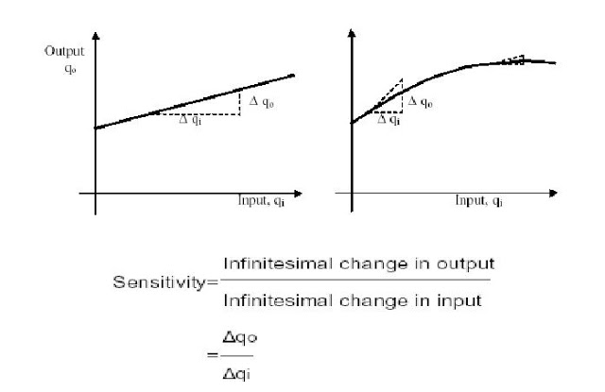
Thus, if the calibration curve is liner, as shown, the sensitivity of the instrument is the slope of the calibration curve. If the calibration curve is not linear as shown, then the sensitivity varies with the input. Inverse sensitivity or deflection factor is defined as the reciprocal of sensitivity. Inverse sensitivity or deflection factor = 1/ sensitivity

Reproducibility:
It is the degree of closeness with which a given value may be repeatedly measured. It is specified in terms of scale readings over a given period of time.
Repeatability:
It is defined as the variation of scale reading & random in nature Drift:
Drift may be classified into three categories:
a) zero drift:
If the whole calibration gradually shifts due to slippage, permanent set, or due to undue warming up of electronic tube circuits, zero drift sets in.

b) Span drift or sensitivity drift:
If there is proportional change in the indication all along the upward scale, the drifts is called span drift or sensitivity drift.
c) Zonal drift:
In case the drift occurs only a portion of span of an instrument, it is called zonal drift.
Resolution:
If the input is slowly increased from some arbitrary input value, it will again be found that output does not change at all until a certain increment is exceeded. This increment is called resolution.
Threshold:
If the instrument input is increased very gradually from zero there will be some minimum value below which no output change can be detected. This minimum value defines the threshold of the instrument.
Stability:
It is the ability of an instrument to retain its performance throughout is
specified operating life.
Tolerance:
The maximum allowable error in the measurement is specified in terms of some value which is called tolerance.
Range or span:
The minimum & maximum values of a quantity for which an instrument is designed to measure is called its range or span.
Dynamic characteristics:
The set of criteria defined for the instruments, which are changes rapidly with time, is called ‘dynamic characteristics’.
The various static characteristics are:
i) Speed of response
ii) Measuring lag
iii) Fidelity
iv) Dynamic error
Speed of response:
It is defined as the rapidity with which a measurement system responds to changes in the measured quantity.
Measuring lag:
It is the retardation or delay in the response of a measurement system to changes in the measured quantity. The measuring lags are of two types:
a) Retardation type:
In this case the response of the measurement system begins immediately after the change in measured quantity has occurred.
b) Time delay lag:
In this case the response of the measurement system begins after a dead time after the application of the input. Fidelity: It is defined as the degree to which a measurement system indicates changes in the measured quantity without dynamic error.
Dynamic error:
It is the difference between the true value of the quantity changing with time & the value indicated by the measurement system if no static error is assumed. It is also called measurement error.

DC VOLTMETER:
Basic Voltmeter:
To use the basic meter as a dc voltmeter, it is necessary to know the amount of current required to deflect the basic meter to full scale known as full scale deflection current (I_{fsd}).
Sensitivity is given as
For I_{fsd} = 50microamp, S = 1/I_{fsd} = 1/50*10⁻⁶ = 20Kiloohms/Volt
Hence a 0-1mAmp would have a sensitivity of 1V/1mAmp = 1Kohm/V.
The sensitivity is based on the fact that the full-scale current of 50 micro amperes results whenever 20000 ohms of resistance is present in the meter circuit for each voltage applied.
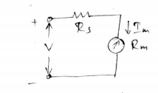
A basic D’Arsonval movement can be converted into a dc voltmeter by adding a series resistor known as multiplier. The multiplier limits the current through the movement so that the current does not exceed the full-scale deflection value.
I_{m}=full scale deflection current I_{fsd}
R_{m}=internal resistance of the movement
R_{s}=multiplier resistance
V=full range voltage of the instrument
From the circuit,
V=I_{m}R_{s}+I_{m}R_{m}
R_{s}= (V-I_{m}R_{m})/I_{m} = (V/I_{m})-R_{m}=(S*V)-R_{m}
The multiplier limits the current through the meter so as not to exceed the value of the full scale deflection I_{fsd}.
Problems:
1. A basic D’Arsonval movement with a full-scale deflection 50microAmp and internal resistance 500 ohms is used as a voltmeter. Find the multiplier resistance needed to measure a voltmeter range of 0-10V.
Sol: R_{s}= (V/I_{m})-R_{m}
= (10/(50*10⁻⁶))-500
=199.5Kiloohms
2. Calculate the value of the multiplier resistance on 50v range of a DC voltmeter that uses 500microamp meter movement with an internal resistance 1killoohm.
Sol: sensitivity of 500microamp meter S=1/I_{m}=1/(500*10⁻⁶) =2Kohms/V
Multiplier resistance R_{s}=(S*V)-R_{m}= (2*50)-1Kiloohms=99Kiloohms.
MULTIRANGE VOLTMETER:
To get a multirange ammeter, a number of shunts are connected across the meter with a multi position switch, similarly a dc voltmeter can be connected into a multimeter voltmeter by connecting number of resistors along with a range switch to provide a greater number of ranges.
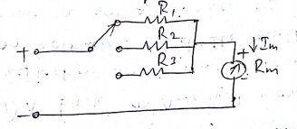
Figure above shows a multirange voltmeter using a 3 positions switch and three multiplier resistances R₁, R₂ and R₃ for voltage values v₁, v₂ and v_{3.}
Modified multirange voltmeter:
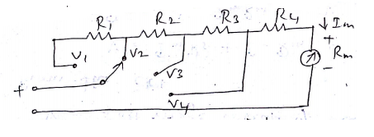
Here the multiplier resistances are connected in series and the range selector selects the appropriate amount of resistance required in series with the meter.
This is advantageous compared to the previous circuit, as all resistance except the resistor R₄ has to be specially manufactured.

Problem:
1. A D’ Arsonval movement with a full-scale deflection current of 50microamp and internal resistance 500ohm is to be connected into a multirange voltmeter. Find the value of the multiplier resistances for 0-20V, 0-50V.
Sol:
I_{m} =50microamp R_{m}=500ohm
For 0-20V
R_{s1}= (V/I_{m})-R_{m}= (20/50*10⁻⁶)-500=399.5Kohm
For 0-50V
R_{s2}= (V/I_{m})-R_{m}= (50/50*10⁻⁶)-500=999.5Kohm

Differential Voltmeter
The differential voltmeter technique, is one of the most common and accurate methods of measuring unknown voltages. In this techique, the voltmeter is used to indicate the difference betweesn known and unknown voltages i.e., an unknown voltage is compared to a known voltage.
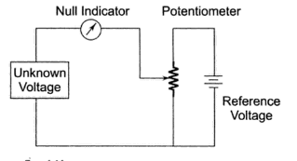
The basic circuit of a differential voltmeter is based on the potentiometric method; hence it is sometimes also called a potentiometric voltmeter.

- Basic differential voltmeter
In this method, the potentiometer is varied until the voltage across it equals the unknown voltage, which is indicated by the null indicator reading zero. Under null conditions, the meter draws current from neither the reference source nor the unknown voltage source, and hence the differential voltmeter presents an infinite impedence to the unknown source. (The null meter serves as an indicator only.)
To detect small differences the meter movement must be sensitive, but it need not be calibrated, since only zero has to be indicated.
The reference source used is usually a 1 V dc standard source or a zener controlled precision supply. A high voltage reference supply is used for measuring high voltages.
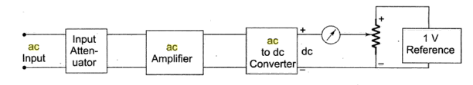
- Block diagram of an ac differential voltmeter.
The usual practice, however, is to employ voltage dividers or attenuators across an unknown source to reduce the voltage. The input voltage divider has a relatively low input impedence, especially for unknown voltages much higher than the reference standard. The attenuation will have a loading effect and the input resistance of voltmeter is not infinity when an attenuator is used.
In order to measure ac voltages, the ac voltage must be converted into dc by incorporating a precision rectifier circuit.
Solid State Voltmeter :
The circuit of an electronic voltmeter using an IC opamp 741C. This is directly coupled to very high gain amplifier. The gain of the opamp can be adjusted to any suitable lower value by provinding appropriate resistance between its output terminal. Pin No. 6, and inverting input, Pin No. 2, to provide a negative feedback.
The ratio R₂/R₁ determines the gain, i.e. 101 in this case, provided by the opamp. The 0.1 µF capacitor across the 100 k resistance R₂ is for stability under stray pick – ups. Terminals 1 and 5 are called offset null terminals. A 10 kΩ potentiometer is connected between these two offset null terminals with its center tap connected to a 5V supply. This poentiometer is called zero set and is used for adjusting zero output for zero input conditions.
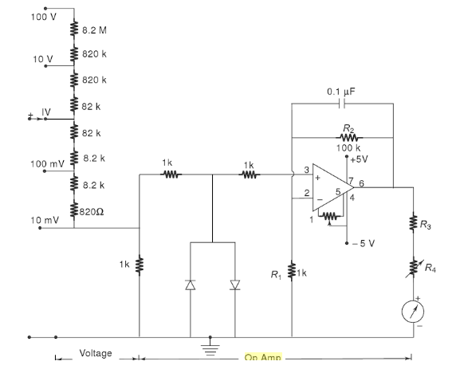

Solid State mV voltmeter using an Op Amp
The two diodes used are for IC protection. Under normal conditions, they are non-conducting, as the maximum voltage across them is 10 mV. If an excessive voltage, say more than 100 mV appears across them, then depending upon the polarity of the voltage, one of the diodes conducts and protects the IC. A µA scale of 50 – 1000 µA full scale deflection can be used as an indicator. R₄ is adjusted to get maximum full scale deflection.
AC Voltmeter:
In electronic ac voltmeters input signal is firstly rectified and then supplied to the dc amplifier, as shown in figure. Sometimes signal is firstly amplified by AC amplifier and then rectified before supplying it to dc meter, as shown in figure. In the former case the advantage is of economical amplifiers and the arrangement is usually used in low priced voltmeters.
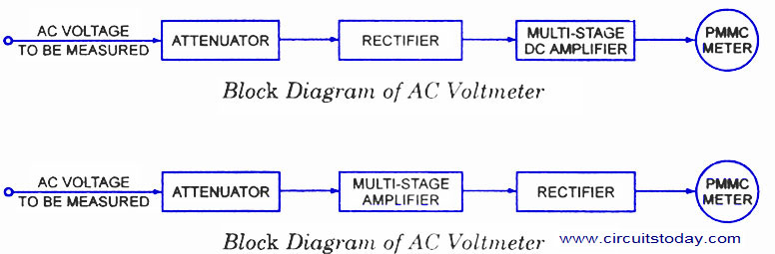
AC Voltmeters are broadly classified into two categories:
- Average Reading AC Voltmeter
- Peak Reading AC Voltmeter

Average Reading AC Voltmeter:
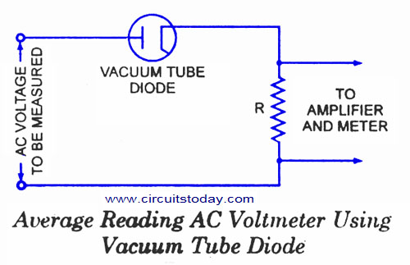
Normally ac voltmeters are average responding type and the meter is calibrated in terms of the rms values for a sine wave. Since most of the voltage measurements involve sinusoidal waveform so this method of measuring rms value of ac voltages works satisfactorily and is less expensive than true rms responding voltmeters. However, in case of measurement of non-sinusoidal waveform voltage, this meter will give high or low reading depending on the form factor of the waveform of the voltage to be measured.
The circuit diagram for an average reading voltmeter using a vacuum tube diode is shown in figure. The arrangement requires a vacuum tube diode, a high resistance (of the order of 10⁵ Q.) R and PMMC instrument, all connected in series, as shown in fig. Resistance R is used to limit the current and make the plate voltage-current characteristics linear. The linear plate characteristics are essential in order to make the current directly proportional to voltage. Also because of high series resistance R, plate resistance of vacuum tube diode becomes negligible and therefore variations in plate resistance do not cause non-linearity in voltage-current characteristics. In this way we get the scale of PMMC instrument uniform and independent of variations of tube plate resistance. Voltage across the high resistance is fed to dc amplifier and output of the amplifier is fed to PMMC instrument. Circuit diagram of an average reading ac voltmeter using semi-conductor diode is shown in figure.

Peak Reading AC Voltmeter:

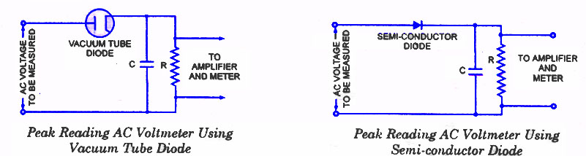

In this type of voltmeters capacitor C is charged to the peak value of the applied voltage and capacitor is discharged through the high resistance R between two peaks of the wave which results in a small fall in capacitor voltage. But this voltage is again built up during next peak of the wave, as shown in figure. So, voltage across capacitor C and resistance R remains almost constant and equal to the peak value of the applied voltage. Either the average voltage across R or the average current through R, can be used to indicate the peak value of applied voltage. In case the vacuum tube diode (or semi-conductor diode), series resistance R shunted by capacitance C and PMMC are connected in series across the source of unknown voltage, the current through the PMMC will indicate the peak value of applied voltage.
In case, the circuit shown in figure making use of rectifying diode, series resistance R, dc amplifier and PMMC is employed, the average voltage across R will indicate the peak value of applied voltage. This alternative is preferred, as explained earlier, the power consumption can be reduced by making series resistance R high. By making series resistance R high a less sensitive type of PMMC instrument can also be used. The high value input resistance also gives more linear relationship between peak applied voltage and the instrument indication.
DC AMMETERS
Ammeter means Ampere-meter which measures ampere value. Ampere is the unit of current so an ammeter is a meter or an instrument which measures current.

Classification or Types of Ammeter
Depending on the constructing principle, there are many types of ammeter we get, they are mainly –
- Permanent Magnet Moving Coil(PMMC) ammeter.
- Moving Iron(MI) Ammeter.
- Electrodynamometer type Ammeter.
- Rectifier type Ammeter.
Depending on this type of measurement we do, we have-
- DC Ammeter.
- AC Ammeter.
DC Ammeter are mainly PMMC instruments, MI can measure both AC and DC currents, also Electrodynamometer type thermal instrument can measure DC and AC, induction meters are not generally used for ammeter construction due to their higher cost, inaccuracy in measurement.

PMMC Ammeter:
Principle PMMC Ammeter:
When current carrying conductor placed in a magnetic field, a mechanical force acts on the conductor, if it is attached to a moving system, with the coil movement, the pointer moves over the scale
Explanation: As the name suggests it has permanent magnets which are employed in this kind of measuring instruments. It is particularly suited for DC measurement because here deflection is proportional to the current and hence if current direction is reversed, deflection of the pointer will also be reversed so it is used only for DC measurement. This type of instrument is called D Arnsonval type instrument. It has major advantage of having linear scale, low power consumption, high accuracy. Major disadvantage of being measured only DC quantity, higher cost etc. Deflecting torque,
Where, B = Flux density in Wb/m². i = Current flowing through the coil in Amp. l = Length of the coil in m. b = Breadth of the coil in m. N = No of turns in the coil.
Extension of Range in a PMMC Ammeter:
Now it looks quite extraordinary that we can extend the range of measurement in this type of instrument. Many of us will think that we must buy a new ammeter to measure higher amount of current and also many of us may think we have to change the constructional TYPE Nature so that we can measure higher currents, but there is nothing like that, we just have to connect a shunt resistance in parallel and the range of that instrument can be extended, this is a simple solution provided by the instrument. 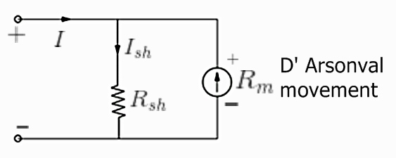
In the figure I = total current flowing in the circuit in Amp. I_{sh} is the current through the shunt resistor
in Amp. R_{m} is the ammeter resistance in Ohm. 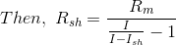

2. THERMO COUPLED TYPE RF AMMETERS
Basically thermocouple consists of two different metals which are placed in contact with each other as shown in the diagram.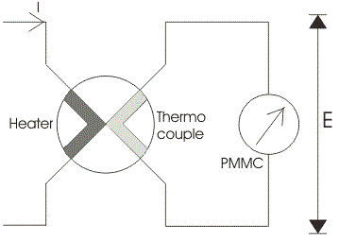
First part is called the heater element because when the current will flow through this, a heat is produced and thus the temperature will increased at the junction. At this junction an emf is produced which is approximately proportional to the temperature difference of hot and cold junctions. The emf produced is a DC voltage which is directly proportional to root mean square value of electric current. A permanent magnet moving coil instrument is connected with the second part to read the current passing through the heater. One question must be arise in our mind that why we have used only a permanent magnet coil instrument? Answer to this question is very easy it is because PMMC instrumenthas greater accuracy and sensitivity towards the measurement of DC value. The thermocouple type instruments employ thermocouple in their construction. Thermocouple type instruments can be used for both ac and DC applications. Also, thermocouple type of instruments has greater accuracy in measuring the current and voltages at very high frequency accurately.
Let us consider temperature of the heater element be T_{a} and the temperature of cold metal be T_{b}. Now it is found that the generated emf at the junction is related to temperature difference as:
Where a and b are constant whose values completely depends upon the type of metal we are using. The above equation represents parabolic function. The approximated value of a is from 40 to 50 micro volts or more per degree Celsius rise in temperature and value of constant b is very small and can be neglected if the air gap field of permanent magnet moving coil is uniform. Thus we can approximate the above temperature emf relation as e = a(T_{a} - T_{b}), here we have assume b = 0. The current flowing through the heater coil produces heat as I²R where I is the root mean square value of current, if we assume the temperature of cold junction is maintained at room temperature then the rise in the temperature of the hot junction will be equal to temperature rise at the junction. Hence we can write (Ta-Tb)is directly proportional to I²R or we can say (T_{a} - T_{b}) = kI²R. Now the deflection angle x in moving coil instrument is equal to; x = Ke or x = K[a(T_{a} - T_{b})] hence we can write k.K.a.I²R = k₁I², where k₁ is some constant. From the above equation we see that the instrument shows the square law response.

Construction of Thermocouple Type Instrument:

The thermocouple type of instruments consists of two major parts which are written below:
  - Thermo electric elements: The thermocouple type of instruments consists of thermo electric elements which can be of four types:

- Contact Type: It has a separate heater which is shown in the diagram.
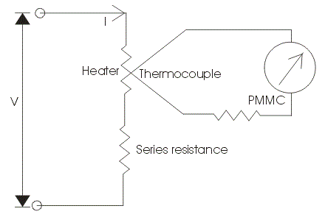 | 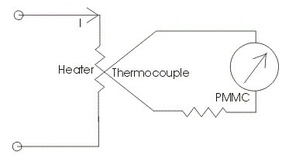

The action of thermocouple type instruments can be explained briefly as,

  - At the junction the electrical energy is being converted to thermal energy in the heater element. A portion of the heat is transferred to the hot junction while most of the heat energy is dissipated away.
  - The heat energy which is transferred to hot junction is again converted to electrical due to Seebeck effect. Only a portion of electrical energy is converted into mechanical energy which is used to produce a deflecting torque. The overall efficiency of the system is low thus the instrument consumes high power. So there is a requirement of highly accurate and sensitive DC instrument.
- Non-Contact Type: In non-contact type there is insulation between the heating element and the thermocouple i.e. there no direct contact between two. Due to this these instruments are not much sensitive as compared contact type.
- Vacuum Thermo-elements: These types of instruments are mostly employed for the measurement of electric current at very high frequency of the order of 100 Megahertz or more as these instruments retain their accuracy even at such high frequency.
- Bridge Type: These bridges are manufactured on the ac ratings usually from 100 milli amperes to 1 amperes. In this two thermocouple are connected to form a bridge which is shown in the figure given below:
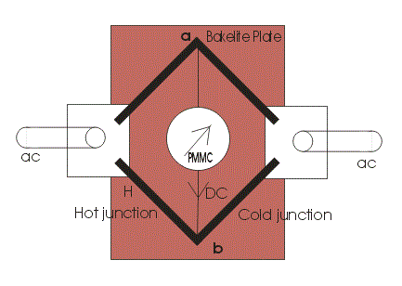
There is no requirement of heating element, the electric current which directly passing through the thermocouple raises the temperature which is directly proportional to the I²R losses. The bridge works on balanced condition at which there will be no current in the arm ab. The connected meter will show the potential difference between the junctions a and b.

Ohmmeters:
The ohmmeter is a device used for measurement of resistance value. These instruments have a low degree of accuracy. There is a wide field of application for this instrument in determining the approximate value of resistance. Micro Ohmmeter, Mega Ohmmeter and Milli Ohmmeters are used to measure resistance in different applications of electrical testing. A Micro Ohmmeter is used to measure extremely low resistances with high accuracy at particular test currents and is used for bonding contact applications. Micro Ohmmeter fluke is a small portable device, which is used to measure voltage, current and test diodes. This meter has multi selectors to select the desired function, and it automatically ranges to select most measurements. Mega Ohmmeter is used to measure large resistance values. Milli Ohmmeter is used to measure low resistance at high accuracy confirming the value of any electrical circuit.
Ohmmeters are classified into two types.
- Series Ohmmeter
- Shunt Ohmmeter

Series Ohmmeter:

Series Ohmmeter consists of basic d’Arsonval movement connected in parallel with a shunting resistor R2. This parallel circuit is in series with resistance R1 and a battery of emf E. the series circuit is connected to the terminals A and B of unknown resistor Rx.
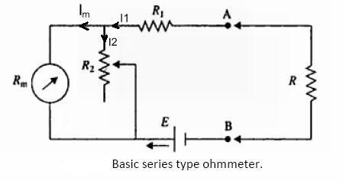

For the figure,
- R1 = current limiting resistor,
- R2 = zero adjusting resistor,
- E = emf of internal battery,
- Rm = internal resistance of D’Arsonval movement
When the unknown resistance Rx = 0 (terminals A and B shorted) maximum current flows through the meter. Under this condition resistor R2 is adjusted until the basic movement meter indicates full scale current Ifs. The full scale current position of the pointer is marked “0Ω” on the scale.
Similarly, when Rx is removed from circuit Rx = ∞ (that is when terminal A and B are open), the current in the meter drops to the zero and the movement indicates zero current which is the marked “∞”.
Thus, the meter will read infinite resistance at the zero-current position and zero resistance at full scale current position. Since zero resistance is indicated when current in the meter is the maximum and hence the pointer goes to the top mark.
When the unknown resistance is inserted at terminal A, B the current through the meter is reduced and hence pointer drops lower on the scale. Therefore, the meter has “0” at extreme right and “∞” at the extreme left.
Intermediate scale marking may be placed on the scale by different known values of the resistance Rx to the instrument.
A convenient quantity to use in the design of the series ohmmeter is the value of the Rx which causes the half scale deflection of the meter. At this position, the resistance across terminals A and B is defined as the half scale position resistance Rh.
The design can be approached by recognizing the fact that when Rh is connected across A and B the meter current reduces to one half of its full-scale value or with Rx = Rh, Im = 0.5 Ifs.
where Im = current through the meter
Ifs = current through the meter for full scale deflection.
This clearly means that Rh is equal to the internal resistance of the ohmmeter looking into terminals A and B.

Shunt Ohmmeter:
In the shunt ohmmeter, the resistance to be measured shunts (is in parallel with) the meter movement of the ohmmeter.
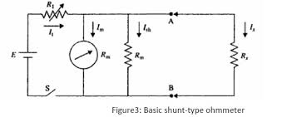
The basic circuit of the shunt-type ohmmeter where movement mechanism is connected parallel to the unknown resistance. In this circuit it is necessary to use a switch, otherwise current will always flow in the movement mechanism. Resistor Rsh is used to bypass excess current. Let the switch be closed. When RX = 0 (short circuit), the pointer reads zero because full current flows through Rx and no current flows through the meter and Rsh. Therefore, zero current reading is marked 0 ohms. When RX = ∞ (open circuit), no current flows through RX. Resistor R1 is adjusted so that full-scale current flows through the meter. Therefore, maximum current reading is marked ∞ ohms.
The most obvious way to tell the difference between the series and shunt ohmmeters is by the scale of the meter.

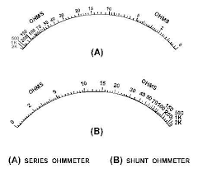

Applications:
An ohmmeter is useful for determining the approximate resistance of circuit components such as heater elements or machine field coils, measuring and sorting of resistors used in electronic circuits, checking of semiconductor diodes and for checking of continuity of circuit.
It is also useful in laboratories as an aid to a precision bridge, for it can help to know the approximate value of resistance which can save time in balancing the bridge.

MULTIMETERS FOR VOLTAGE, CURRENT AND RESISTANCE MEASUREMENT
Multimeter:
A multimeter consists of an ammeter, voltmeter and ohmmeter combined, with a function switch to connect the appropriate circuit to the D’Arsonval movement.
Salient features of multimeter are
- The basic circuit of multimeter includes balanced bridge d.c. amplifier.
- To limit the magnitude of the input signal, RANGE switch is provided. By properly adjusting input attenuator input signal can be limited.
- It also includes rectifier section which converts a.c. input signal to the d.c. voltage.
- It facilitates resistance measurement with the help of internal battery and additional circuitry.
- The various parameters measurement is possible by selecting required function using FUNCTION switch.
- The measurement of various parameters is indicated with the help of Indicating Meter.
Multimeter for D.C. Voltage Measurement:
For getting different ranges of voltages, different series resistances are connected in series which can be put in the circuit with the range selector switch. We can get different ranges to measure the d.c. voltages by selecting the proper resistance in series with the basic meter.
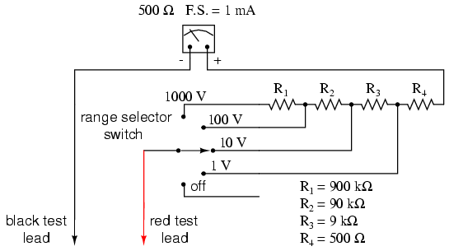

Multimeter for Measurement of A.C Voltage:
The rectifier used in the circuit rectifies a.c. voltage into d.c. voltage for measurement of a.c. voltage before current passes through the meter. The other diode is used for the protection purpose.

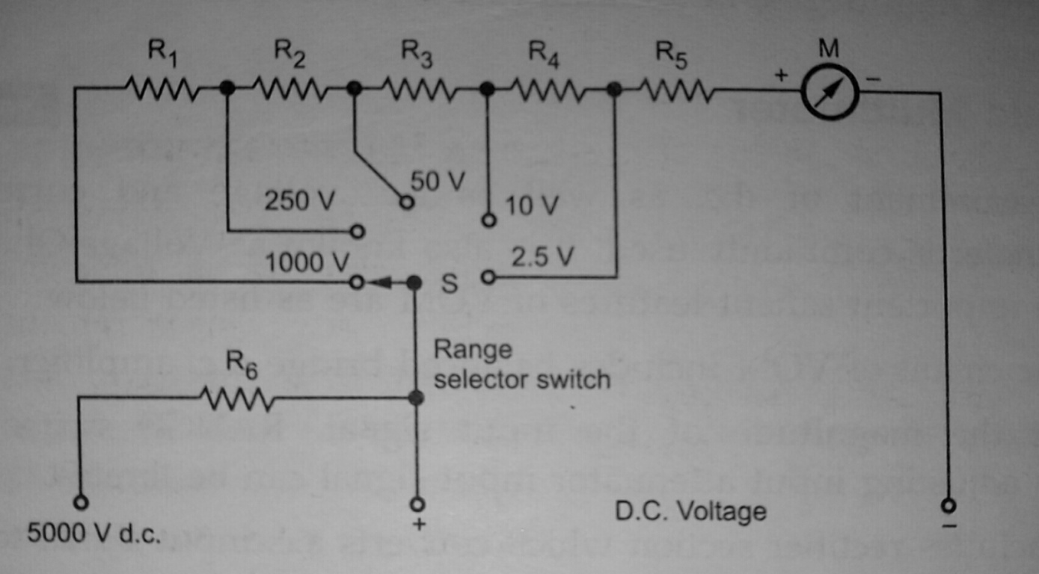
Multimeter as an Ammeter:
To get different current ranges, different shunts are connected across the meter with the help of range selector switch. The working is same as that of PMMC ammeter. Range changing is accomplished by shunts in such a way that the current passing through the meter does not exceed the maximum rated value.
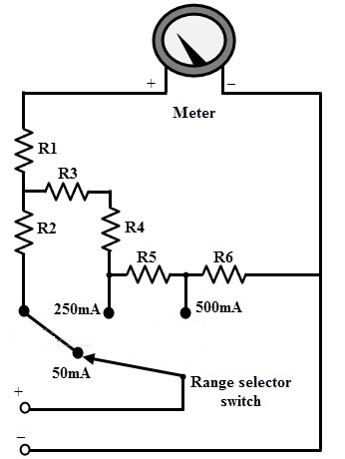
Multimeter for Resistance Measurement:
Before any measurement is made, the instrument is short circuited and “zero adjust” control is varied until the meter reads zero resistance i.e. it shows full scale current. Now the circuit takes the form of a variation of the shunt type ohmmeter. Scale multiplications of 100 and 10,000 can also be used for measuring high resistances. Voltages are applied to the circuit with the help of battery.
The range of an ohmmeter can be changed by connecting the switch to suitable shunt resistance. By using different values of shunt resistance, different ranges can be obtained.

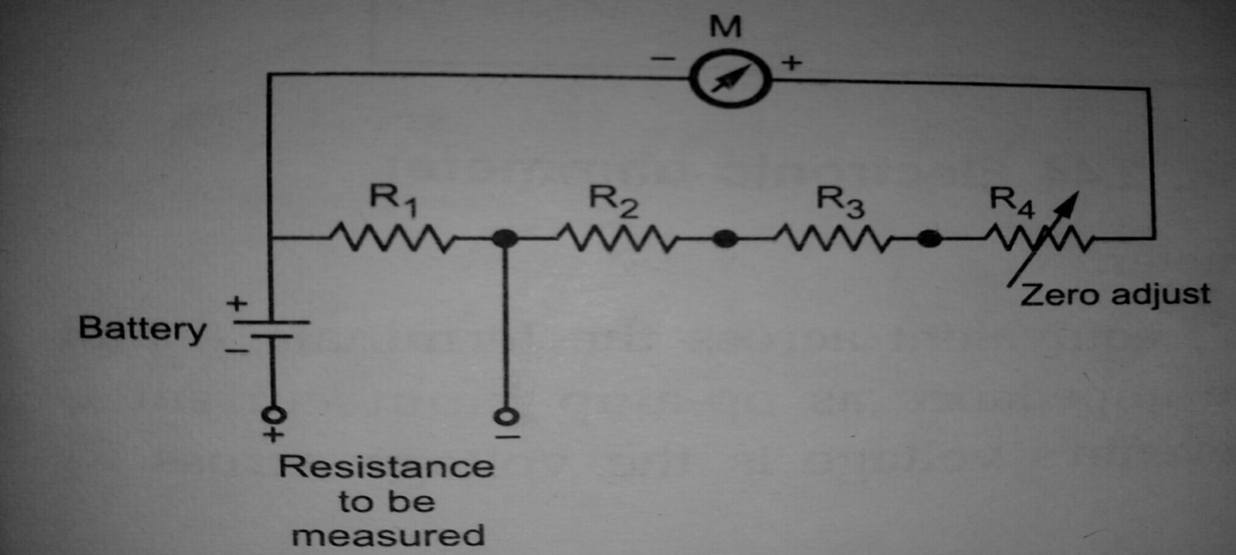

Advantages:
- The input impedance is high.
- The frequency range is high.
- The circuit is simple.
- The cost is less.
- The construction is rugged.
- It is less suffered from electric noise.
Disadvantages
- The accuracy is less.
- The resolution is poor.
- It is difficult to interface the output with the external devices.
- Not compact in size.
- The reliability and repeatability are poor.

UNIT-II

SIGNAL GENERATORS
A signal generator is a very important equipment in the test setups and in the electronic developments and the troubleshooting. Signal generators provides an excitation to the electronic measurement systems and processing circuits, which converts various transducer outputs into useful data. The excitation provided by signal generator may be a constant d. c. voltage or current or even stable a. c. signal. In some cases, it is required to vary the frequency as well as amplitude of the excitation. This purpose is served by using signal generators.
Signal generators provide a variety of different signals for testing various electronic circuits at low powers. The signal generator is an instrument which provides several different output waveforms including sine wave, square wave, triangular wave, pulse train and an amplitude modulated waveform.
In various instrumentation systems, the signal at audio frequency as well as at radio frequency are required. In most of the cases, the signal at particular frequency is generated using an oscillator which provides fixed frequency signal. Some other variable frequency oscillators are also available.
When we consider oscillator, it is described as an instrument which provides only sinusoidal output signal with either fixed or variable frequency. In contrast with this, generator can be described as an instrument capable of providing different types of output signal such as sinusoidal, square, triangular, modulated waveform etc. Note that even though such an instrument is called a generator, no energy is created but only d. c. signal is converted into a. c. signal at a required frequency.
There are various types of signal generators.
- Fixed frequency oscillator
- Variable frequency oscillator
But the several requirements are common to all types. There are
- The frequency of the signal should be known and stable.
- The amplitude should be controllable from very small to relatively large values.
- Finally, the signal should be distortion-free
The above-mentioned requirements vary for special generators such as function generators, pulse and sweep generators.
The oscillator circuit commonly appears in a fixed frequency form. For example, when it provides a 1000Hz excitation source for an AC Bridge. In other cases, such as in a Q-meter, oscillators in the form of a variable frequency arrangement for covering Q-measurements over a wide range of frequencies from a few 100 kHz to the MHz range are used. In contrast with self-contained oscillators that generates only the specific signals required by the instrument, the class of generators that are available as separate instruments to provide signals for general test purposes are usually designated as signal generators. These AF and RF generators are designed to provide extensive and continuous coverage over a wide range of frequencies as is practical.
In RF signal generators, additional provision is generally made to modulate the continuous wave signal to provide a modulated RF signal. Most of the service type AF generators commonly cover from 20 Hz to 200 kHz, which is far beyond the AF range. The frequency limits are listed in the table below.

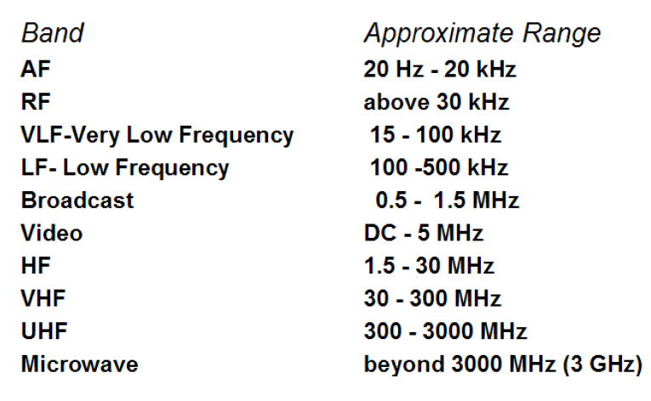
Fixed Frequency AF Oscillator:
In many cases, a self-contained oscillator circuit is an integral part of the instrument circuitry and is used to generate a signal at some specified audio frequency. Such a fixed frequency might be a 400 Hz signal used for audio testing or a 1000 Hz signal for exciting a bridge circuit. Oscillations at specified audio frequencies are easily generated by the use of an iron core transformer to obtain positive feedback through inductive coupling between the primary and secondary windings.
Variable AF Oscillator:
Variable AF oscillators used for general lab purpose should cover at least full audio range i.e., from 20Hz to 20 kHz and have a constant pure sine wave output. They are of RC feedback oscillator type or Beat Frequency Oscillator type (BFO).

Audio Frequency Amplifiers:

A low-frequency oscillator (LFO) is an electronic oscillator that generates a frequency below ≈20 Hz. This term is typically used in the field of audio synthesizers, to distinguish it from an audio frequency oscillator. An audio oscillator produces frequencies in the audio range, about 16 Hz to 20 kHz. To generate audio frequency signals, in practice RC feedback oscillators are used. The most commonly used RC feedback oscillators are Wien bridge oscillator and RC phase shift oscillator.

Wien Bridge Oscillator:
A Wien bridge oscillator is a type of electronic oscillator that generates sine waves. It can generate a large range of frequencies. The oscillator is based on a bridge circuit originally developed by Max Wien in 1891 for the measurement of impedances. The bridge comprises four resistors and two capacitors. The oscillator can also be viewed as a positive gain amplifier combined with a band pass filter that provides positive feedback. Automatic gain control, intentional non-linearity and incidental non-linearity limit the output amplitude in various implementations of the oscillator.
Under the condition that R₁=R₂=R and C₁=C₂=C, the frequency of oscillation is given by:
F=1/2*PI*R*C
and the condition of stable oscillation is given by
Rb=Rf/2
Advantages:
1.By varying the two capacitor values simultaneously, by mounting them on the common shaft, different frequency ranges can be obtained. The perfect sine wave output is possible. It is useful audio frequency range i.e. 20 Hz to 100 kHz.
2. The output is correct sine wave.
3. It has low distortion and excellent frequency stability.
4. Different frequencies can be obtained easily.
RC Phase Shift Oscillator:
A phase-shift oscillator is a linear electronic oscillator circuit that produces a sine wave output. It consists of an inverting amplifier element such as a transistor or op amp with its output fed back to its input through a phase-shift network consisting of resistors and capacitors in a ladder network. The feedback network 'shifts' the phase of the amplifier output by 180 degrees at the oscillation frequency to give positive feedback. Phase-shift oscillators are often used at audio frequency as audio oscillators.
The filter produces a phase shift that increases with frequency. It must have a maximum phase shift of more than 180 degrees at high frequencies so the phase shift at the desired oscillation frequency can be 180 degrees. The most common phase-shift network cascades three identical resistor-capacitor stages that produce a phase shift of zero at low frequencies and 270° at high frequencies.
RC Phase Shift Oscillators a linear electronic oscillator circuit that produces a sine wave output. It consists of an inverting amplifier element, such as Op-Amp or transistor with its output fed back to its input through a phase-shift network consisting of capacitors and resistors in a ladder network. It is a linear electronic oscillator circuit that produces a sine wave output. Phase-shift oscillators are often used at audio frequency by audio oscillators. The filter produces phase shift that increase with the frequency

Op-amp implementation:
One of the simplest implementations for this type of oscillator uses an operational amplifier (op-amp), three capacitors and four resistors, as shown in the diagram.
The mathematics for calculating oscillation frequency and oscillation criterion for this circuit are surprisingly complex, due to each RC stage loading the previous ones. The calculations are greatly simplified by setting all the resistors (except the negative feedback resistor) and all the capacitors to the same values. In the diagram, if R₁=R₂=R₃=R, and C₁=C₂=C₃=C, then:
Without the simplification of all the resistors and capacitors having the same values, the calculations become more complex.
Oscillation criterion:
As with other feedback oscillators, when the power is applied to the circuit, thermal electrical noise in the circuit or the turn-on transient provides an initial signal to start oscillations. The oscillations grow rapidly in amplitude until saturation of the op-amp or transistor limits the gain, and they stabilize at a constant amplitude at which the loop gain of the circuit is unity.
One potential problem with the single op-amp circuit is the high gain required to maintain the oscillation. If it is assumed that each RC segment does not affect the other, a gain of about 8 to 10 will be sufficient to enable oscillation. As mentioned previously, each RC section loads the next section, and a larger gain is required to keep the circuit in oscillation. An improved version of this circuit can be made by putting an op-amp buffer between each RC stage. The voltage gain of the inverting channel is always unity.
When the oscillation frequency is high enough to be near the amplifier's cutoff frequency, the amplifier will contribute significant phase shift itself, which will add to the phase shift of the feedback network. Therefore, the circuit will oscillate at a frequency at which the phase shift of the feedback filter is less than 180 degrees.
Disadvantages of RC Phase Shift Oscillator:
The output is small and It is due to smaller feedback. The frequency stability is not as good as that of the Wien bridge oscillator. It is difficult for the circuit to start oscillations as the feedback is usually small.
Square Wave Generator: -

- The circuit configuration of a square wave generator consists of the basic elements of a sine wave generator (i.e., Wien bridge oscillator, attenuator) and square wave shaper and square wave amplifier.

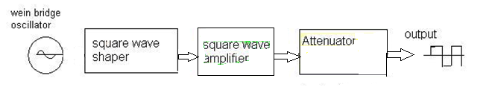
Fig: Block diagram of square wave generator

- A square wave is obtained by feeding the sinusoidal output of the wein bridge oscillator to the Square Wave Shaper circuit.
- The square wave shaper is usually a sine-to-square wave converter.
- The square wave is further processed through square wave amplifier and attenuator in order to obtain a square wave of desired amplitude.
- The frequency of the square wave can be varied by varying the oscillation frequency of wein bridge oscillator.

Square and Pulse Generator: -

- These generators are used as measuring devices in combination with a CRO.
- They provide both quantitative and qualitative information of the system under test. They are made use of in transient response testing of amplifiers.
- The fundamental difference between a pulse generator and a square wave generator is in the duty cycle.
- Duty cycle = A square wave generator has a 500/o duty cycle.

Requirements of a Pulse:

- The pulse should have minimum distortion, so that any distortion, in the display is solely due to the circuit under test.
- The basic characteristics of the pulse are rise time, overshoot, ringing, sag, and undershoot.
- The pulse should have sufficient maximum amplitude, if appreciable output power is required by the test circuit, e.g. for magnetic core memory. At the same time, the attenuation range should be adequate to produce small amplitude pulses to prevent over driving of some test circuit.
- The range of frequency control of the pulse repetition rate (PRR) should meet the needs of the experiment. For example, a repetition frequency of 100 MHz is required for testing fast circuits
- Other generators have a pulse-burst feature which allows a train of pulses rather than a continuous output.
- Some pulse generators can be triggered by an externally applied trigger signal; conversely, pulse generators can be used to produce trigger signals, when this output is passed through a differentiator circuit.
- The output impedance of the pulse generator is another important consideration. In a fast pulse system, the generator should be matched to the cable and the cable to the test circuit.
- A mismatch would cause energy to be reflected back to the generator by the test circuit, and this may be re-reflected by the generator, causing distortion of the pulses.
- DC coupling of the output circuit is needed, when dc bias level is to be maintained.
- The basic circuit for pulse generation is the asymmetrical multi-vibrator.
A laboratory type square wave and pulse generator is shown in Fig .The frequency range of the instrument is covered in seven decade steps from 1Hz to 10 MHz, with a linearly calibrated dial for continuous adjustment on all ranges.
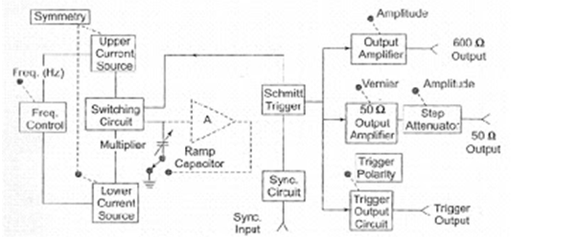

Fig: Block diagram of pulse generator

- The duty cycle can be varied from 25 - 75%.
- Two independent outputs are available, a 50Ω source that supplies pulses with a rise and fall time of 5 ns at 5V peak amplitude and a 600Ω Source which supplies pulses with a rise and fall time of 70 ns at 30 V peak amplitude.
- The instrument can be operated as a free running generator or, it can be synchronized with external signals.
- The basic generating loop consists of the current sources, the ramp capacitor, the Schmitt trigger and the current switching circuit as shownin the fig.
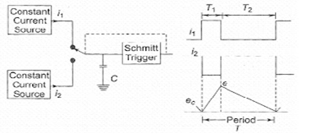
Fig: Basic generating loop
- The upper current source supplies a constant current to the capacitor and the capacitor voltage.
- Increases linearly. When the positive slope of the ramp voltage reaches the upper limit set by the internal circuit components, the Schmitt trigger changes state.
- The trigger circuit output becomes negative and reverses the condition of the current switch. The capacitor discharges linearly, controlled by the lower current source.
- When the negative ramp reaches a predetermined lower level, the Schmitt trigger switches back to its original state. The entire process is then repeated.
- The ratio i1/i2 determines the duty cycle, and is controlled by symmetry control.
- The sum of i1 and i2 determines the frequency.
- The size of the capacitor is selected by the multiplier switch.
- The unit is powered by an internal supply that provides regulated voltages for all stages of the instrument.

Random Noise Generator:

Block diagram:
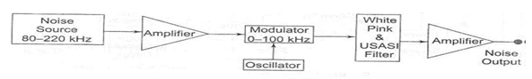
Fig: Random noise generator

- The spectrum of random noise covers all frequencies the lower density spectrum tells us how the energy of the signal is distributed in frequency, but it does not specify the signal uniquely nor does it tell us very much about how the amplitude of the signal varies with time.
- The spectrum does not specify the signal uniquely because it contains no phase information.
- The method of generating noise is usually to use a semi conductor noise which delivers frequencies in a band roughly extending from 80 – 220 KHz.
- The output from the noise diode is amplified and heterodyned down to audio frequency band by means of a balanced symmetrical modulator.
- The filter arrangement controls the bandwidth and supplies an output signal in three spectrum choices, white noise, pink noise and USANi noise.
- The Fig it is seen that white noise is flat from 20Hz to 20 KHz and has upper cut-off frequency of 50 kHz with a cut-off slope of -12dbs/ octave.
- Pink noise is so called because the lower frequencies have larger amplitude, similar to red light. Pink noise has a voltage spectrum which is inversely proportional to the square root of frequency and is used in band analysis.
- USANi noise ranging simulates the energy distribution of speech and music frequencies and is used for testing audio amplifiers and loud speakers.

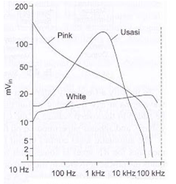

Fig: Random noise generator

Sweep Generator Block Diagram:

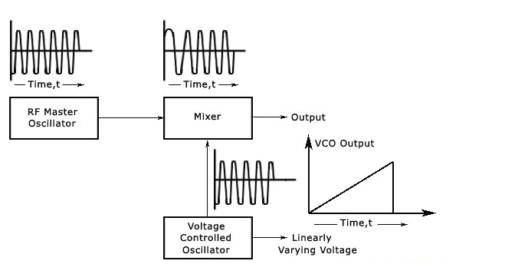
- The most important component of a sweep-frequency generator is the master oscillator. It is mostly an RF type and has many operating ranges which are selected by a range switch.
- Either mechanical or electronic variations can be brought to the frequency of the output signal of the signal generator. In the case of mechanically varied models, a motor driven capacitor is used to tune the of the output signal of the master oscillator.
- In the case of electronically tuned models, two frequencies are used. One will be a constant frequency that is produced by the master oscillator. The other will be a varying frequency signal, which is produced by another oscillator, called the voltage controlled oscillator (VCO).
- The VCO contains an element whose capacitance depends upon the voltage applied across it. This element is used to vary the frequency of the sinusoidal output of the VCO.
- A special electronic device called a mixer is then used to combine the output of the VCO and the output of the master oscillator. When both the signals are combined, the resulting output will be sinusoidal, and its frequency will depend on the difference of frequencies of the output signals of the master oscillator and VCO.
- For example, if the master oscillator frequency is fixed at 10.00 MHz and the variable frequency is varied between 10.01 MHz to 35 MHz, the mixer will give sinusoidal output whose frequency is swept from 10 KHz to 25 MHz.
- Adjustments can be brought to the sweep rates in a sweep frequency generator and it normally can be varied from 100 to 0.01 seconds per sweep.
- The X-axis of an oscilloscope or X-Y recorder can be easily driven synchronously with a voltage that varies linearly or logarithmically. In the electronically tuned sweep generators, the same voltage which drives the VCO serves as this voltage.
- When the frequency varies linearly or logarithmically, the values of the end frequencies can be used to find the frequency of various points along the frequency-response curve. Markers can be employed for more accuracy.
- It provides a sinusoidal output voltage whose frequency varies smoothly and continuously over an entire frequency band, usually at an audio rate. The process of frequency modulation may be accomplished electronically or mechanically.
- It is done electronically by using the modulating voltage to vary the reactance of the oscillator tank circuit component, and mechanically by means of a motor driven capacitor, as provided for in a modern laboratory type signal generator.
- Figure shows a basic block diagram of a sweep generator. The frequency sweep provides a variable modulating voltage which causes the capacitance of the master oscillator to vary. A representative sweep rate could be of the order of 20 sweeps/second.
- A manual control allows independent adjustment of the oscillator resonant frequency. The frequency sweeper provides a varying sweep voltage synchronization to drive the horizontal deflection plates of the CRO.
- Thus, the amplitude of the response of a test device will be locked and displayed on the screen.
- To identify a frequency interval, a marker generator provides half sinusoidal waveforms at any frequency within the sweep range.
- The marker voltage can be added to the sweep voltage of the CRO during alternate cycles of the sweep voltage, and appears superimposed on the response curve.
- The automatic level control circuit is a closed loop feedback system which monitors the
- RF level at some point in the measurement system. This circuit holds the power delivered to the
- Load or test circuit constant and independent o frequency and impedance changes. A constant power level prevents any source mismatch and also provides a constant readout calibration without frequency.

AF Sine and Square Wave Generator:
A wien bridge oscillator (suitable for AF range) is used in this generator (refer
Fig). The frequency of the oscillations can be changed by varying the
capacitance in the oscillator or in steps by switching in resistors of different
values.
The output of the oscillator goes to a function switch which directs the
oscillator output to either sine wave amplifier or to the square wave shaper. The
attenuator varies the amplitude of the output which is taken through a push-pull
amplifier.

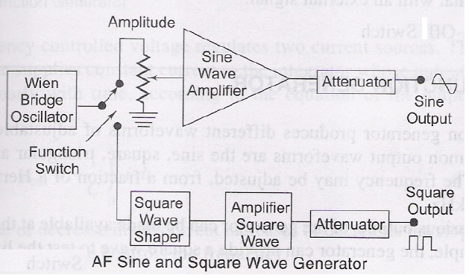
The front panel of the signal generator consists of the following:
Frequency selector: It selects the frequency in different ranges and varies it continuously in a ratio of 1: 10. The scale is non-linear.
Frequency multiplier: It selects the frequency range over 5 decades, from 10 Hz to 1MHz.
Amplitude multiplier:
- It attenuates the sine wave in 3 decades, x 1, x 0.1 and x 0.01.
- Variable amplitude: It attenuates the sine wave amplitude continuously.
- Symmetry control: It varies the symmetry of the square wave from 30% to 70%.
- Amplitude: It attenuates the square wave output continuously.
- Function switch: It selects either sine wave or square wave output. Output available: This provides sine wave or square wave output.
Sync This terminal is used to provide synchronization of the internal signal with an external signal.
On-Off Switch
Spectrum analyser:

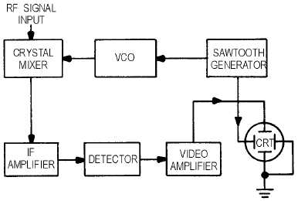
Fig:Block diagram of spectrum analyzer

A spectrum analyzer measures the magnitude of an input signal versus frequency within the full frequency range of the instrument. The primary use is to measure the power of the spectrum of known and unknown signals.
The input signal that a spectrum analyzer measures is electricalhowever, spectral compositions of other signals, such as acoustic pressure waves and optical light waves, can be considered through the use of an appropriate transducer. Optical spectrum analyzers also exist, which use direct optical techniques such as a monochromator to make measurements.
The display of a spectrum analyzer has frequency on the horizontal axis and the amplitude displayed on the vertical axis. To the casual observer, a spectrum analyzer looks like an oscilloscope and, in fact, some lab instruments can function either as an oscilloscope or a spectrum analyzer.
Types :
Spectrum analyzer types are distinguished by the methods used to obtain the spectrum of a signal. There are swept-tuned and Fast Fourier Transform (FFT) based spectrum analyzers:
- A swept-tuned analyzer uses a superheterodyne receiver to down-convert a portion of the input signal spectrum to the center frequency of a narrow band-pass filter, whose instantaneous output power is recorded or displayed as a function of time. By sweeping the receiver's center-frequency (using a voltage-controlled oscillator) through a range of frequencies, the output is also a function of frequency. But while the sweep centers on any particular frequency, it may be missing short-duration events at other frequencies.
- An FFT analyzer computes a time-sequence of periodograms. FFT refers to a particular mathematical algorithm used in the process. This is commonly used in conjunction with a receiver and analog-to-digital converter. As above, the receiver reduces the center-frequency of a portion of the input signal spectrum, but the portion is not swept. The purpose of the receiver is to reduce the sampling rate that the analyzer must contend with. With a sufficiently low sample-rate, FFT analyzers can process all the samples (100% duty-cycle), and are therefore able to avoid missing short-duration events

Functional Wave Generator:
A functional generator is used to generate different types of electrical waveforms over the wide range of frequencies which uses electronic test equipment or a software. The waveforms which can be easily generated are sine waveform, square waveform, triangle wave form and saw tooth wave form. Functional generator covers both audio frequency and RF frequency. Function Generator controls frequency, DC offset, Duty cycle.
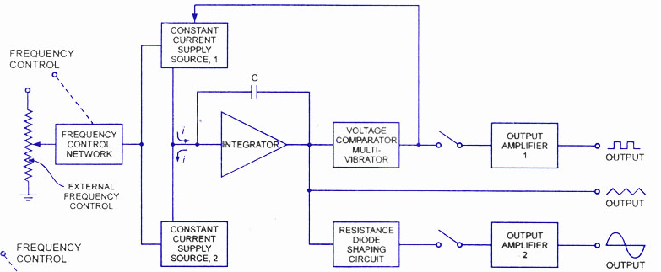
Block Diagram of Functional Generator:
There are three different types of functional generator
- Analogue function generator
- Digital functional generator
- Sweep function generator
Analogue Function Generator:
This is the first type of signal generator before the existence of the Digital functional generator. Some of its advantages over digital are cost effective, simple to use and maximum frequencies.

Digital Function Generator:
One among the many ways of generating the digital waveforms most preferable will be direct digital synthesis (DSS). The fundamental ideas of DSS technology are generating an arbitrary periodic waveform from a period ramp signal and generating a digital ramp.
Direct digital synthesis uses a phase accumulator, a DAC and a look up table which contains waveforms. It offers high stability and accuracy.

Sweep Function Generator:
It will sweep its frequency by digital technology and also by analogue. Sweep function is able to sweep up to 100:1. The sweep can be featured in linear and logarithmic. Here we can observe that functional generator is giving multiple outputs square, triangle and sine. Functional generator controls Frequency, Waveform Types, Sine, Square, Triangle, DC Offset, and Duty Cycle.
Applications:
- In the development and research
- Electrical and electronic equipment repair business
- In the Electronic hobbyists
- It is used in the many educational institutions
- Response or stimulus testing, frequency response characterization
- In the circuit signal injection.

Amplitude multiplier:
- It attenuates the sine wave in 3 decades, x 1, x 0.1 and x 0.01.
- Variable amplitude: It attenuates the sine wave amplitude continuously.
- Symmetry control: It varies the symmetry of the square wave from 30% to 70%.
- Amplitude: It attenuates the square wave output continuously.
- Function switch: It selects either sine wave or square wave output. Output available: This provides sine wave or square wave output.
Sync This terminal is used to provide synchronization of the internal signal with an external signal.

Harmonic Distortion Analyzers:
A total harmonic distortion analyzer calculates the total harmonic content of a sine wave with some distortion, expressed as total harmonic distortion (THD). A typical application is to determine the THD of an amplifier by using a very-low-distortion sine wave input and examining the output. The figure measured will include noise, and any contribution from imperfect filtering out of the fundamental frequency. Harmonic-by-harmonic measurement, without wideband noise, can be measured by a more complex wave analyser.
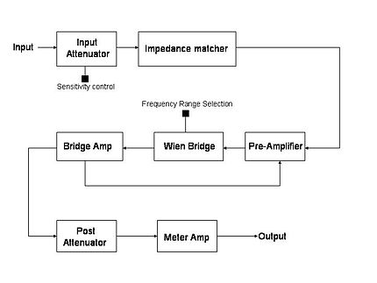
Types of Analyzers:
There are several types of distortion analyzers:
- Fundamental suppression
- Heterodyne type
- Tuned circuit
- Spectrum analyzer

Principles of operation:
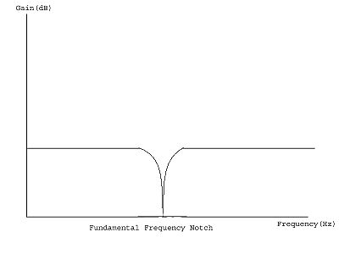
The frequency response of a Fundamental Suppression Analyzer
A fundamental suppression analyzer consists of three main sections: input section with impedance matcher, a notch filter and amplifier section, and an output metering circuit. Negative feedback from the bridge amplifier to the pre-amp section may be applied to enable the rejection circuit to work more accurately.

Working of a typical unit:
The input is impedance-matched with the rejection circuit with the help of an attenuator and an impedance matcher. This signal is then pre-amplified to a desired level. The following section consists of a Wien bridge notch filter tuned to reject the fundamental frequency and balanced for minimum output by adjusting the bridge controls. The output, which is the remaining signal after the fundamental has been suppressed, is amplified to a measurable level. A feedback loop from the bridge amplifier output to the pre-amp input helps to eliminate any remaining contribution from the fundamental frequency. The output from these blocks is measured, typically using an instrumentation amplifier driving an analog or digital meter. The voltage at the meter is due to the harmonic distortion products plus noise.
Standard and Practical AF Generator:
An audio frequency generator is a very useful addition to the workbench. Common purposes of this instrument are:
1. Signal source, to check if amplifier stages actually work (requires additional signal tracer).
2. Measurements of AC gain at various frequencies, i.e. assessment of frequency curve and -3 dB bandwidth (requires AF milli voltmeter).
3. Examination of the transient response of a circuit: do square waves cause ringing or oscillation? (requires an oscilloscope).
4. Assessment of the overload margin of an amplifier.
5. Distortion measurements.
My generator can produce sine- and square waves with frequencies between 1 Hz and 100 kHz and amplitudes ranging from zero to 1.55 Vreff in 600 Ohms. Sine wave distortion is 0.1% or less between 20 Hz and 20 kHz, somewhat greater outside this region. The output voltage varies less than 0.1 dB within the audio range (20 Hz to 20 kHz); there is some roll off (less than 1 dB) at the frequency extremes.
The instrument consists of four different modules within a single enclosure, and is fed from an external (+ and - 15V) power supply. The modules are:
Sine wave generator with amplitude stabilization circuit [1];
Schmitt trigger (sine-to-square wave converter) [2];
600 Ohm line driver (with stepped attenuator and volume control) [3];
Output indicator [4].
Most sine wave generators (including the circuit from publication 1) can be tuned continuously over a 1:10 range of frequencies, using a stereo pot meter (audio taper). Inspired by reference 4, I used a different approach. My generator is tuned in small steps (0.1 on a log scale) using a dual rotary switch with 12 positions. The resistors wired to the switch are accurate within 1%; proper values are obtained by wiring standard resistors in series. Much better tracking is obtained with a stepped attenuator than with a common stereo pot meter, resulting in lower distortion. Resistor values can be calculated with the formula: f = 1/(2*PI*R*C), in which PI = 3.14159 (R in Ohms and C in Farads). The capacitors which I employed were also selected for low tolerance (accurate values), using a digital capacitance meter. They are wired to a dual rotary switch with 5 positions, corresponding to 5 frequency ranges. Measured frequencies produced by the prototype.
Table 1. Output of generator prototype (frequencies in Hz)
C à  R | 6.8 µF | 680 nF | 68 nF | 6.8 nF | 680 pF
14k7 | 1.6 | 16.2 | 158 | 1591 | 14925
11k5 | 2.0 | 20.3 | 198 | 1996 | 18493
9k3 | 2.6 | 25.5 | 250 | 2508 | 22882
7k3 | 3.3 | 32.1 | 314 | 3144 | 28154
5k9 | 4.0 | 40.3 | 394 | 3932 | 34450
4k7 | 5.0 | 50.9 | 499 | 4952 | 42220
3k7 | 6.4 | 64.2 | 628 | 6206 | 51268
3k0 | 8.0 | 80.5 | 788 | 7740 | 61663
2k4 | 10.0 | 101.0 | 988 | 9632 | 73631
1k8 | 12.9 | 129.0 | 1262 | 12173 | 88479
1k5 | 16.0 | 160.5 | 1568 | 14965 | 103469
1k2 | 20.2 | 203.0 | 1983 | 18645 | 121546
You will notice that lower frequencies are produced than would be expected from the formula when C=680pF. This is normal and due to stray capacitances within the circuit.
Generator Circuit:
The sinewave generator is based on 4 op-amps which are present in a single TL084 i.c. (see fig.1). Op-amps A1 and A2 are connected to the frequency determining RC networks R5+P1a/C1 and R6+P1b/C2, respectively. In my version of the generator, P1 is replaced by a stepped attenuator (dual rotary switch with 12 positions, see above). Moreover, I have included two additional frequency ranges; thus, S1 is in my version a dual rotary switch with 5 rather than 3 positions.
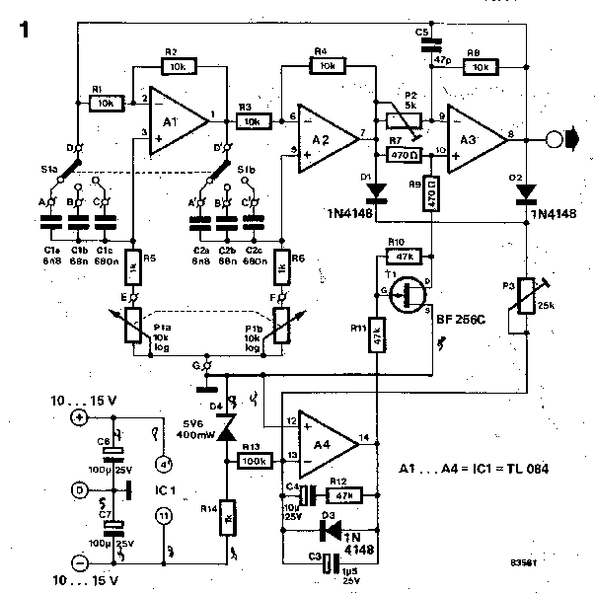
The combination of RC network and inverting amplifier causes a 90 degrees phase shift at a frequency determined by the RC time of the network. The two stages (A1 and A2) in series have 180 degrees phase shift at that particular frequency. Inverting amplifier A3 causes an additional 180 degrees phase shift and it provides sufficient gain to allow the system to oscillate at the selected frequency (a combined phase shift of 360 degrees corresponds to positive feedback). Capacitor C5 has been added in the feedback loop of A3 to suppress undesired parasitic RF oscillations above 100 kHz.
The output voltage of A2 and A3 is rectified by the diodes D1 and D2 and fed to the inverting input of A4 via the variable resistor P3. The op-amp A4 compares this rectified voltage with a reference voltage which is provided by the zener diode D4. The apparent drain-source resistance of FET T1 is dependent on the difference between output and reference, since the gate of T1 is driven by opamp A4. Thus, the input voltage of A3 is continuously adjusted and the output of the generator is maintained at a constant level.
A number of precautions were taken to ensure proper operation of the amplitude stabilizing circuit. Capacitor C3 in the feedback loop integrates the input signal of A4; C4 and R12 have been added to suppress bouncing of the regulatory mechanism. Diode D3 was added to provide overload protection for the gate of T1. The article in Elektuur specified a BF256C for T1; I replaced this by a BF245C since I had that FET in my junk box. Amplitude stabilization with a JFET normally results in a distortion of the sine wave of 1% or more, but the ingenious circuit of Mr. Mieslinger causes distortion to remain below 0.1% over the audio range.
Alignment of the generator proceeds as follows: Set P3 in center position and adjust P2 until the DC voltage at the output of A4 is between -1 and -2 V. Then adjust P3 until the output voltage of A3 is 1.55 Veff.
Keep all wiring to S1 and P1 (in my version, S2) as short and neat as possible to avoid stability problems or dips in the output. My (relatively neat) prototype works so well that the range of operating frequencies could be extended from 20 Hz - 20 kHz (Elektuur specification) to 1 Hz - 100 kHz. Not bad for a cheap op-amp! The layout of a PC board for the generator is shown in Fig.2.
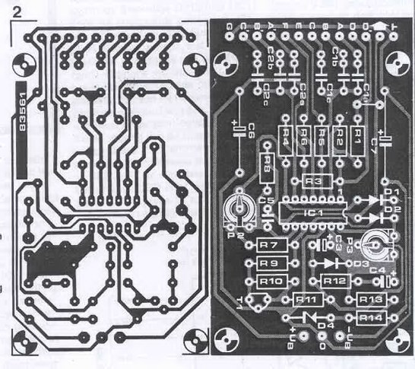

Schmitt trigger:
The sine is transformed into a square wave by a simple and efficient circuit (see Fig.3). Transistors T8 and T9 form a classical Schmitt-trigger. Emitter follower T10 ensures low output impedance. RF transistors are used to allow rapid switching and a large bandwidth. The trigger level is set with the variable resistor P5; symmetry of the square wave is adjusted with P2.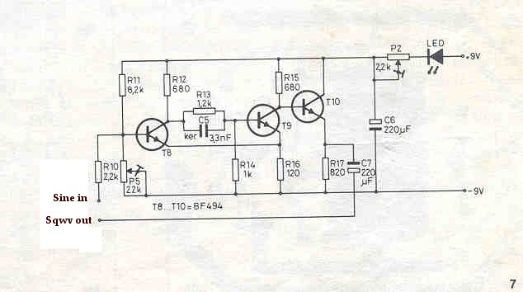
In my version of the sine-to-square wave converter, a signal LED is not included. P2 is connected directly to the +15V lead of the power supply; the negative pole of C6 goes to ground. A PC board for the Schmitt trigger is shown in Fig.4.In my version of the sine-to-square wave converter, a signal LED is not included. P2 is connected directly to the +15V lead of the power supply; the negative pole of C6 goes to ground. A PC board for the Schmitt trigger is shown in Fig.4.
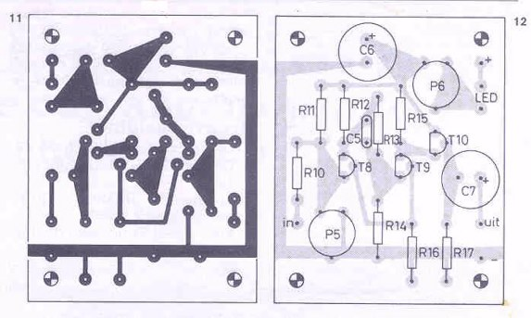

Output buffer:
An output buffer was added to isolate generator and Schmitt trigger from the load. The simple circuit described by Rod Elliott on his website (see Fig.5) has low distortion and can easily drive a 600 Ohm load. Rod used a ±12V supply, but the circuit works equally well on ±15V. I have hardwired the buffer in dead bug style on a piece of unetched PC board, using the copper as a ground plane.
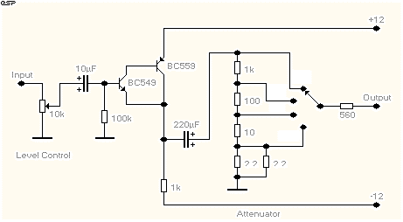
Module 4: Output meter
This simple circuit provides a visible indication that the generator is switched on and is producing an AF signal. The 200 Ohm trim pot should be adjusted until 1.55 Veff produces a full-scale reading on the meter. Output voltages of 0.5-1.5 Veff lead to different meter readings. If the output attenuator (see above) is built not with 1:10 but with 1:3 steps, every value of the output voltage can be directly monitored. The circuit is so simple that all parts could be glued to the back of the 500µA meter (cannibalized from an old Panasonic amplifier).
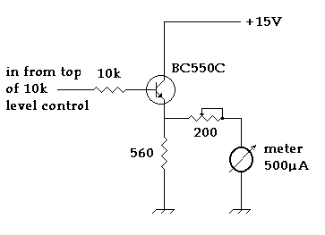

Spectrum analyzer:

Fig:Block diagram of spectrum analyzer

A spectrum analyzer measures the magnitude of an input signal versus frequency within the full frequency range of the instrument. The primary use is to measure the power of the spectrum of known and unknown signals.
The input signal that a spectrum analyzer measures is electricalhowever, spectral compositions of other signals, such as acoustic pressure waves and optical light waves, can be considered through the use of an appropriate transducer. Optical spectrum analyzers also exist, which use direct optical techniques such as a monochromator to make measurements.
The display of a spectrum analyzer has frequency on the horizontal axis and the amplitude displayed on the vertical axis. To the casual observer, a spectrum analyzer looks like an oscilloscope and, in fact, some lab instruments can function either as an oscilloscope or a spectrum analyzer.

Types :
Spectrum analyzer types are distinguished by the methods used to obtain the spectrum of a signal. There are swept-tuned and Fast Fourier Transform (FFT) based spectrum analyzers:
- A swept-tuned analyzer uses a superheterodyne receiver to down-convert a portion of the input signal spectrum to the center frequency of a narrow band-pass filter, whose instantaneous output power is recorded or displayed as a function of time. By sweeping the receiver's center-frequency (using a voltage-controlled oscillator) through a range of frequencies, the output is also a function of frequency. But while the sweep centers on any particular frequency, it may be missing short-duration events at other frequencies.
- An FFT analyzer computes a time-sequence of periodograms. FFT refers to a particular mathematical algorithm used in the process. This is commonly used in conjunction with a receiver and analog-to-digital converter. As above, the receiver reduces the center-frequency of a portion of the input signal spectrum, but the portion is not swept. The purpose of the receiver is to reduce the sampling rate that the analyzer must contend with. With a sufficiently low sample-rate, FFT analyzers can process all the samples (100% duty-cycle), and are therefore able to avoid missing short-duration events.

Functional Wave Generator:
A functional generator is used to generate different types of electrical waveforms over the wide range of frequencies which uses electronic test equipment or a software. The waveforms which can be easily generated are sine waveform, square waveform, triangle wave form and saw tooth wave form. Functional generator covers both audio frequency and RF frequency. Function Generator controls frequency, DC offset, Duty cycle.
Fig: Block Diagram of Functional Generator

There are three different types of functional generator
- Analogue function generator
- Digital function generator
- Sweep function generator

Analogue Function Generator:
This is the first type of signal generator before the existence of the Digital functional generator. Some of its advantages over digital are cost effective, simple to use and maximum frequencies.

Digital Function Generator:
One among the many ways of generating the digital waveforms most preferable will be direct digital synthesis (DSS). The fundamental ideas of DSS technology are generating an arbitrary periodic waveform from a period ramp signal and generating a digital ramp.
Direct digital synthesis uses a phase accumulator, a DAC and a look up table which contains waveforms. It offers high stability and accuracy.

Sweep Function Generator:
It will sweep its frequency by digital technology and also by analogue. Sweep function is able to sweep up to 100:1. The sweep can be featured in linear and logarithmic.
Here we can observe that functional generator is giving multiple outputs square, triangle and sine. Functional generator controls Frequency, Waveform Types, Sine, Square, Triangle, DC Offset, and Duty Cycle
Applications:
- In the development and research
- Electrical and electronic equipment repair business
- In the Electronic hobbyists
- It is used in the many educational institutions
- Response or stimulus testing, frequency response characterization
- In the circuit signal injection.

