UNIT I
-------------------------------------------------------------------------------------------------------------------------------
SYLLABUS:
CELLULAR MOBILE RADIO SYSTEMS: Introduction to Cellular Mobile System, Performance criteria, uniqueness of mobile radio environment, operation of cellular systems, Hexagonal shaped cells, Analog and Digital Cellular systems.
ELEMENTS OF CELLULAR RADIO SYSTEM DESIGN: General description of the problem, concept of frequency channels, Co-channel Interference Reduction Factor, desired C/I from a normal case in a Omni directional Antenna system, Cell splitting, consideration of the components of Cellular system.
-------------------------------------------------------------------------------------------------------------------------------
  - Introduction to Cellular Mobile System
    - Conventional mobile telephone systems
In Conventional mobile telephone systems available frequency spectrum is divided into mobile radio telephone channels using FDM without reuse facility, serving an area with large size. A dedicated channel is allocated for each user, whether uses it or not. It has several limitations such as
- Limited service capability
- Poor service performance
- Inefficient frequency spectrum utilization.

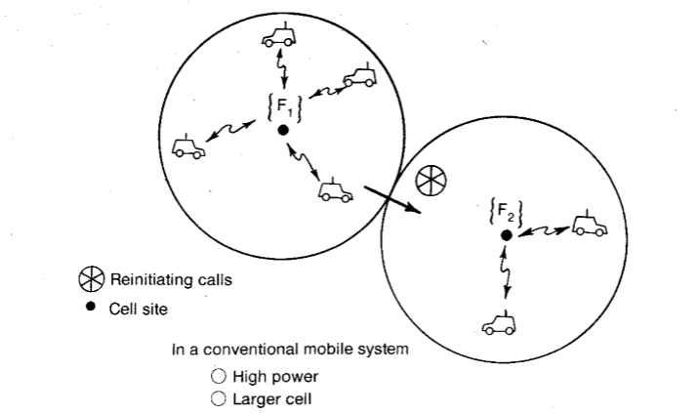

Limited service capability:
- Specific frequency allocation for use in autonomous geographic zones, as shown in Fig.1.1. The coverage area of each zone is planned to be as large as possible, which results in high transmitted power.
- The user need to reinitiate the call when moving into a new zone because the call will be dropped (i.e. no auto handoff).
- One frequency per channel and the number of active users is limited to the number of channels assigned to a particular frequency zone.

Poor service performance:
The blocking probability is high during busy hours in conventional mobile telephone systems, to overcome this high-capacity system for mobile telephones was needed.

Inefficient frequency spectrum utilization:
The blocking probability depends on actual average calling time and frequency spectrum utilization measurement M_{0.} To reduce the blocking probability, we must decrease the value of the frequency spectrum utilization measurement M_{0.} In this system the frequency utilization measurement M₀ is defined as the maximum number of customers that could be served by one channel at the busy hour.

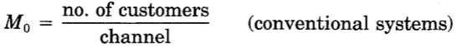
In conventional system each channel can only serve one customer at a time in a whole area which results inefficient utilization of spectrum. A new system is required that can measures the frequency spectrum utilization differently from above equation and proves to be efficient.

    - Cellular System:
The Cellular system is developed to overcome the limitations in the conventional mobile telephone systems. In this large area is divided into cells with 2 to 50 km diameter, available spectrum is divided into discrete channels which are assigned in groups to geographic cells covering an area and the frequencies are reused. Thus low power transmissions and improved spectrum utilization.
Basic Cellular System:
A basic cellular system consists of three parts:
- Mobile units:
A mobile telephone unit contains a control unit, a transceiver, and an antenna system.

- Cell site:
The cell site provides interface between the MTSO and the mobile units. It has a control unit, radio cabinets, antennas, a power plant, and data terminals.

- MTSO:
The switching office is the central coordinating element for all cell sites, contains the cellular processor and cellular switch. It interfaces with telephone company zone offices, controls call processing, and handles billing activities.

- Connections:
The radio and high-speed data links connect the three subsystems. Each mobile unit can only use one channel at a time for its communication link But the channel is not fixed; it can be any one in the entire band assigned by the serving area. Each site having multichannel capabilities that can connect simultaneously to many mobile units.
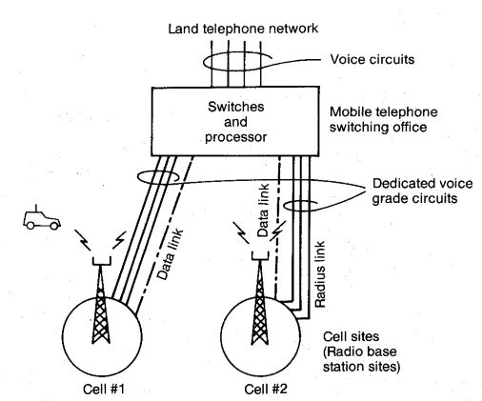
Fig. 1.2 Cellular system
The MTSO provides central coordination and cellular administration. The cellular switch, which can be either analog or digital, switches calls to connect mobile subscribers to other mobile subscribers and to the nationwide telephone network. It uses voice trunks, it also contains data links providing supervision links between the processor and the switch and between the cell sites and the processor. The radio link carries the voice and signaling between the mobile unit and the cell site. The high speed data links cannot be transmitted over the standard telephone trunks and therefore must use either microwave links or T-carriers (wire lines). Microwave radio links or T-carriers carry both voice and data between the cell site and the MTSO.

  - Performance Criteria:
There are three categories for specifying performance criteria.

Voice quality:
For commercial communications system, a set value x at which y percent of customers rate the system voice quality (from transmitter to receiver) and circuit merits as follows:
CM5 excellent (speech perfectly understandable)
CM4 good (speech easily understandable, some noise)
CM3 fair (speech understandable with a slight effort, occasional repetitions needed)
CM2 poor (speech understandable only with considerable effort, frequent repetitions needed)
CM1 unusable (speech not understandable)

Service quality:
Three items are required for service quality.
- Coverage. The system should serve an area as large as possible, because of irregular terrain configurations, it is usually not practical to cover 100 percent of the area for two reasons:
- The transmitted power would have to be very high to illuminate weak spots with sufficient reception, a significant added cost factor.
- Higher the transmitted power, harder it becomes to control interference.
- Required grade of service. The grade of service is specified for a blocking probability of .02 for initiating calls at the busy hour, this is an average value. But the blocking probability at each cell site will be different. To decrease the blocking probability requires a good system plan and a sufficient number of radio channels.
- Number of dropped calls. During Q calls in an hour, if a call is dropped and Q - 1 calls are completed, then the call drop rate is 1/Q. This drop rate must be kept low. A high drop rate could be caused by either coverage problems or handoff problems related to inadequate channel availability.

Special features:
System would like to provide as many special features as possible, such as call forwarding, call waiting, voice stored (VSR) box, automatic roaming, or navigation services.

  - Uniqueness of Mobile Radio Environment.
Mobile Radio Transmission Medium:
The propagation path loss increases not only with frequency but also with distance. The propagation path loss of 40dB/dec is the general rule for the mobile radio environment. (“dec” is an abbreviation of decade, a 40-dB loss at a signal receiver will be observed by the mobile unit as it moves from 1 to 10 km.)

Therefore C ∝ R⁻⁴ = α R⁻⁴
where C = received carrier power
R = distance measured from the transmitter to the receiver
α = constant
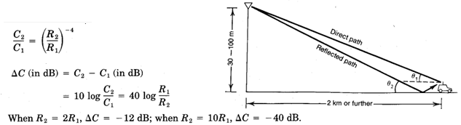
This 40 dB/dec is the general rule for the mobile radio environment. Similarly the general rule for the free-space propagation is 20 dB/dec.
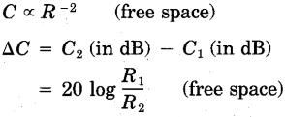
In a real mobile radio environment, the propagation path-loss slope varies as
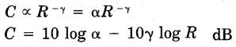
γ usually lies between 2 and 5 and cannot be lower than 2

Model of transmission medium
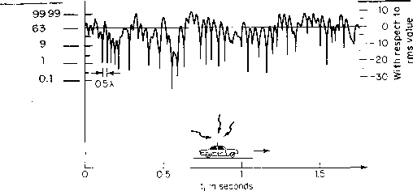
The antenna height of the mobile unit is lower than its typical surroundings and the carrier wavelength is much less than the sizes of the surrounding structures, multipath waves are generated causes a signal-fading phenomenon. The signal fluctuates in a range of about 40 dB (10 dB above and 30 dB below the average signal). The nulls of the fluctuation at the baseband at about every half wavelength in space, but all nulls do not occur at the same level. If the mobile unit moves fast, the rate of fluctuation is fast.

A mobile radio signal r(t), can be artificially characterized by two components m(t) and r₀(t) based on natural physical phenomena.
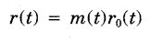
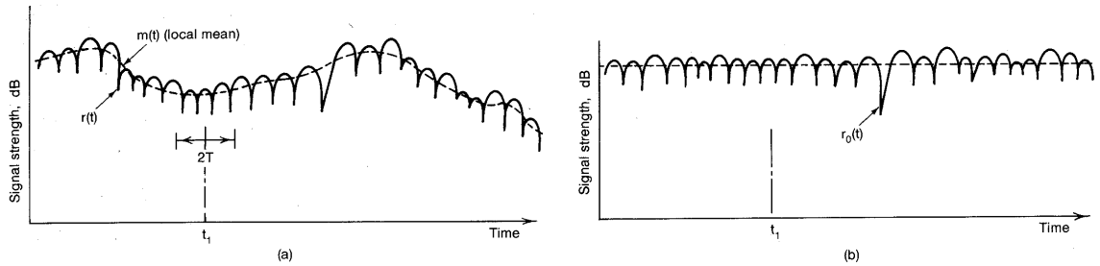
Fig. 1.3 A mobile radio signal fading representation, (a) A mobile signal fading. (b) A short-term signal fading.

The component m(t) is called local mean, long-term fading, or lognormal fading and its variation is due to the terrain contour between the base station and the mobile unit. The factor r₀ is called multipath fading, short-term fading, or Rayleigh fading and its variation is due to the waves reflected from the surrounding buildings and other structures.
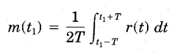
2T is the time interval for averaging r(t). T can be determined based on the fading rate of r(t), usually 40 to 80 fades, so m(t) is the envelope of r{t).

In space scale
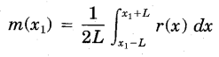
The length of 2L has been determined to be 20 to 40 wavelengths. The factor m(t) or m(x) is also found to be a log-normal distribution based on its characteristics caused by the terrain contour. The short-term fading r₀ is obtained by
r₀ (in dB) = r(t) - m(t) dB
as shown in Fig. 1.3b. The factor r₀(t) follows a Rayleigh distribution, assuming that only reflected waves from local surroundings are the ones received (a normal situation for the mobile radio environment). Therefore, the term Rayleigh fading is often used.

Mobile fading characteristics
Rayleigh fading is also called multipath fading in the mobile radio environment. These multipath waves bounce back and forth due to the buildings and houses, they form many standing-wave pairs in space. Those standing-wave pairs are summed together and become an irregular wave-fading structure. When a mobile unit is standing still, its receiver only receives a signal strength at that spot, so a constant signal is observed.
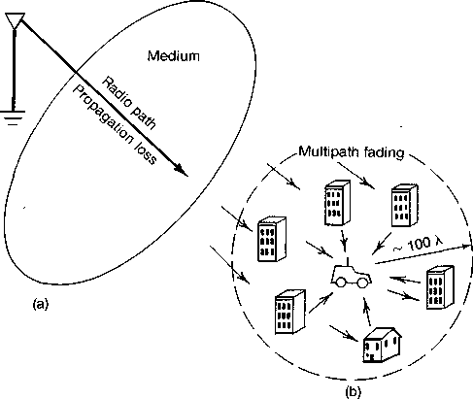
Fig. A mobile radio environment—two parts. (1) Propagation loss; (2) multipath fading.

When the mobile unit is moving, the fading structure of the wave in the space is received. It is a multipath fading. The recorded fading becomes fast as the vehicle moves faster. The radius of the active scatterer region is roughly 100 wavelengths. The active scatterer region always moves with the mobile unit as its center.
  - Operation of Cellular Systems
Mobile unit initialization. The receiver of the mobile unit scans 21 set-up channels which are designated among the 333 channels and selects the strongest one and locks on for a certain time. Each site is assigned a different set-up channel, locking onto the strongest set-up channel means selecting the nearest cell site. After 60 s, the self-location procedure is repeated.

Mobile originated call. The user places the called number into an originating register in the mobile unit and pushes the “send” button. A request for service is sent on a selected set-up channel obtained from a self-location scheme. The cell site receives it, at the same time sends a request to the MTSO via a high-speed data link. The MTSO selects an appropriate voice channel for the call, and the cell site selects the best directive antenna to link the mobile unit. The MTSO also connects the wire-line party through the telephone company zone office.

Network originated call. A land-line party dials a mobile unit number. The telephone company zone office recognizes that the number is mobile and forwards the call to the MTSO. The MTSO sends a paging message to certain cell sites based on the mobile unit number and the search algorithm. Each cell site transmits the page on its own set-up channel. The mobile unit recognizes its own identification on a strong set-up channel, locks onto it, and responds to the cell site. The mobile unit also follows the instruction to tune to an assigned voice channel and initiate user alert.

Call termination. When the mobile user turns off the transmitter, a particular signal (signaling tone) transmits to the cell site, and both sides free the voice channel. The mobile unit resumes monitoring pages through the strongest set-up channel.

Handoff procedure. During the call, two parties are on a voice channel. When the mobile unit moves out of the coverage area of a particular cell site, the reception becomes weak. The present cell site requests a handoff. The system switches the call to a new frequency channel in a new cell site without either interrupting the call or alerting the user. The call continues as long as the user is talking. The user does not notice the handoff occurrences.

Hexagonal-haped Cells
The hexagonal-shaped cells on a layout are used to simplify the planning and design of a cellular system instead of circular cell shaped cells. The hexagonal-shaped cells fit the planned area where as the circular shapes have overlapped areas which make the drawing unclear.

Hexagonal cells
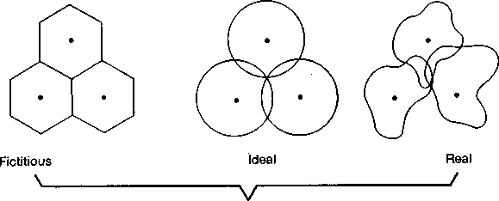

Signal coverage
Elements Of Cellular Radio System Design:
The major elements are (1) the concept of frequency reuse channels, (2) the cochannel interference reduction factor, (3) the desired carrier-to-inter- ference ratio, (4) the handoff mechanism, and (5) cell splitting.

Concept of Frequency Reuse Channels
A particular radio channel, say F_{u} used in one geographic zone to call a cell, say C_{u} with a coverage radius R can be used in another cell with the same coverage radius at a distance D away.

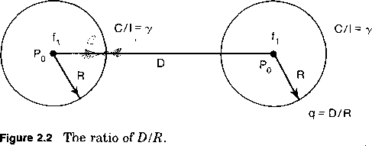

The frequency reuse system can drastically increase the spectrum efficiency, but if the system is not properly designed, serious interference may occur. Interference due to the common use of the same channel is called cochannel interference and is our major concern in the concept of frequency reuse.

Frequency reuse schemes
The frequency reuse concept can be used in the time domain and the space domain. Frequency reuse in the time domain results in the occupation of the same frequency in different time slots. It is called time- division multiplexing (TDM).

Frequency reuse in the space domain can be divided into two categories.
- Same frequency assigned in two different geographic areas.
- Same frequency repeatedly used in a same general area in one system,the scheme is used in cellular systems

Frequency reuse distance
The minimum distance which allows the same frequency to be reused will depend on many factors, such as the number of cochannel cells in the vicinity of the center cell, the type of geographic terrain contour, the antenna height, and the transmitted power at each cell site.

The frequency reuse distance D can be determined from
D = (3K)^{1/2}R
Where K is the frequency reuse pattern shown in Fig. 2.2, then
3.46 R | K = 4
4.6 R | K = 7
6 R | K = 12
7.55 R | K = 19

If all the cell sites transmit the same power, then K increases and the frequency reuse distance D increases. This increased D reduces the chance that cochannel interference may occur.

Theoretically, a large K is desired. However, the total number of allocated channels is fixed. When if it is too large, the number of channels assigned to each of K cells becomes small. It is always true that if the total number of channels in K cells is divided as if increases, trunking inefficiency results. The same principle applies to spectrum inefficiency: if the total number of channels are divided into two network systems serving in the same area, spectrum inefficiency increases. Now the challenge is to obtain the smallest number K which can still meet our system performance requirements. This involves estimating cochannel interference and selecting the minimum frequency reuse distance D to reduce cochannel interference. The smallest value of K is If = 3, obtained by setting i = 1 ,j = 1 in the equation if = i² + ij + j²

- Handoff Mechanism
Two cochannel cells using the frequency F_{A} separated by a distance D. The radius R and the distance D are governed by the value of q. Now we have to fill in with other frequency channels such as F₂, F₃, and F_{A} between two cochannel cells in order to provide a communication system in the whole area.

The fill-in frequencies F₂, F₃, and F₄ are also assigned to their corresponding cells C₂, C₃, and C₄ according to the same value of q. Suppose a mobile unit is starting a call in cell C_{t} and then moves to C₂. The call can be dropped and reinitiated in the frequency channel from F₁ to F₂ while the mobile unit moves from cell Cj to cell C₂. This process of changing frequencies can be done automatically by the system without the user’s intervention. This process of handoff is carried on in the cellular system.
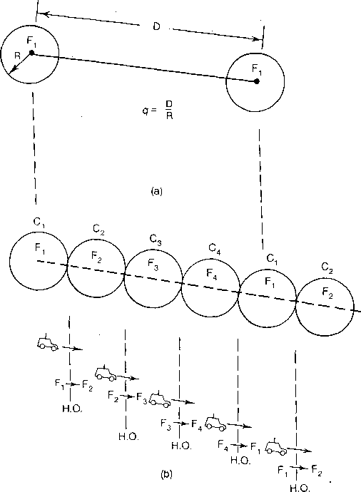
Cell Splitting

There are two kinds of cell-splitting techniques:
- Permanent splitting. The installation of every new split cell has to be planned ahead of time; the number of channels, the transmitted power, the assigned frequencies, the choosing of the cell-site selection, and the traffic load consideration should all be considered. When ready, the actual service cut-over should be set at the lowest traffic point, usually at midnight on a weekend. Hopefully, only a few calls will be dropped because of this cut-over, assuming that the downtime of the system is within 2 h.
- Dynamic splitting. This scheme is based on utilizing the allocated spectrum efficiency in real time. The algorithm for dynamically splitting cell sites is a tedious job since we cannot afford to have one single cell unused during cell splitting at heavy traffic hour.

REFERENCE :
Mobile Cellular Telecommunications – W.C.Y. Lee, Tata McGraw Hill, 2rd Edn., 2006.

