Priority Queues (Heaps)

Advanced Data Structures

1

Motivation

- Queues are a standard mechanism for ordering tasks on a first-come, first-served basis

- However, some tasks may be more important or timely than others (higher priority)

- Priority queues

  - Store tasks using a partial ordering based on priority

  - Ensure highest priority task at head of queue

- Heaps are the underlying data structure of priority queues

2

Priority Queues

- Main operations

  - insert (i.e., enqueue)

  - deleteMin (i.e., dequeue)

    - Finds the minimum element in the queue, deletes it from the queue, and returns it

- Performance

  - Goal is for operations to be fast

  - Will be able to achieve O(log₂N) time insert/deleteMin amortized over multiple operations

  - Will be able to achieve O(1) time inserts amortized over multiple insertions

3

Simple Implementations

- Unordered list

  - O(1) insert

  - O(N) deleteMin

- Ordered list

  - O(N) insert

  - O(1) deleteMin

- Balanced BST

  - O(log₂N) insert and deleteMin

- Observation: We don’t need to keep the priority queue completely ordered

4

Binary Heap

- A binary heap is a binary tree with two properties

- Structure property

  - A binary heap is a complete binary tree

    - Each level is completely filled

    - Bottom level may be partially filled from left to right

- Height of a complete binary tree with N elements is log2 N

5

Binary Heap Example
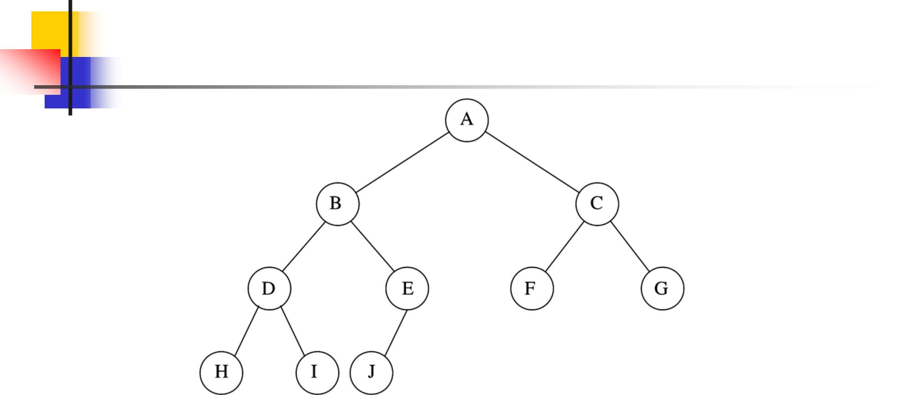

6

Binary Heap

- Heap-order property

  - For every node X, key(parent(X)) ≤ key(X)

  - Except root node, which has no parent

- Thus, minimum key always at root

  - Or, maximum, if you choose

- Insert and deleteMin must maintain heap-order property

7

Implementing Complete Binary Trees as Arrays

- Given element at position i in the array

  - i’s left child is at position 2i

  - i’s right child is at position 2i+1

  - i’s parent is at position i / 2

8

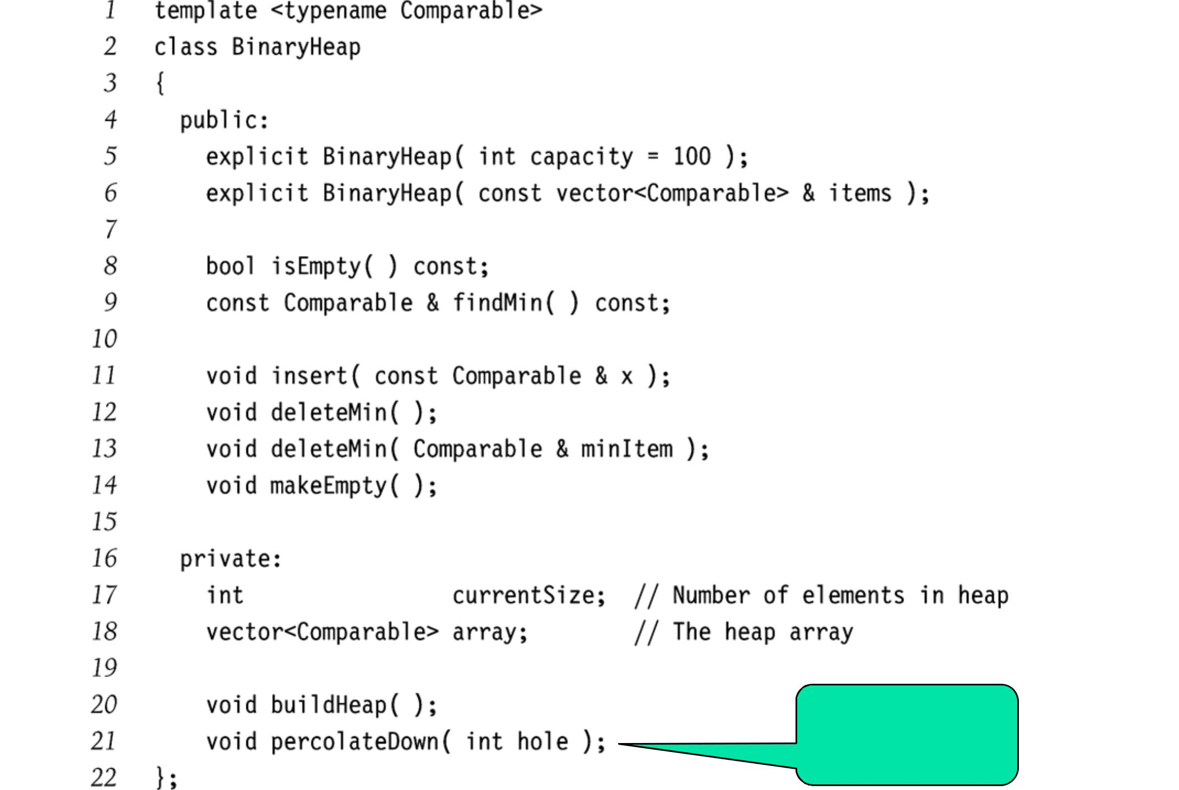

Fix heap after

deleteMin

9

Heap Insert

- Insert new element into the heap at the next available slot (“hole”)

  - According to maintaining a complete binary tree

- Then, “percolate” the element up the heap while heap-order property not satisfied

10

Heap Insert: Example
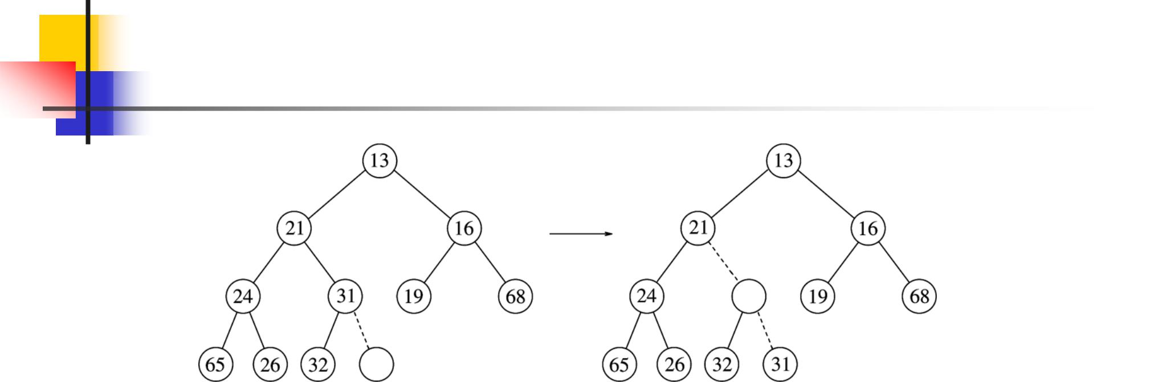

Insert 14:
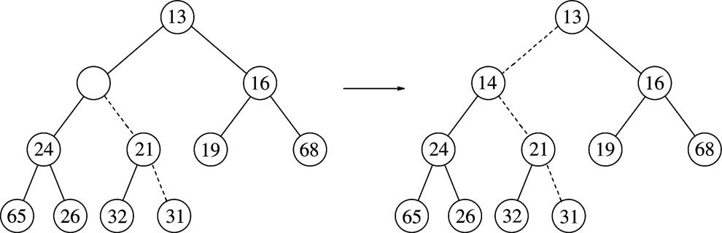

11

Heap Insert: Implementation
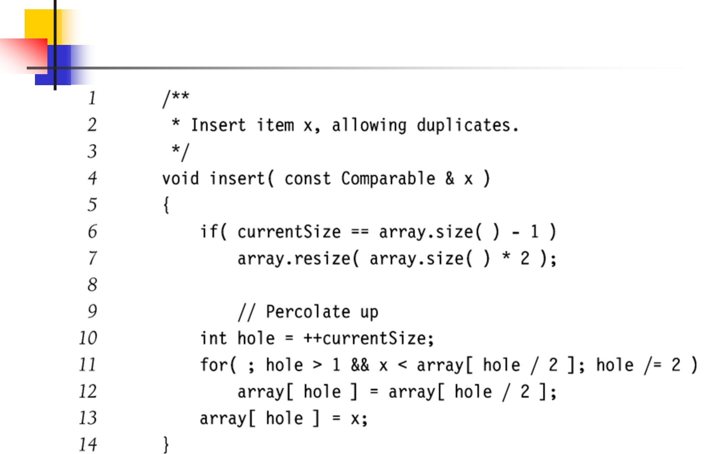

12

Heap DeleteMin

- Minimum element is always at the root

- Heap decreases by one in size

- Move last element into hole at root

- Percolate down while heap-order property not satisfied

13

Heap DeleteMin: Example
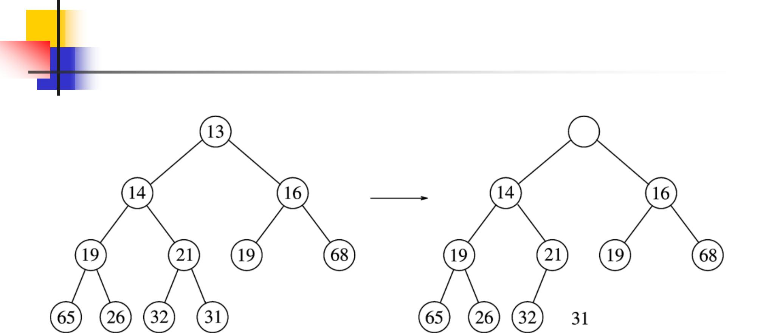

14

Heap DeleteMin: Example
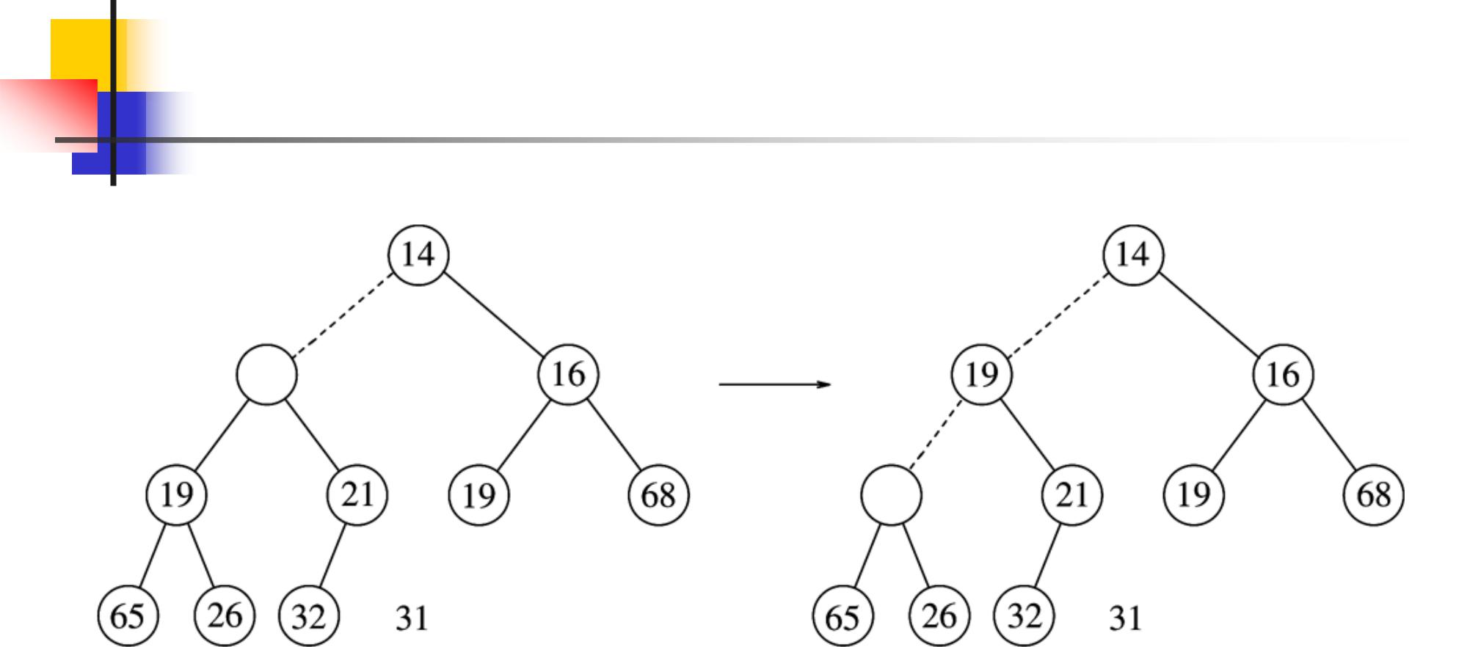

15

Heap DeleteMin: Example
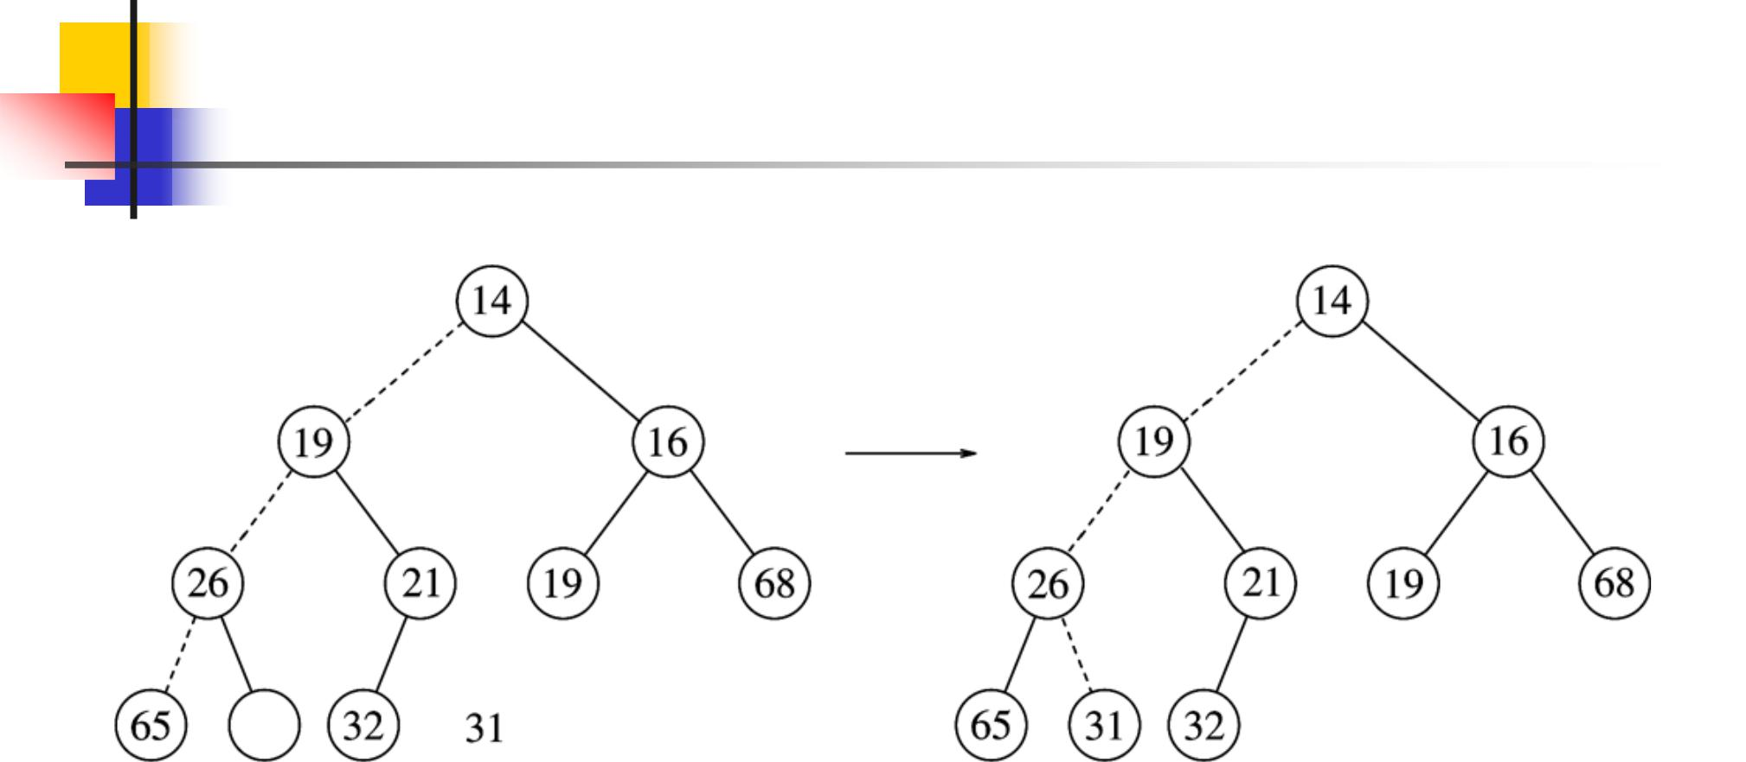

16

Heap DeleteMin:

Implementation
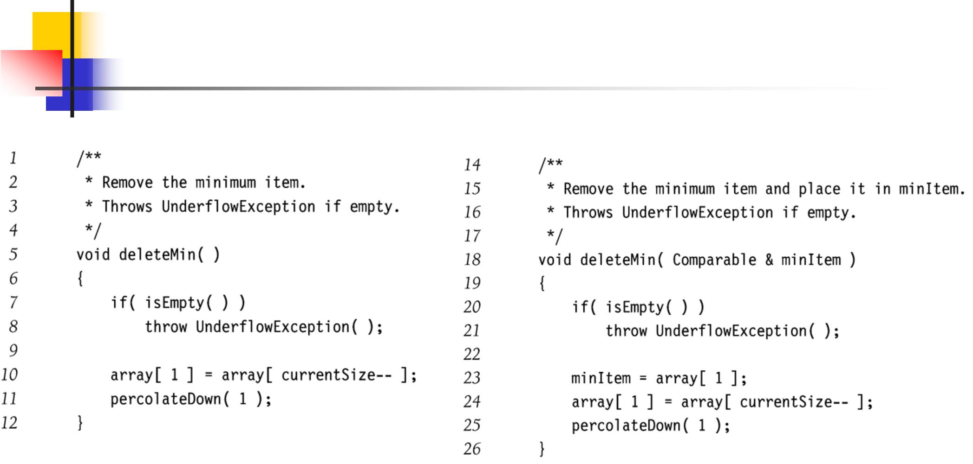

17

Heap DeleteMin:

Implementation
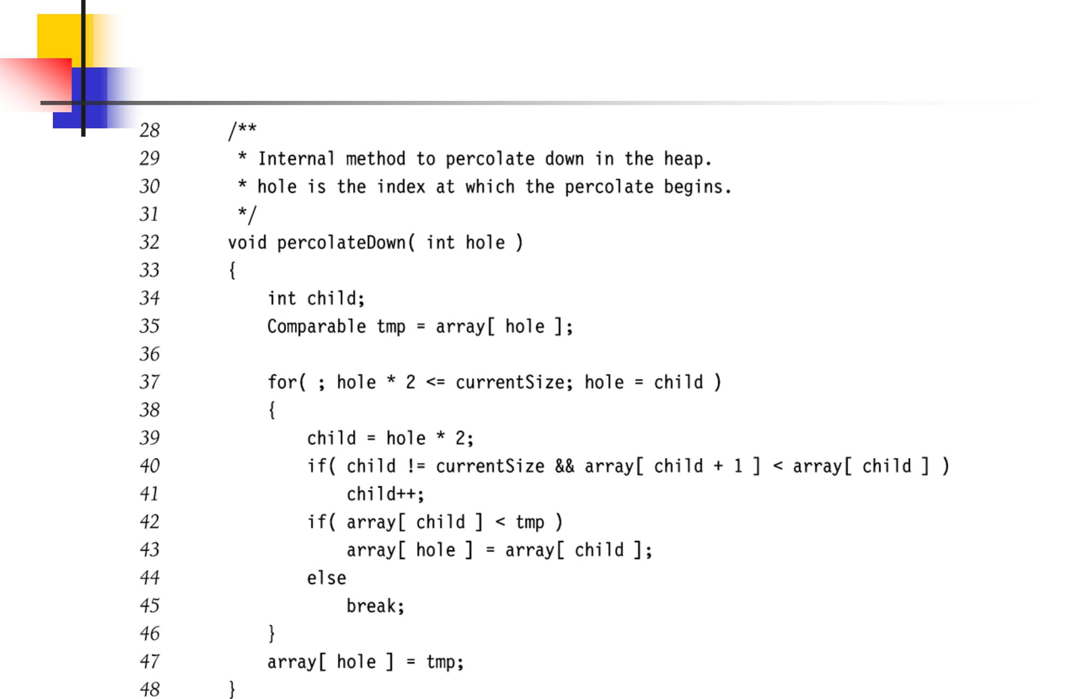

18

Other Heap Operations

- decreaseKey(p,v)

  - Lowers value of item p to v

  - Need to percolate up

  - E.g., change job priority

- increaseKey(p,v)

  - Increases value of item p to v

  - Need to percolate down

- remove(p)

  - First, decreaseKey(p,-∞)

  - Then, deleteMin

  - E.g., terminate job

19

Building a Heap

- Construct heap from initial set of N items

- Solution 1

  - Perform N inserts

  - O(N) average case, but O(N log₂ N) worst-case

- Solution 2

  - Assume initial set is a heap

  - Perform a percolate-down from each internal node (H[size/2] to H[1])

20

BuildHeap Example
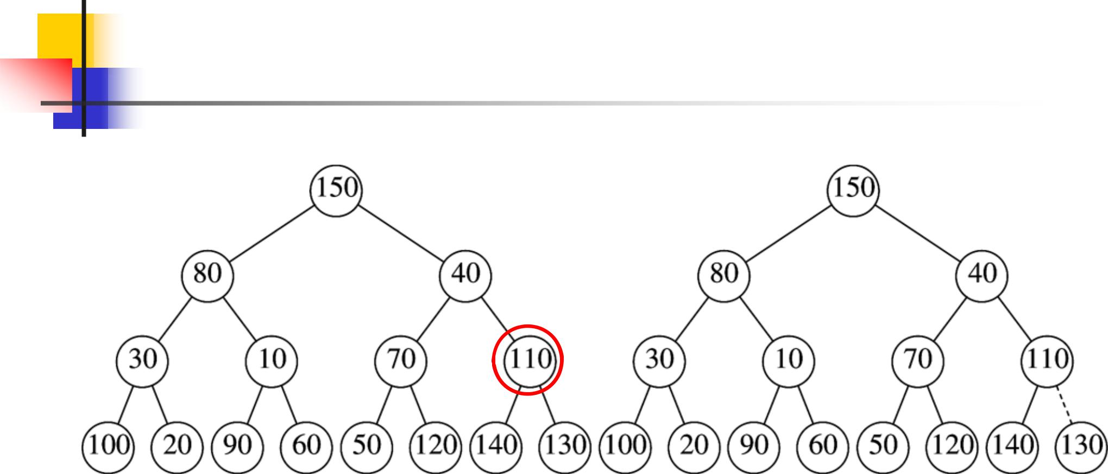

Leaves are all valid heaps

21

BuildHeap Example
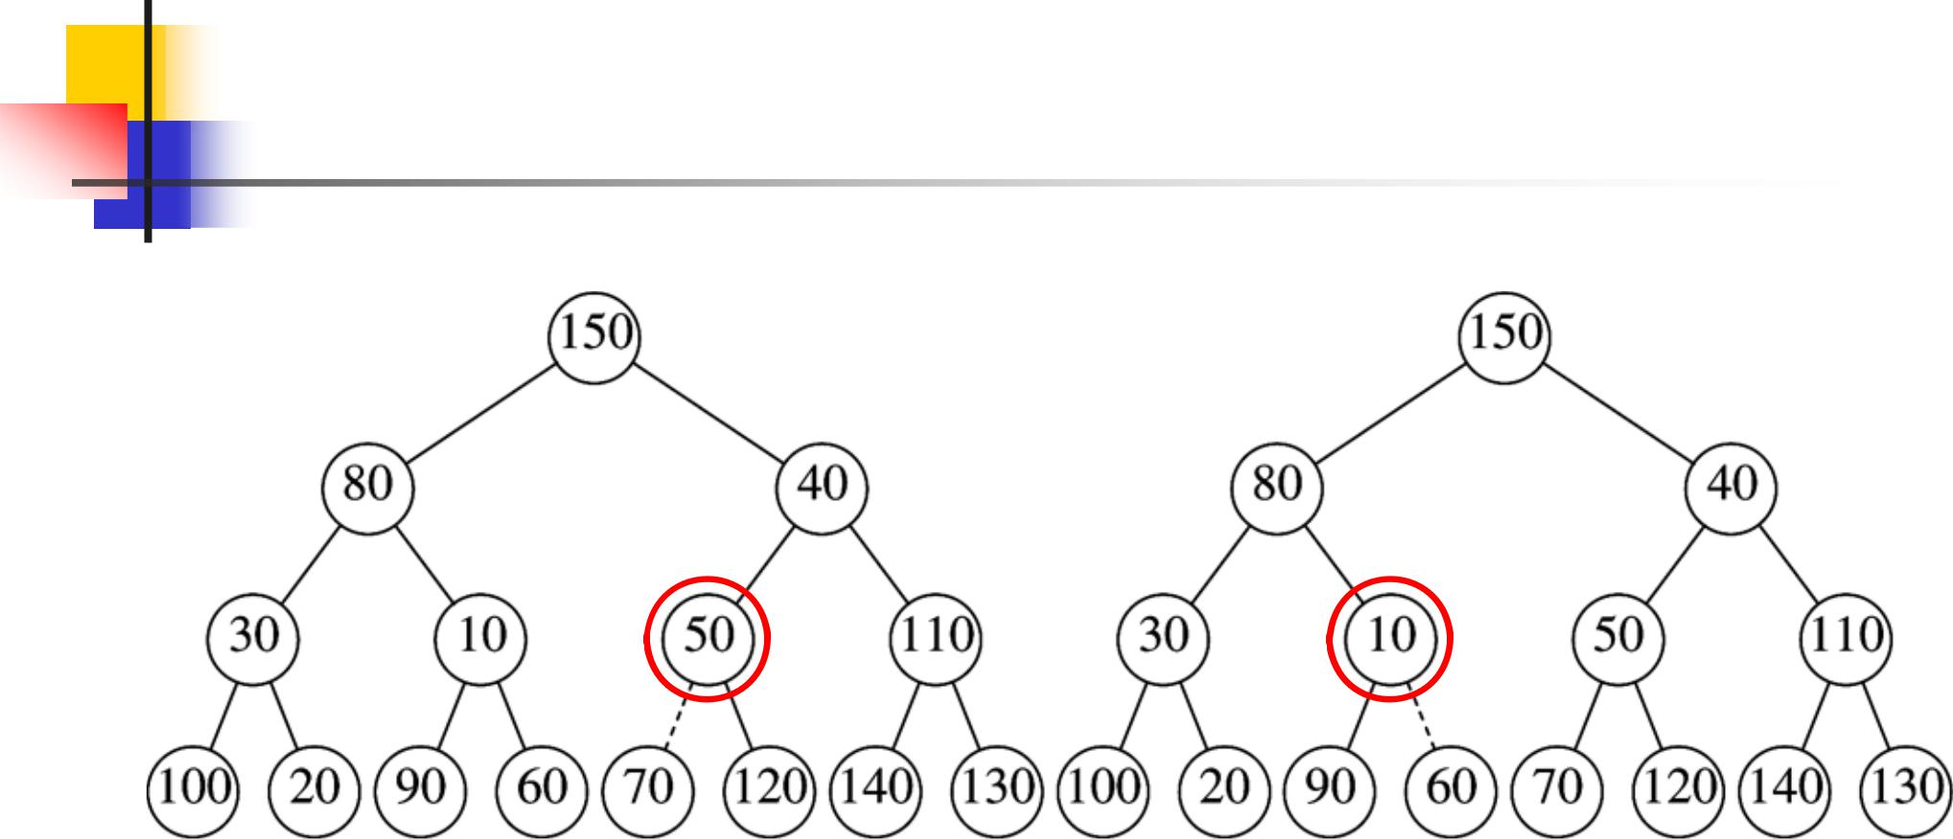

22

BuildHeap Example
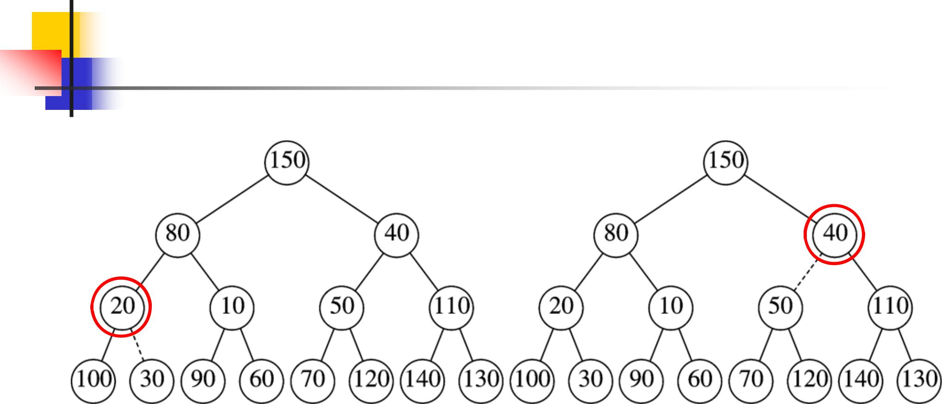

23

BuildHeap Example
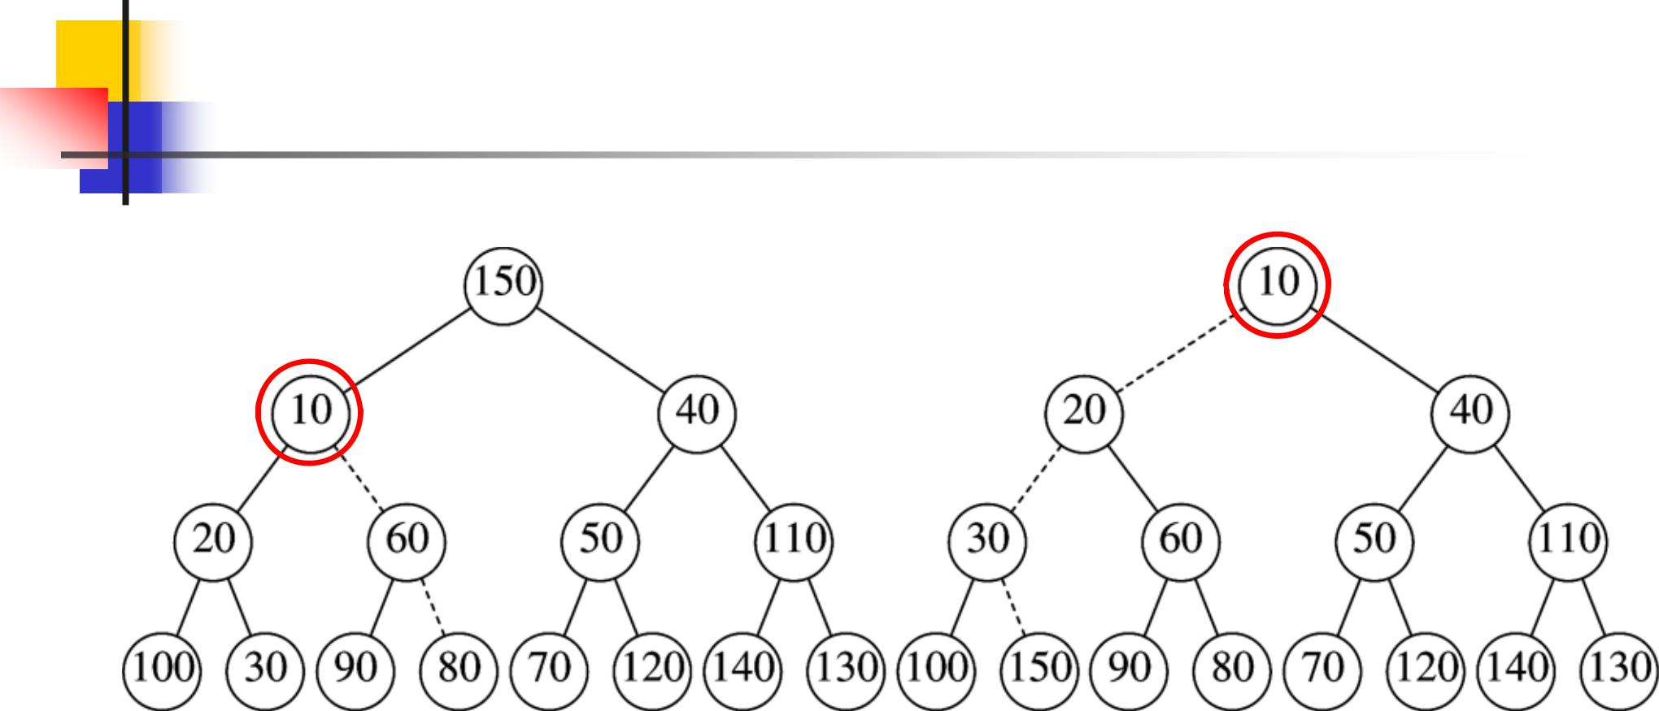

24

BuildHeap Implementation
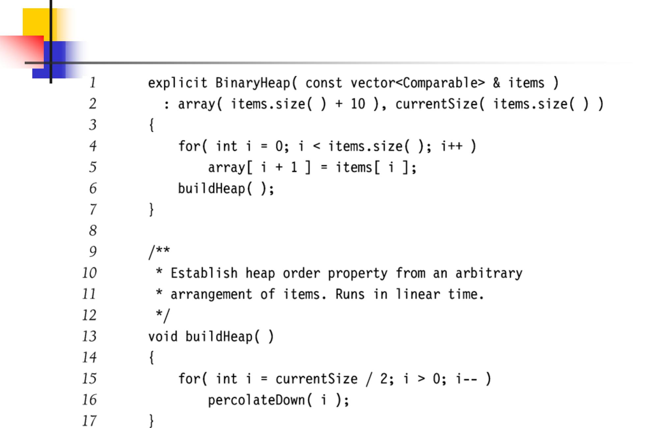

25

BuildHeap Analysis

- Running time of buildHeap proportional to sum of the heights of the nodes

- Theorem 6.1

  - For the perfect binary tree of height h containing 2^{h+1} – 1 nodes, the sum of heights of the nodes is 2^{h+1} – 1 – (h + 1)
- Since N = 2h+1 – 1, then sum of heights is O(N)

- Slightly better for complete binary tree

26

Binary Heap Operations Worst-case Analysis

- Height of heap is log₂ N

- insert: O(log₂N)

  - 2.607 comparisons on average, i.e., O(1)

- deleteMin: O(log₂N)

- decreaseKey: O(log₂N)

- increaseKey: O(log₂N)

- remove: O(log₂N)

- buildHeap: O(N)

27

Applications

- Operating system scheduling

  - Process jobs by priority

- Graph algorithms

  - Find the least-cost, neighboring vertex

- Event simulation

  - Instead of checking for events at each time click, look up next event to happen

28

Priority Queues: Alternatives to Binary Heaps

- d-Heap

  - Each node has d children

  - insert in O(log_{d} N) time

  - deleteMin in O(d log_{d} N) time

- Binary heaps are 2-Heaps

29

Mergeable Heaps

- Heap merge operation

  - Useful for many applications

  - Merge two (or more) heaps into one

  - Identify new minimum element

  - Maintain heap-order property

  - Merge in O(log N) time

  - Still support insert and deleteMin in O(log N) time

    - Insert = merge existing heap with one-element heap

- d-Heaps require O(N) time to merge

30

Leftist Heaps

- Null path length npl(X) of node X

  - Length of the shortest path from X to a node without two children

- Leftist heap property

  - For every node X in heap, npl(leftChild(X)) ≥ npl(rightChild(X))

- Leftist heaps have deep left subtrees and shallow right subtrees

  - Thus if operations reside in right subtree, they will be faster

31

Leftist Heaps

npl(X) shown in nodes
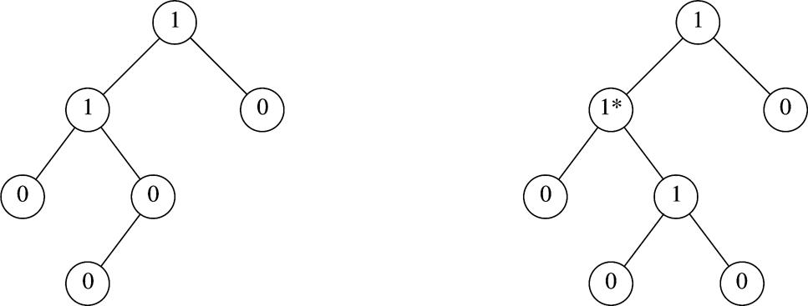

Leftist heap Not a leftist heap

32

Leftist Heaps

- Theorem 6.2

  - A leftist tree with r nodes on the right path must have at least 2r – 1 nodes.

- Thus, a leftist tree with N nodes has a right path with at most log(N +1) nodes

33

Leftist Heaps

- Merge heaps H1 and H2

  - Assume root(H1) > root(H2)

  - Recursively merge H1 with right subheap of H2

  - If result is not leftist, then swap the left and right subheaps

  - Running time O(log N)

- DeleteMin

  - Delete root and merge children

34

Leftist Heaps: Example
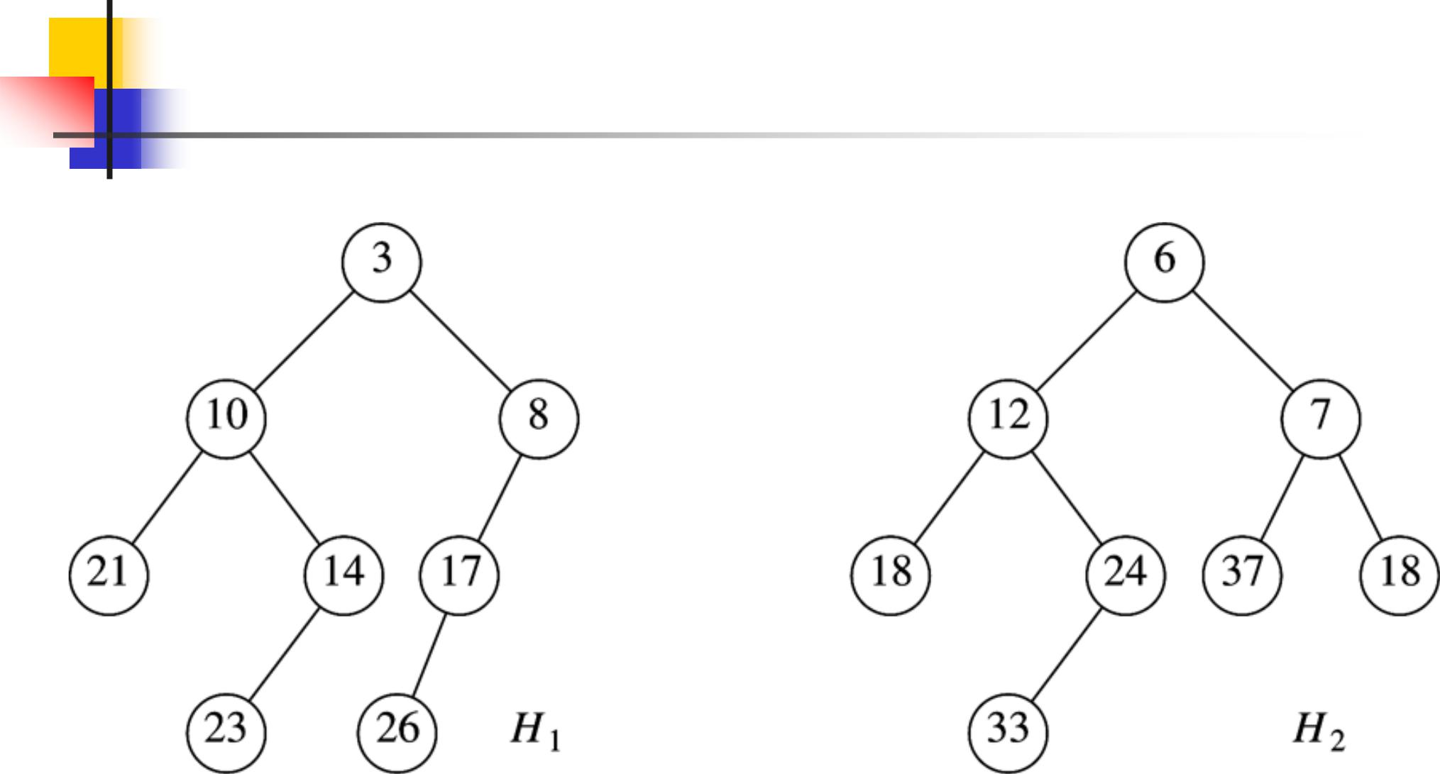

35

Leftist Heaps: Example
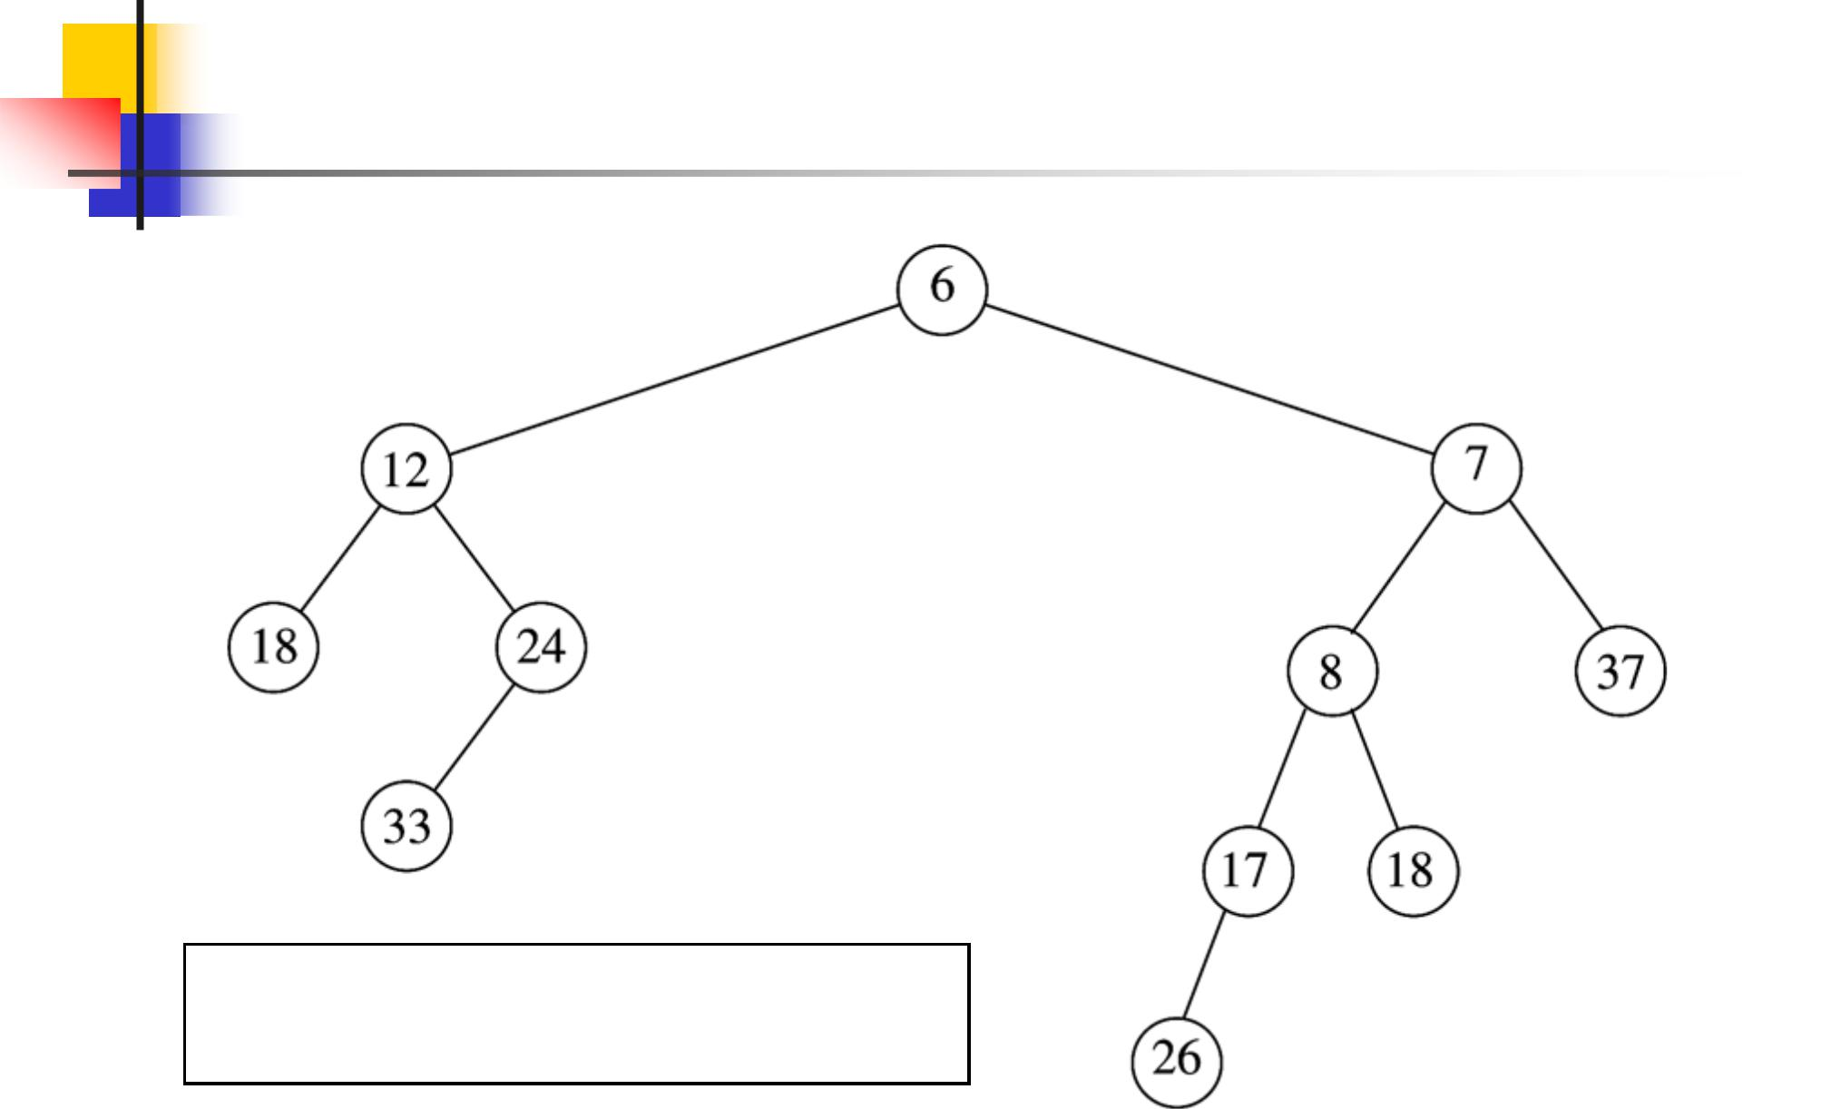

Merge H2 (larger root) with right

sub-heap of H1 (smaller root).

36

Leftist Heaps: Example
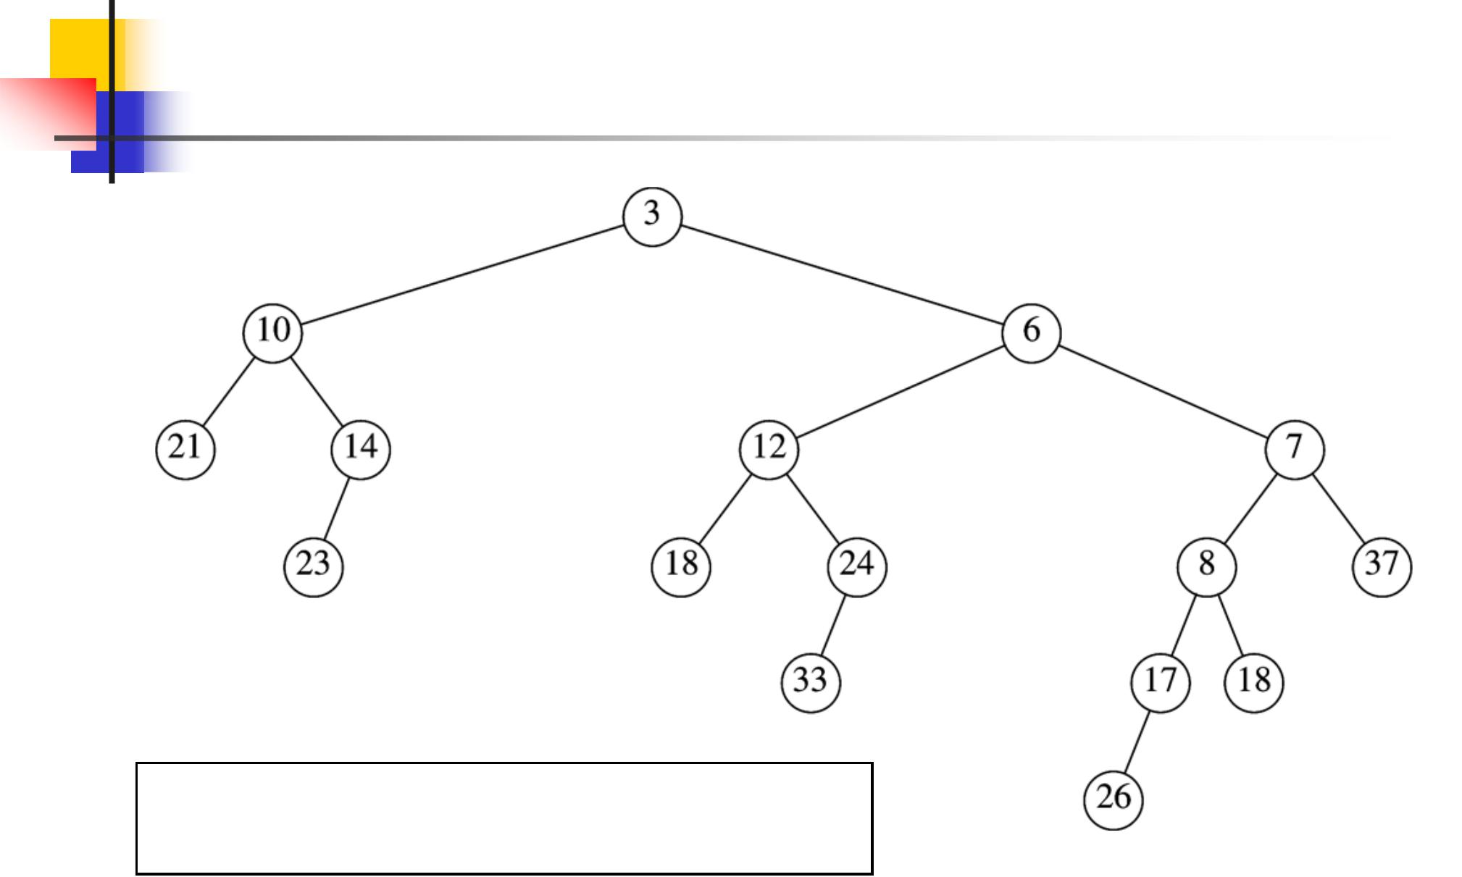

Attach previous heap as H1’s right child.

Leftist heap?

37

Leftist Heaps: Example
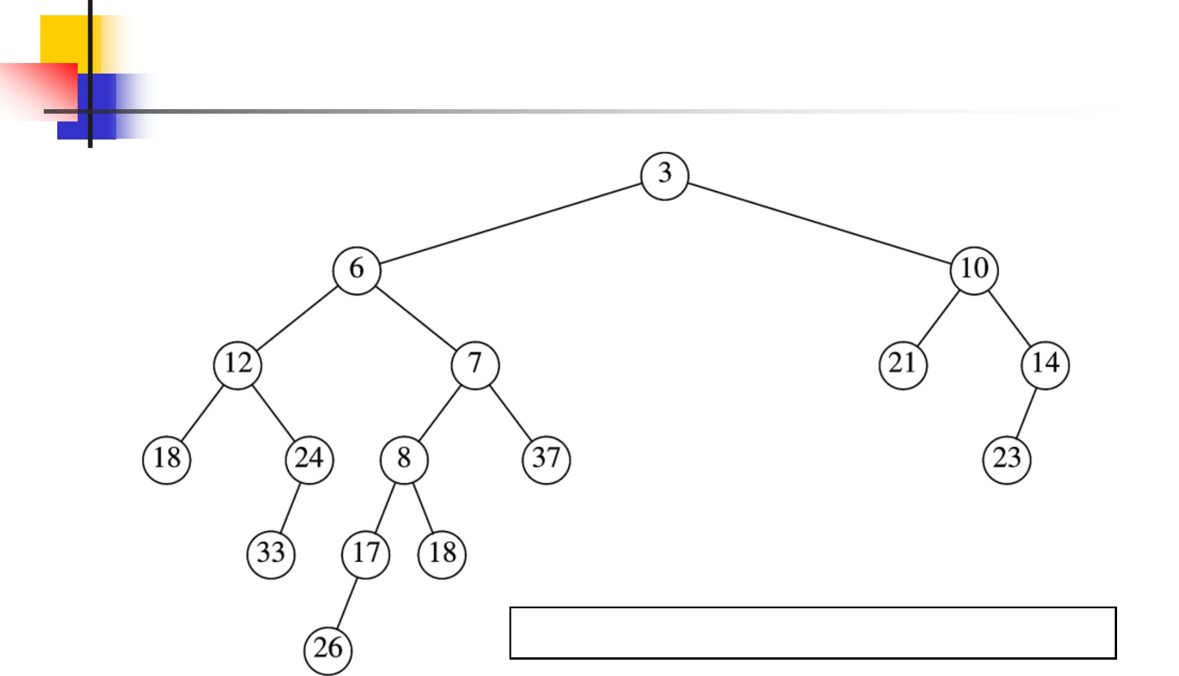

Swap root’s children to make leftist heap.

38

Skew Heaps

- Self-adjusting version of leftist heap

- Skew heaps are to leftist heaps as splay trees are to AVL trees

- Skew merge same as leftist merge, except we always swap left and right subheaps

- No need to maintain or test NPL of nodes

- Worst case is O(N)

- Amortized cost of M operations is O(M log N)

39

Binomial Queues

- Support all three operations in O(log N) worst-case time per operation

- Insertions take O(1) average-case time

- Key idea

  - Keep a collection of heap-ordered trees to postpone merging

40

Binomial Queues

- A binomial queue is a forest of binomial trees





Each in heap order

Each of a different height

- A binomial tree B_{k} of height k consists of two B_{k-1} binomial trees
  - The root of one B_{k-1} tree is the child of the root of the other B_{k-1} tree
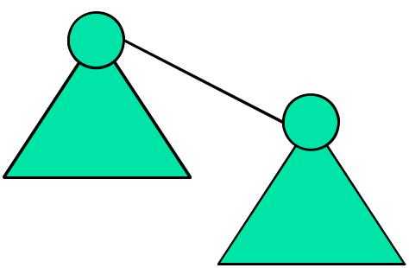

B_{k} =

^{B}k-1
^{B}k-1

41

Binomial Trees
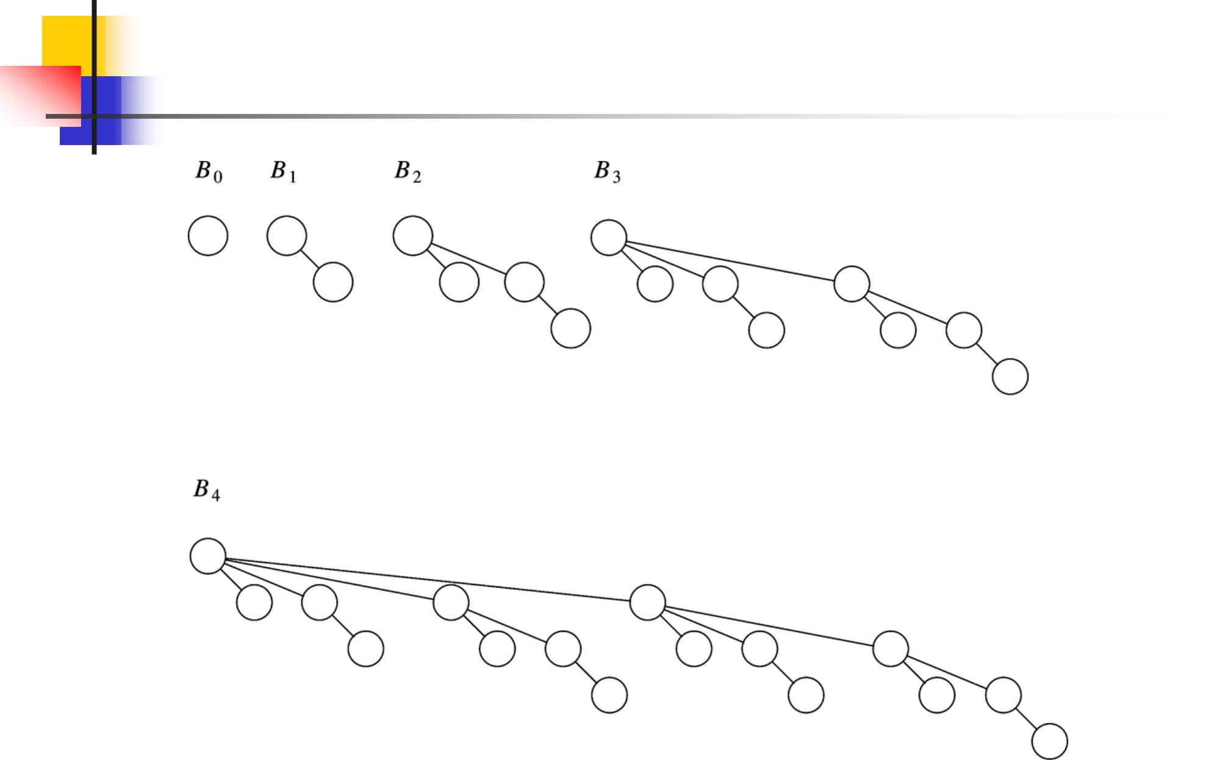

42

Binomial Trees

- Binomial trees of height k have exactly 2k nodes
 |  | k | , the
 Number of nodes at depth d is
binomial coefficient | ^{d}

- A priority queue of any size can be represented by a binomial queue

  - Binary representation of B_{k}
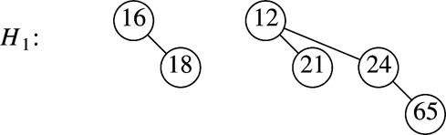

43

Binomial Queue Operations

- Minimum element found by checking roots of all trees

  - At most (log₂ N) of them, thus O(log N)

  - Or, O(1) by maintaining pointer to minimum element

44

Binomial Queue Operations

- Merge (H1,H2)  H3

  - Add trees of H1 and H2 into H3 in increasing order by depth

  - Traverse H3

    - If find two consecutive B_{k} trees, then create a B_{k+1} tree

    - If three consecutive B_{k} trees, then leave first, combine last two
    - Never more than three consecutive B_{k} trees

- Keep binomial trees ordered by height

- min(H3) = min(min(H1),min(H2))

- Running time O(log N)

45

Merge Example
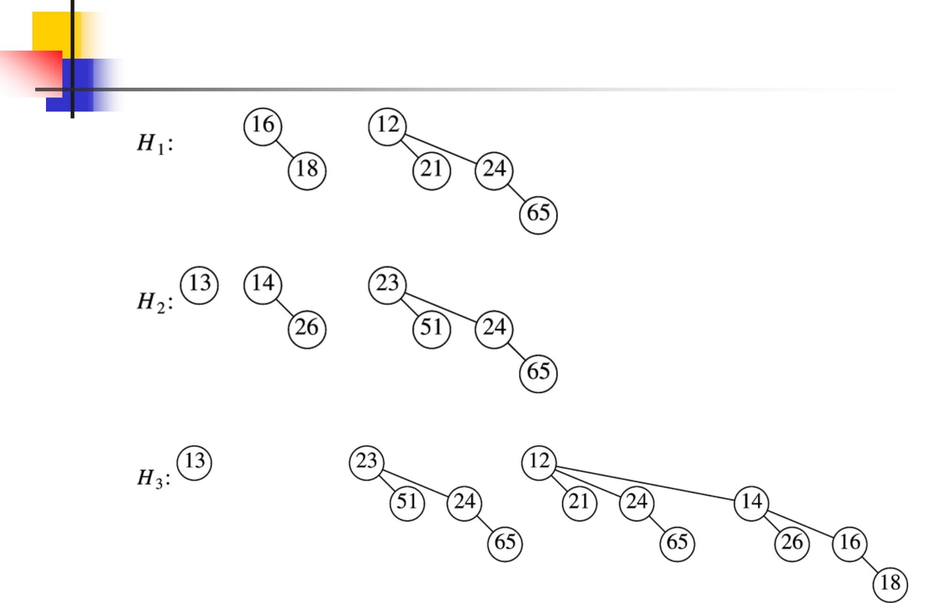

46

Binomial Queue Operations

- Insert (x, H1)

  - Create single-element queue H2

  - Merge (H1,H2)

- Running time proportional to minimum k such that B_{k} not in heap

- O(log N) worst case

- Probability B_{k} not present is 0.5

  - Thus, likely to find empty B_{k} after two tries on average

  - O(1) average case

47

Binomial Queue Operations

- deleteMin (H1)

  - Remove min(H1) tree from H1

  - Create heap H2 from the children of min(H)

  - Merge (H1,H2)

- Running time O(log N)

48

deleteMin Example
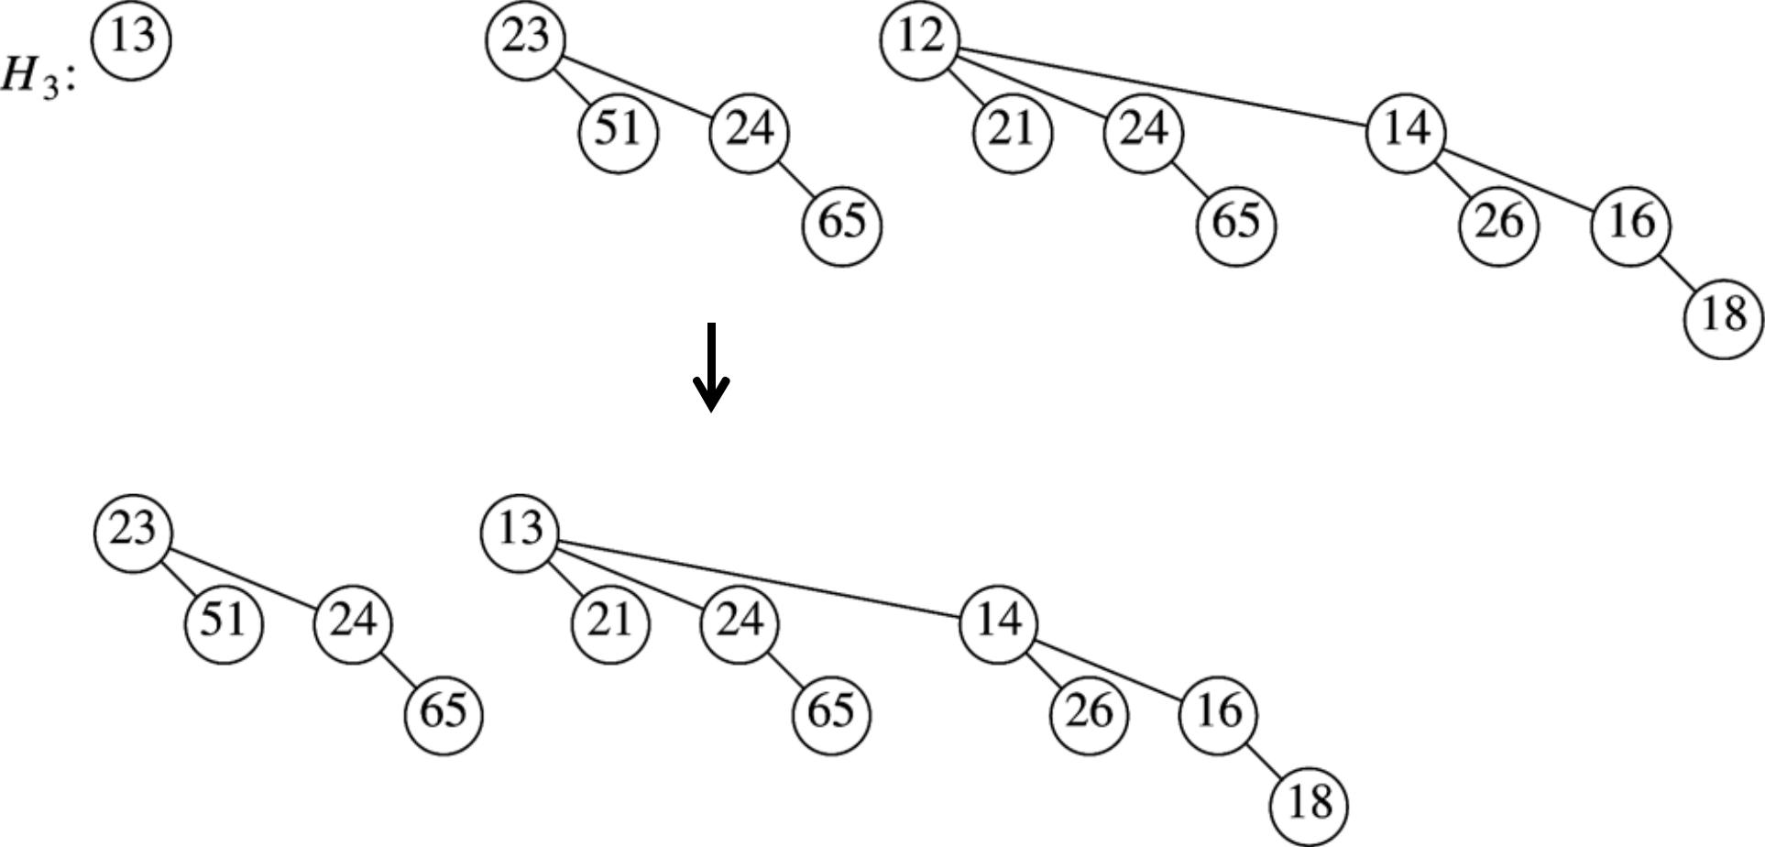

49

Binomial Queue Implementation

- Array of binomial trees

- Trees use first-child, right-sibling representation

H₃:
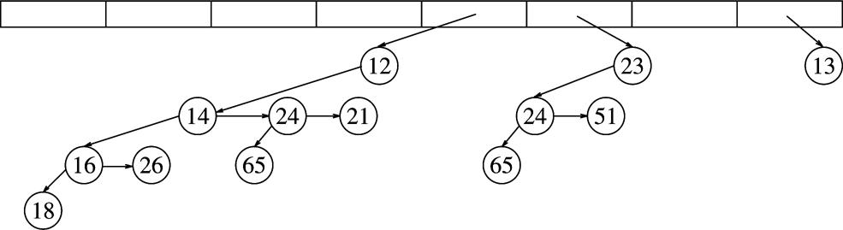

50

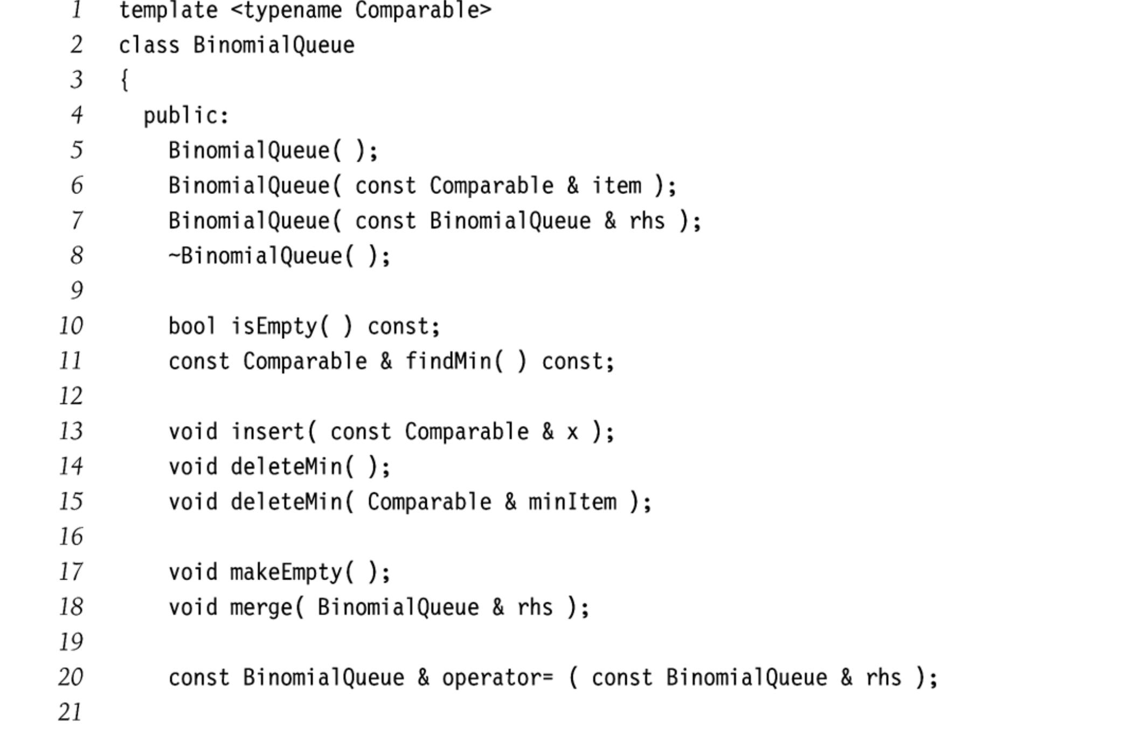

51

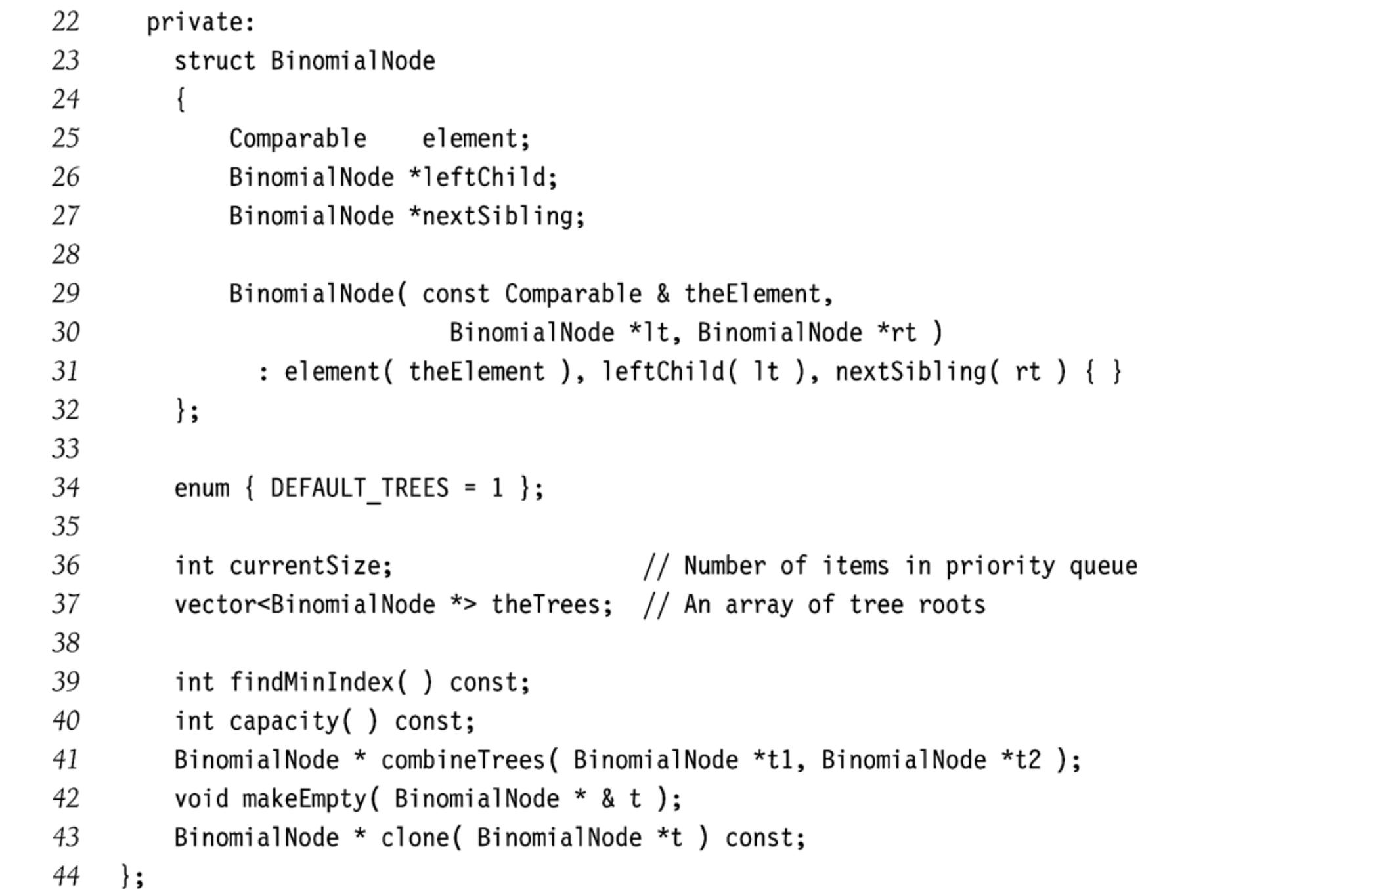

52

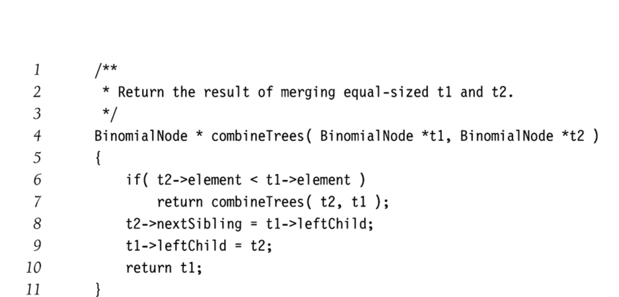

53

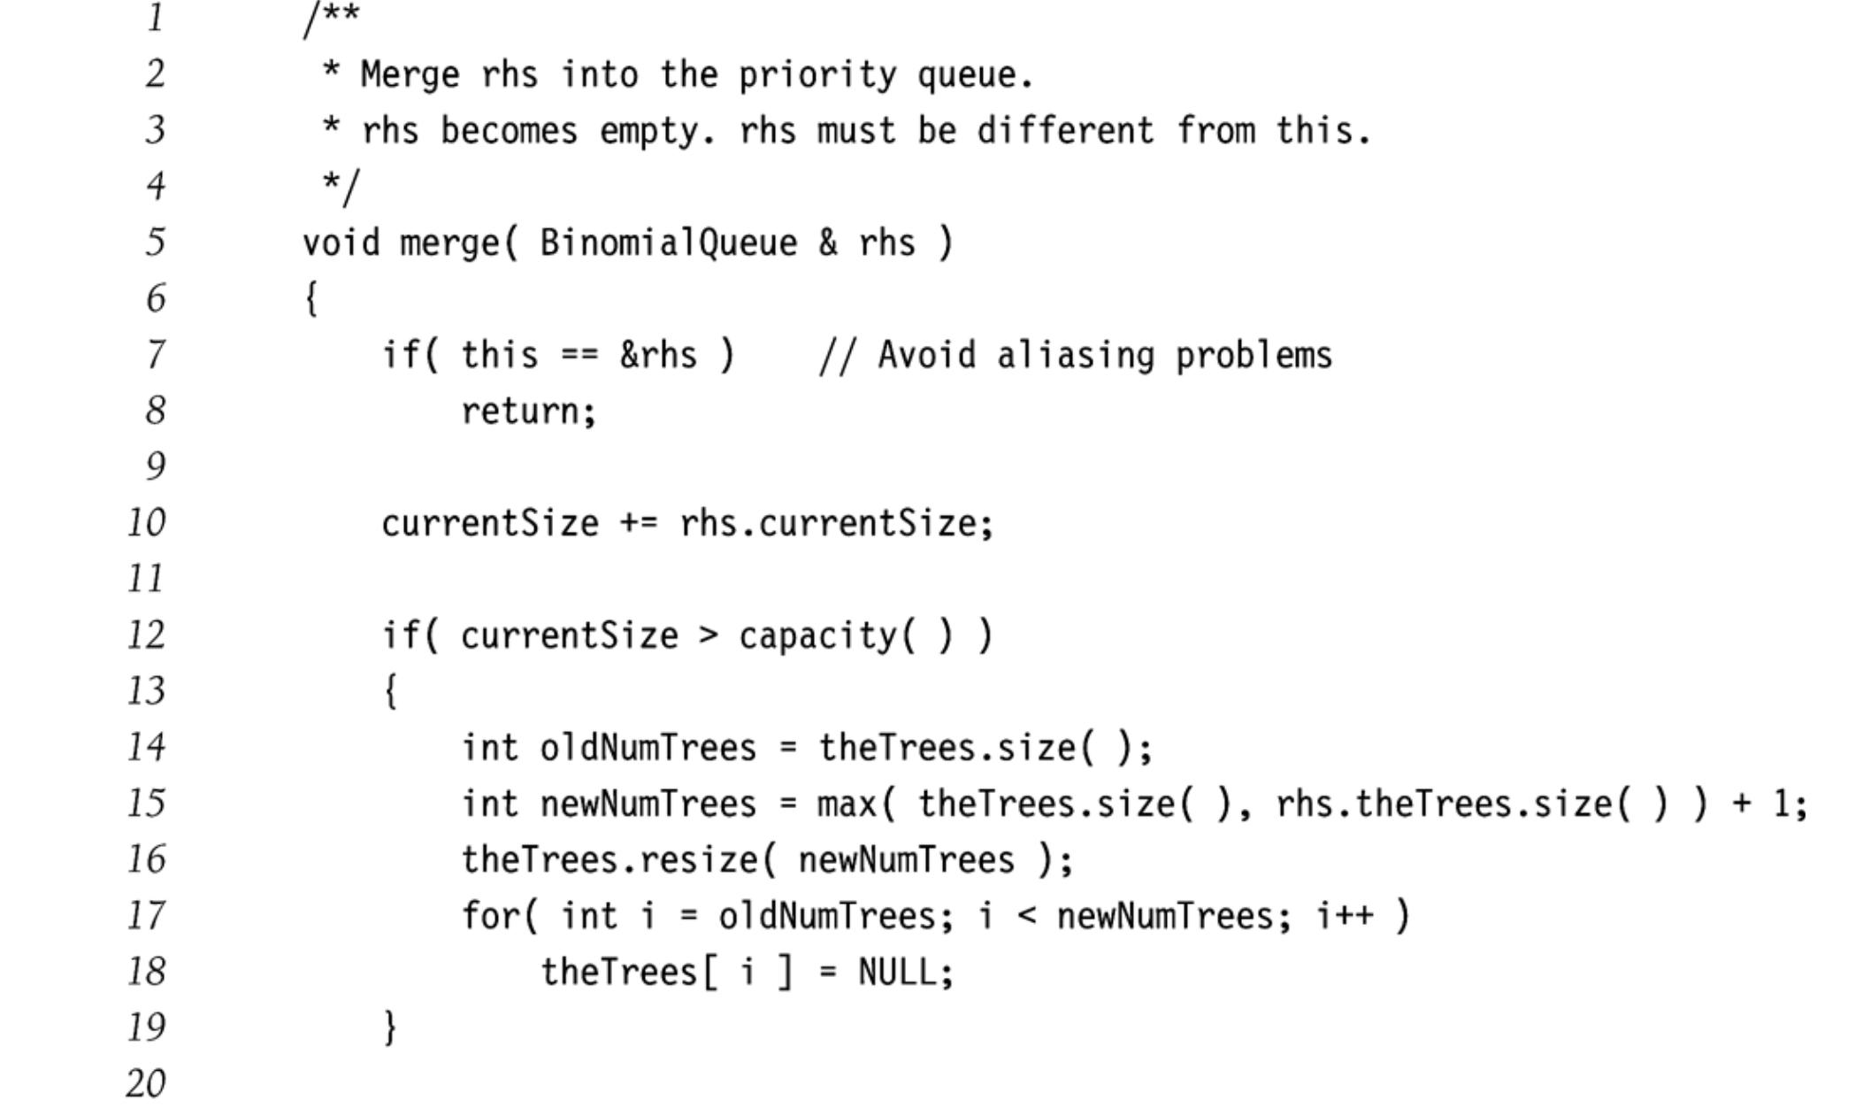

54

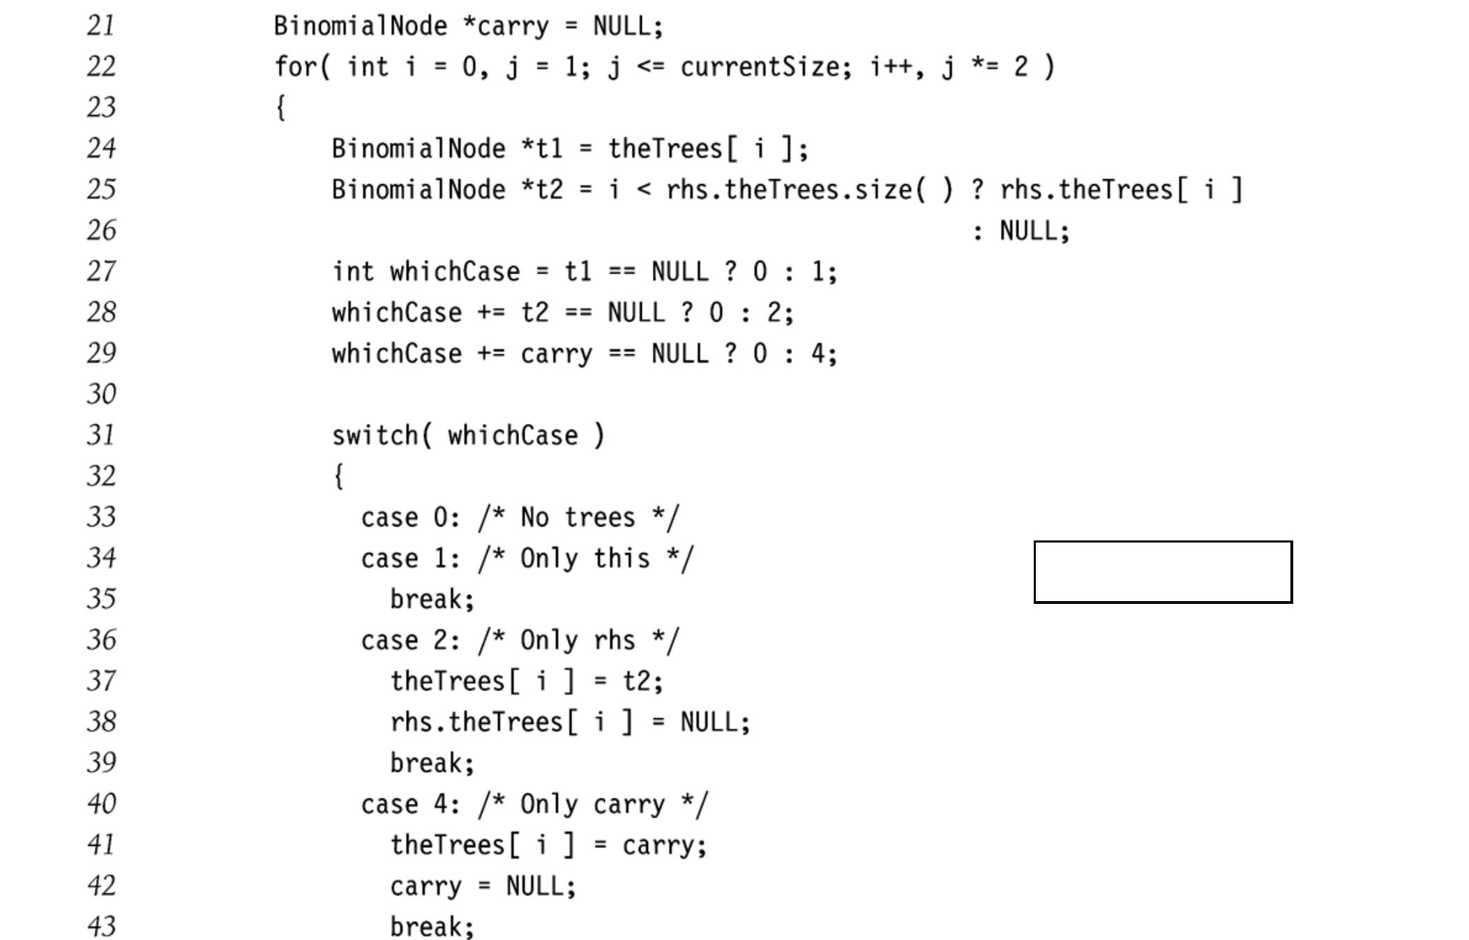

merge (cont.)

55

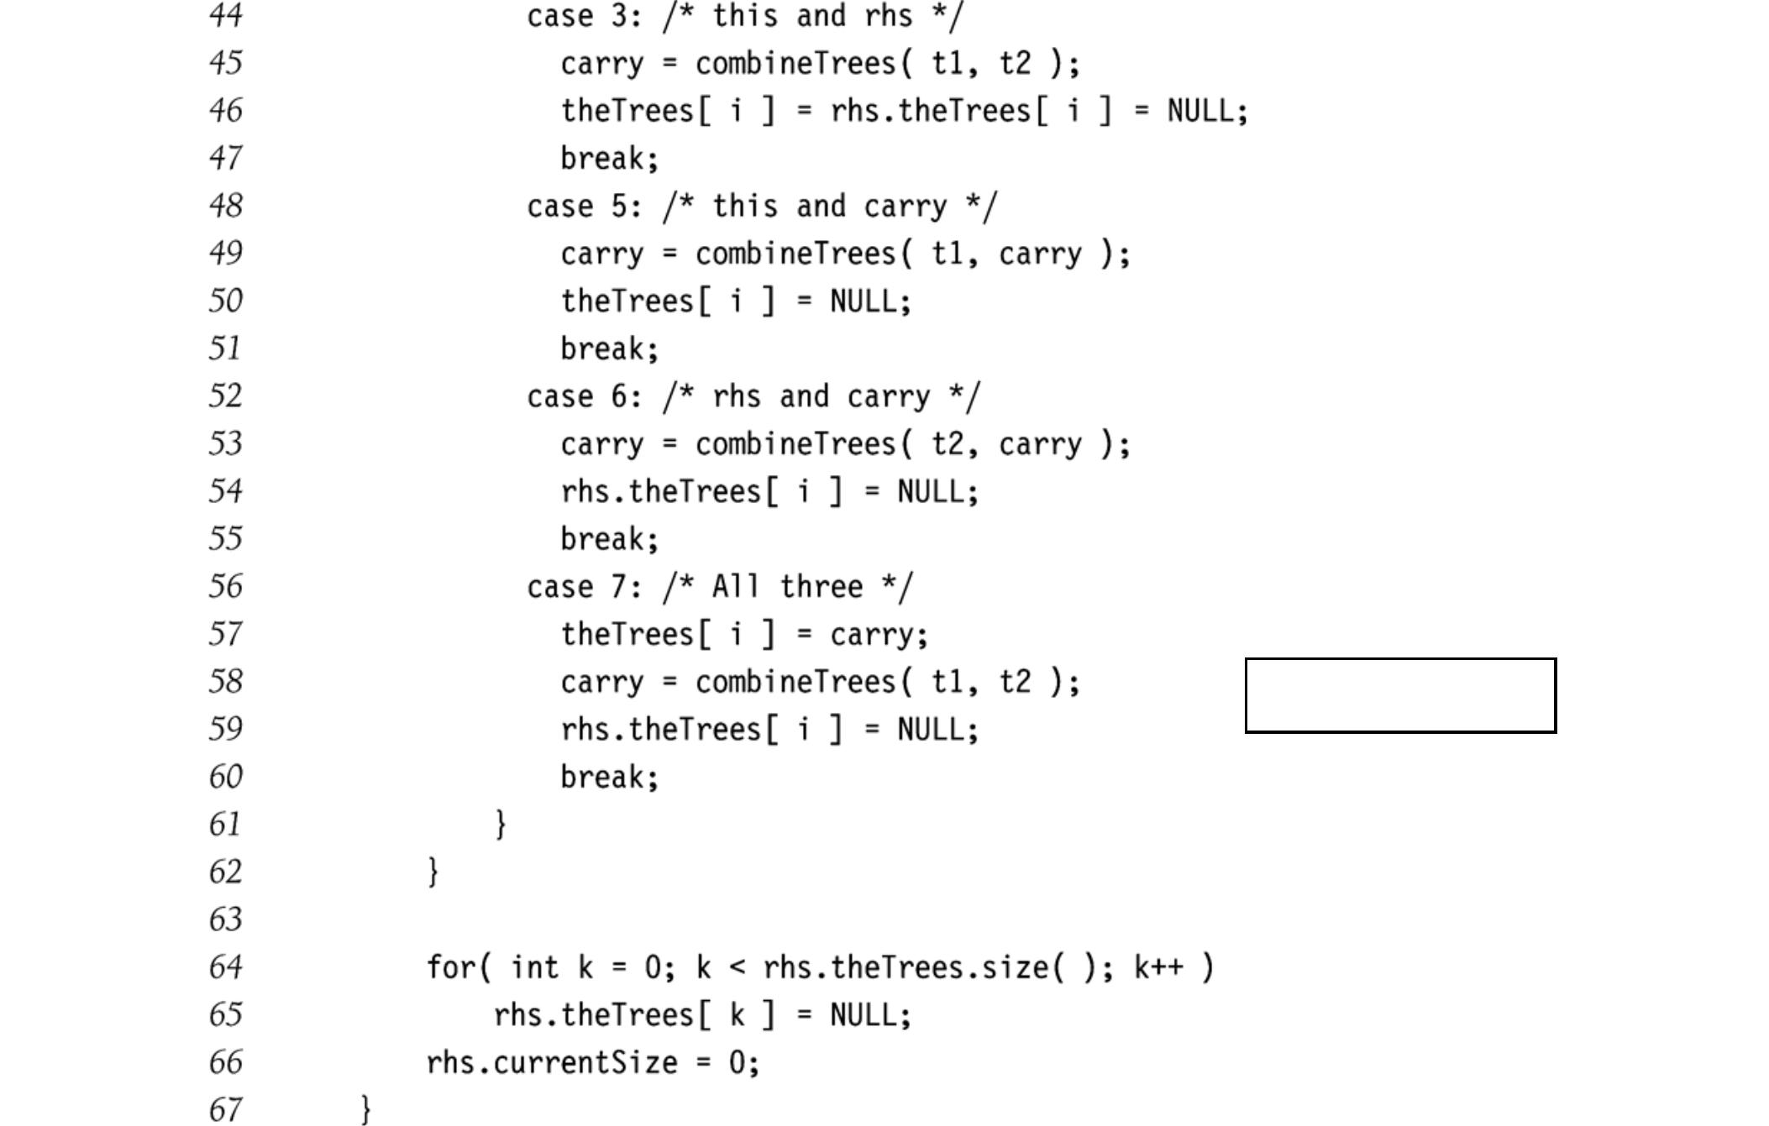

merge (cont.)

56

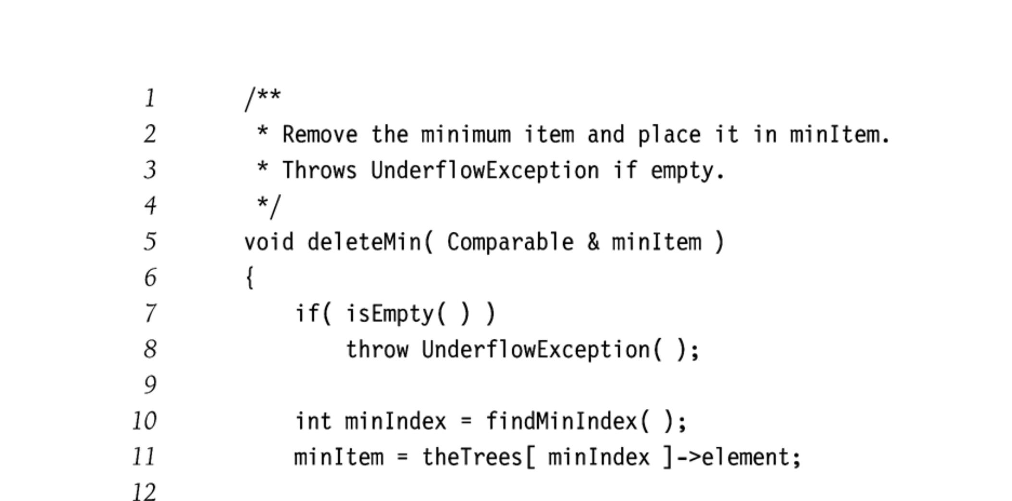

57

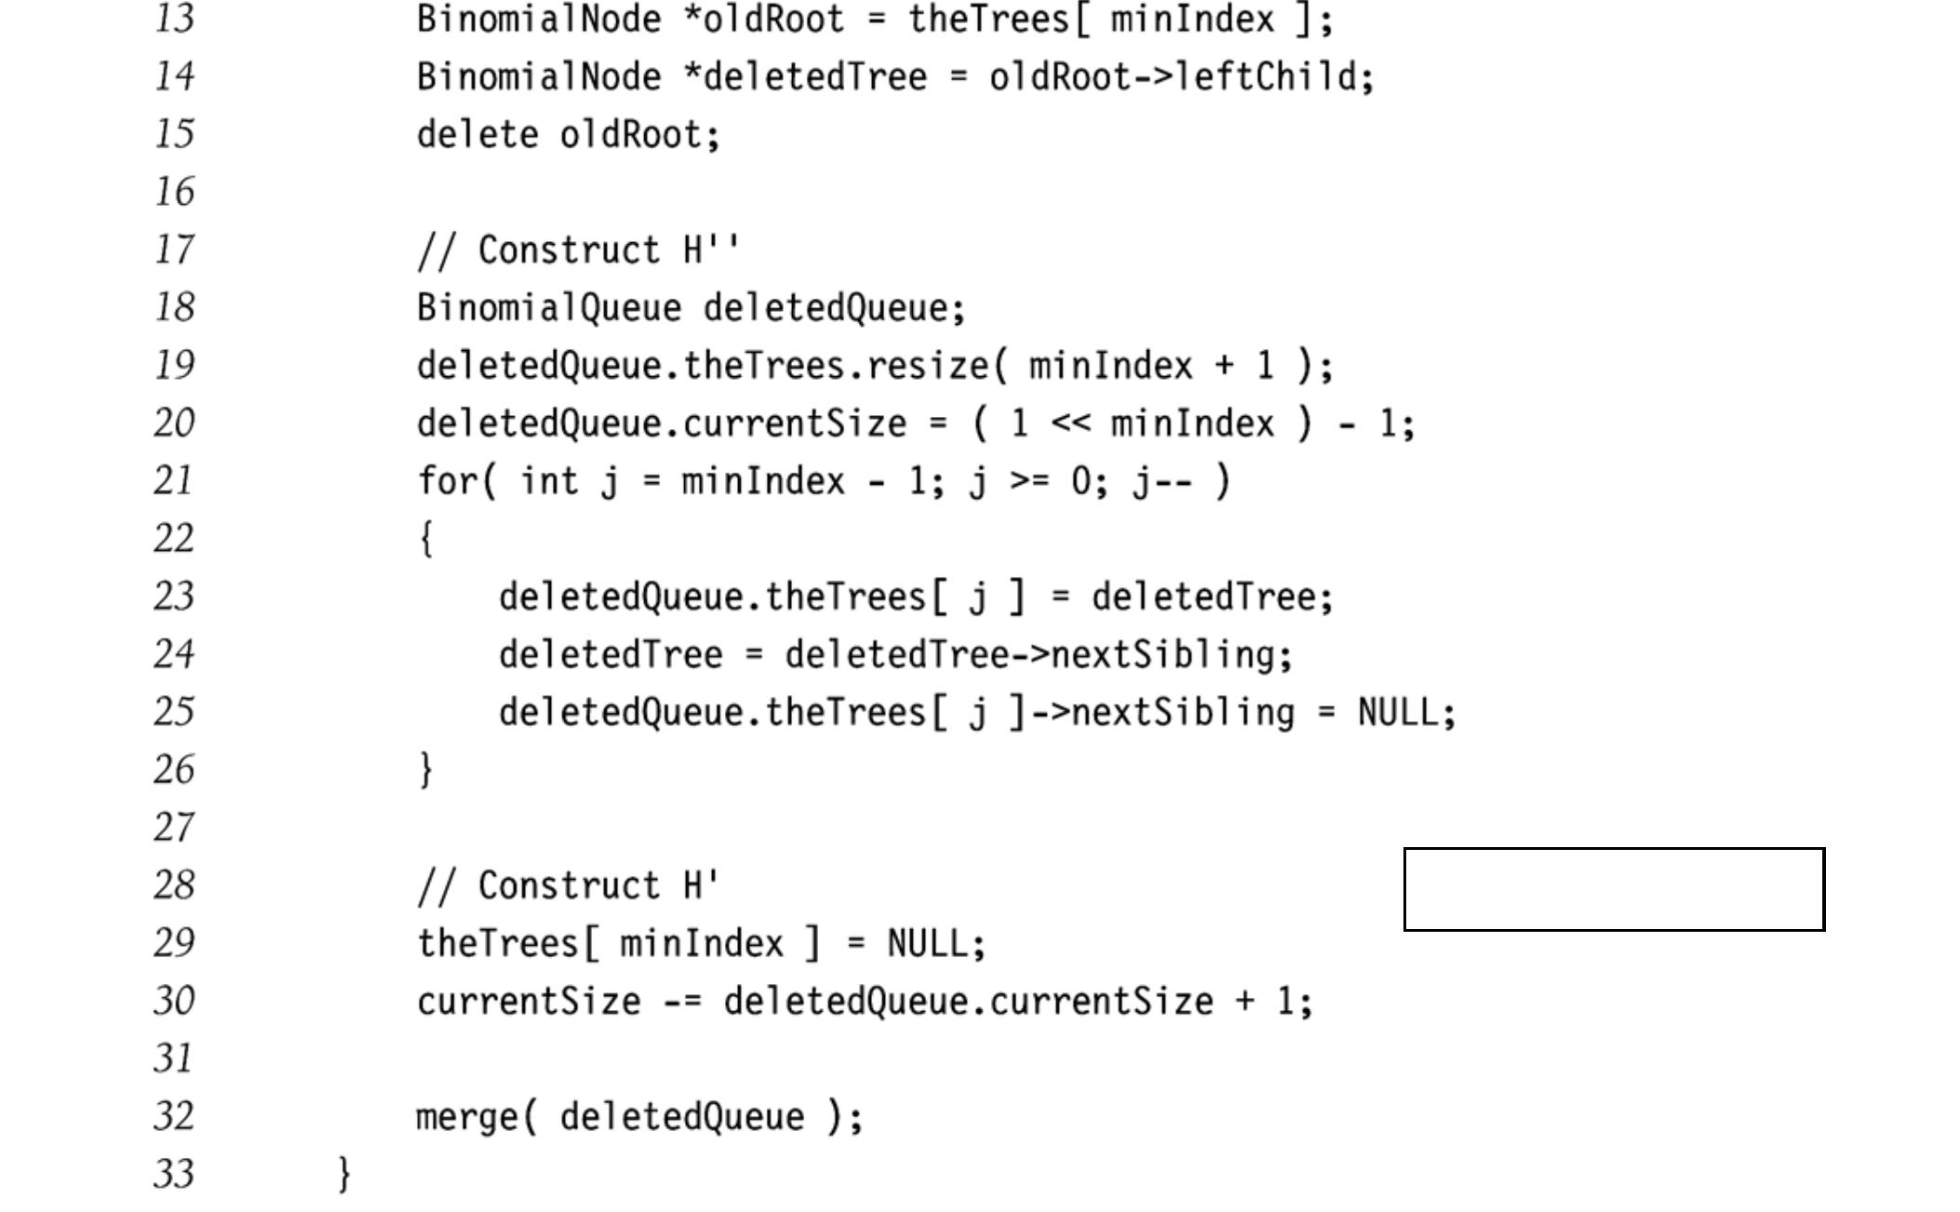

deleteMin (cont.)

58

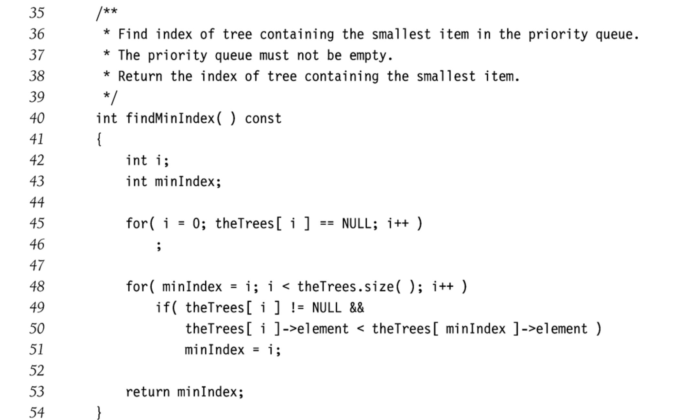

59

Priority Queues in STL

- Binary heap

- Maintains maximum element

- Methods

  - Push, top, pop, empty, clear

#include <iostream> #include <queue> using namespace std;
int main ()

{

priority_queue<int> Q; for (int i=0; i<100; i++)

Q.push(i);

while (! Q.empty())

{

cout << Q.top() << endl;

Q.pop();

}

}

60

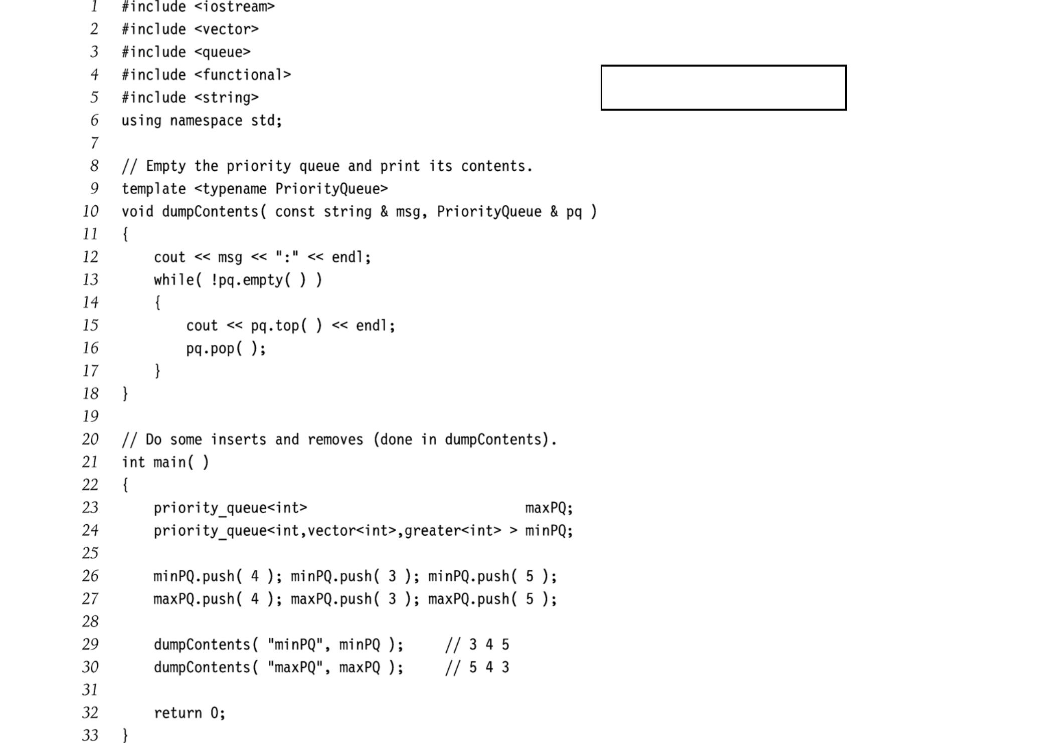
STL priority queue

61

Summary

- Priority queues maintain the minimum or maximum element of a set

- Support O(log N) operations worst-case

  - insert, deleteMin, merge

- Support O(1) insertions average case

- Many applications in support of other algorithms

62

